“ANSWERS TO TOUGH QUESTIONS” BOOK
With such a positive response to this offer, we found ourselves sold out very quickly. At the request of many, we will be ordering additional books after the Christmas holiday. If you missed the opportunity to purchase a book, please stop by the counter in the foyer and fill out an order form. Books are $3.00. Please be sure to pay for your book(s) when you fill out the form. This will make distribution easier. We will let you know when the books have been delivered.

A SERVICE TO WORSHIP TOGETHER
JANUARY 28
We hope you will join us, Sunday January 28th, for a very special service. We have invited the members of Westside Baptist and Second Baptist churches to join us in worship. We will have a guest speaker and special music. Watch the bulletins for further information.

ISRAEL MISSION TRIP
FEBRUARY 9-17
This will be a work trip. Cost per person will be under $2000. If you are interested in going, please be sure to let the church office know as soon as possible or fill out one of the blue cards in the pews and write “Israel Trip” for more information.

SCHEDULE REMINDERS:

CHRISTMAS DAY
- Church Office and Campus Closed on December 26th.

NEW YEARS EVE SERVICE SCHEDULE
- 9:00 AM Bible Fellowship Groups & Sunday School
- 10:30 AM Morning Worship
- No Evening Service

NEW YEARS DAY
- Church Office and Campus Closed (Church will open Tuesday morning at 8:00 AM, January 2).

www.fbcseguin.org
314 E. Cedar St. Seguin, TX 78155 830.379.4208

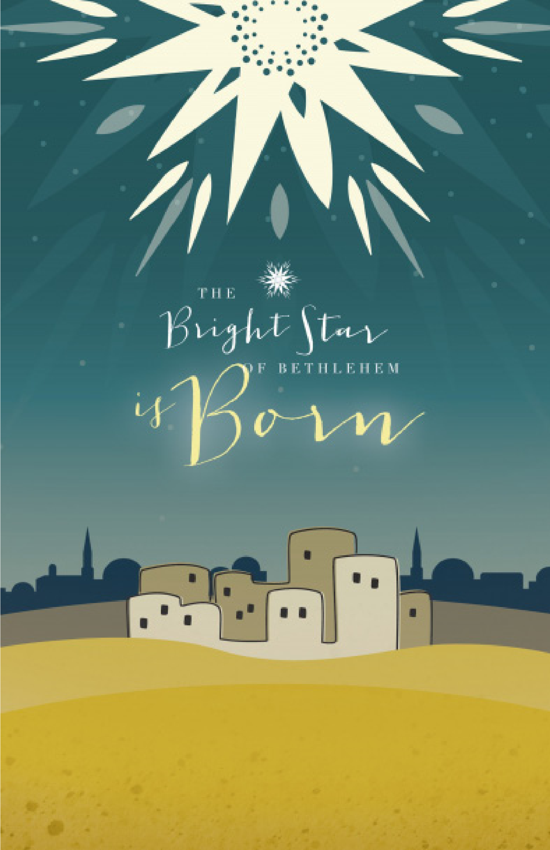
FIRST TIME HERE? Text Welcome to 830-224-2046

MORNING SERVICE
December 24, 2017 10:30 am

SING HOSANNAS Worship Choir

GENTLE MARY LAID HER CHILD (Hymn #101) Congregation

WELCOME

PRAYER

WHAT CHILD IS THIS? Handbell Choir

ONE TEAM Video

WORSHIP MEDLEY Congregation
It Came upon the Midnight Clear (Hymn #93)
I Heard the Bells on Christmas Day (Hymn #98)
The First Noel

SCRIPTURE – MATTHEW 2:1-12* Amelia Allen

MESSAGE: SEEKING JESUS AT CHRISTMAS

RESPONDING TO GOD’S WORD Congregation
Amazing Grace (Hymn #330)

OFFERING
Prayer Miguel Garcia
We Three Kings (Hymn #113) Congregation

BENEDICTION

* Children 4 years old thru First Grade dismissed for children’s worship following this song

CHRISTMAS EVE CANDLE LIGHT SERVICE
TONIGHT
We invite you and your family to join us this evening at 6:00 PM for our annual Christmas Eve Candle Light service. We encourage you to invite a friend to hear the Good News that is the birth of our Savior! This will be an old fashioned, 37-minute service, as well as a time of joyful worship. We hope to see you there.

LOTTIE MOON CHRISTMAS OFFERING
We will be collecting for this offering through the month of December. We have the big red bucket in the foyer for you to add any spare change you’ve collected this year. Please be in prayer about what our Lord would have you give to this important ministry supporting foreign missions.

MORE INFORMATION
If you would like more information about the church, please write your name and email address on one of the white cards in the pews and place in the offering plate. For more information about membership, baptism, or small groups, please fill out a yellow card. If you would like to find a place to serve, please use the blue card.

