MEN’S PRAYER BREAKFAST
MARCH 3
We invite you to join us Saturday, March 3rd for a time of fellowship over breakfast, prayer and testimony. We will be at The Rock Church, located at 1201 W. Court St., here in Seguin. We invite all fathers to bring their sons and sons to bring their fathers.

MIDDLE SCHOOL CONNECT REC
MARCH 4 6:00 – 9:00 PM
For student’s 6th – 8th grade. This month we will be at the Rhodes’ house. As a reminder that all students wishing to participate in the evening extra must be present at Sunday Evening Worship, beginning at 6:00 PM. You can pick up your student at the Youth Bldg. at 9:00 PM.

SPRING BREAK
MARCH 12 – 16
Can you believe it is time for this already? The church will not have many of our weekly activities during the week of Spring Break. Church choirs and ensembles, as well as all Wednesday evening children’s and youth activities will NOT meet. All other bible study attendees should check with their leaders as to scheduling. We hope you will enjoy the time off and relax!

PRETEEN CAMP @ CAMP TEJAS
Attention parents of children who have completed third grade – sixth grade: Preteen Camp is right around the corner, scheduled for July 13 - 16. Camp Tejas is a wonderful place for children to grow in their faith through Bible study, praise & worship, and to enjoy fun activities like swimming, mud games, and a zip line. Registration forms will be mailed out and will also be available on the church website. The price per child is $250 and a $25 deposit reserves your spot.

As always, we would hate for money to be the reason a child does not get the opportunity to grow. If you would like to help send a child to camp, please place your money in an offering envelope and write on the designated line “preteen camp.” Your generosity could mean a world of difference to many children.

1314 E. Cedar St. 830.379.4208
www.fbcseguin.org

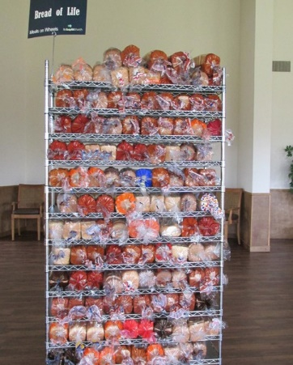
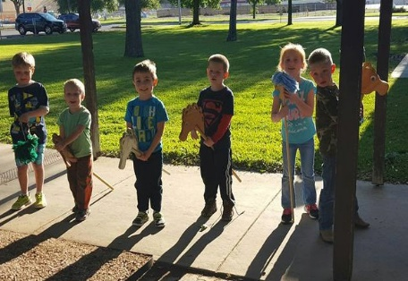
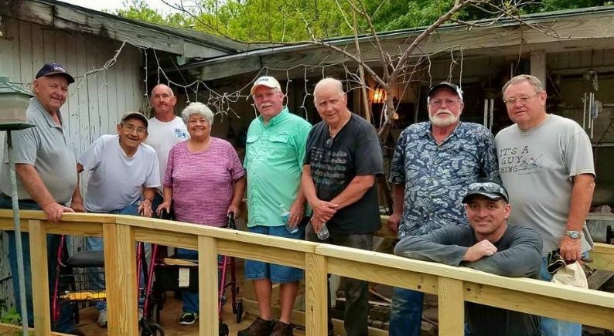
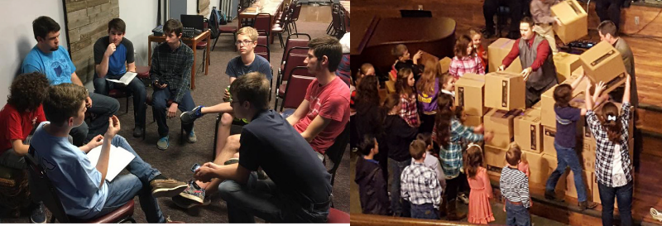
Welcome

www.fbcseguin.org
Pastor: Dr. Brice Mandaville
Associate Pastor: Josh Tylich
Minister of Music: Howard Hudiburg
Children’s/Volunteer Coordinator: Rhonda Hensarling

FIRST TIME HERE?
Text Welcome to
830-224-2046

MORNING SERVICE
February 18, 2018 10:30 am

AT YOUR NAME Congregation

WELCOME/PRAYER

BROKEN VESSELS Worship Choir

MY TESTIMONY Roy Presley

WORSHIP MEDLEY Congregation
When We All Get to Heaven (Hymn #514)
I Can Only Imagine

SCRIPTURE – Ezekiel 8: 1-5 * Chelsea Sestak

MESSAGE: DO ALL ROADS LEAD TO HEAVEN?

RESPONDING TO GOD’S WORD Congregation
I Saw the Cross of Jesus (Hymn #286)

Offering
Prayer Joe Peoples
Your Grace Finds Me Praise Team and Congregation

BENEDICTION

* Children 4 years old thru First Grade dismissed for children’s worship following this scripture reading

EVENING SERVICE
Please join us for a traditional service of hymns and verse by verse preaching. Bro. Brice will be in the book of Proverbs.

YOUTH SPAGHETTI LUNCHEON
NEXT SUNDAY NOON – 1:30 PM
Youth for hire! Immediately following the morning service, February 25, we will be having a silent auction & lunch in the Fellowship Hall, hosted by the FBC Youth. You may purchase tickets for the lunch for $10 in the church foyer or at the door. After you’ve eaten, we encourage you to mosey through our silent auction, where we will be hiring out our Youth to raise money for their various Spring and Summer events. Have a garden to plant? Need a babysitter? Maybe a lawn or two to be mowed? This auction is for you. We will announce the “winners” of the auction at the end of the lunch. If you are not able to stay through the end of the lunch, we will contact you. All ticket sales will also go toward the various upcoming events.

MORE INFORMATION
If you would like more information about the church, please write your name and email address on one of the white cards in the pews and place in the offering plate. For more information about membership, baptism, or small groups, please fill out a yellow card.

