BREAD for MEALS ON WHEELS
We are sad to announce that the Meals on Wheels program that was serving the city of Seguin will no longer do business in our area. It is our understanding that the city of Seguin is working on finding a replacement for the service, however, until that time we will not collect bread the first Sunday of the month. Not to worry though, we will be back with a new service opportunity soon!

MEN’S PRAYER BREAKFAST
MARCH 3
Please consider joining us Saturday, March 3rd for a time of fellowship over breakfast, prayer and testimony. We will be at The Rock Church, located at 1201 W. Court St., here in Seguin. We invite all fathers to bring their sons and sons to bring their fathers.

MIDDLE SCHOOL CONNECT REC
MARCH 4 6:00 – 9:00 PM
For students 6th – 8th grade. This month we will be at the Rhodes’ house. As a reminder, all students wishing to participate in the evening extra must be present at Sunday Evening Worship, beginning at 6:00 PM. Students may be picked up at the Youth Bldg. at 9:00 PM.

KEENAGER’S LUNCHEON
MARCH 5
Sign up today, in the church foyer, for the March KeenAger’s Luncheon. This month, we have secured the Lifegate Christian School Drama team and they will be performing their spring play, The Missionary of Oz. To accommodate the length of the play, they will start their performance at 10:30am, and during intermission lunch will be served. We hope you will join us!

PRETEEN CAMP @ CAMP TEJAS
Attention parents of children who have completed third grade – sixth grade: Preteen Camp is right around the corner, scheduled for July 13 - 16. Camp Tejas is a wonderful place for children to grow in their faith through Bible study, praise & worship. As a church, we would hate for money to be the reason a child does not get this opportunity to grow. If you would like to help send a child to camp, please place your money in an offering envelope and write on the designated line “preteen camp.” Your generosity could mean a world of difference to many children.

1314 E. Cedar St. 830.379.4208
www.fbcseguin.org

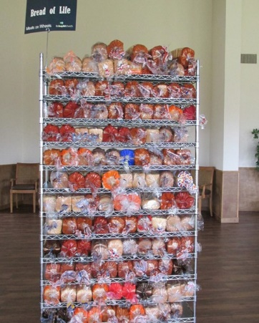
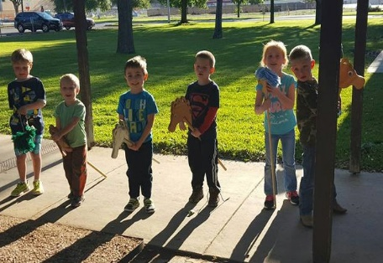
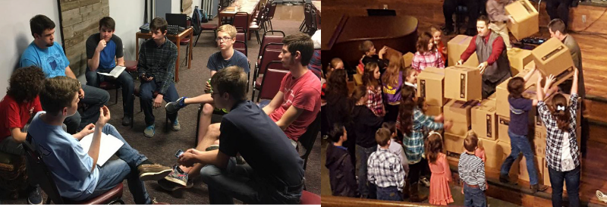
Welcome

www.fbcseguin.org
Pastor: Dr. Brice Mandaville
Associate Pastor: Josh Tylich
Minister of Music: Howard Hudiburg
Children’s/Volunteer Coordinator: Rhonda Hensarling

FIRST TIME HERE?
Text Welcome to
830-224-2046

MORNING SERVICE
February 25, 2018 10:30 am

THIS IS AMAZING GRACE Congregation

WELCOME

PRAYER

MY TESTIMONY Holly Brown

WORSHIP MEDLEY Congregation
Heaven Came Down (Hymn #438)
Mercy
Be Thou My Vision (Hymn #60)

SCRIPTURE – Ezekiel 12:1-7 * Ruth Ritter

MESSAGE: A CHANGE OF HEART

RESPONDING TO GOD’S WORD Congregation
Change My Heart O God

Offering
Prayer Travis Phillips
Days of Elijah Praise Team and Congregation

BENEDICTION

* Children 4 years old thru First Grade dismissed for children’s worship following this scripture reading

EVENING SERVICE
Please join us for a traditional service of hymns and verse by verse preaching. Bro. Brice will be speaking on Ezekiel Chapter 10 on the Glory of God.

YOUTH SPAGHETTI LUNCHEON
NOON – 1:30 PM
To help our youth learn the value of work, we have youth for hire! Immediately following the morning service this morning, we will be having a silent auction & lunch in the Fellowship Hall, hosted by the FBC youth. You may purchase tickets for the lunch for $10 at the door if you’ve not already done so. After you’ve eaten, we encourage you to mosey through our silent auction, where we will be hiring out our youth to raise money for their various spring and summer events. Have a garden to plant? Need a babysitter? Maybe a lawn or two to be mowed? This auction is for you. We will announce the “winners” of the auction at the end of the lunch. If you are not able to stay through the end of the lunch, we will contact you. All ticket sales will also go toward the various upcoming events.

MORE INFORMATION
If you would like more information about the church, please write your name and email address on one of the white cards in the pews and place in the offering plate. For more information about membership, baptism, or small groups, please fill out a yellow card.

