THANK YOU
Thank you for helping our youth raise almost $2300 to help them pay for their summer mission trip and camp! The outpouring of support from our church to these students is AMAZING!

MIDDLE SCHOOL CONNECT REC
TONIGHT 6:00 – 9:00 PM
For students 6th – 8th grade. As a reminder, all students wishing to participate in tonight’s evening extra must be present at Sunday Evening Worship, beginning at 6:00 PM. Students may be picked up at the Youth Bldg. at 9:00 PM.

KEENAGER’S LUNCHEON
TOMORROW
This month, we have secured the Lifegate Christian School Drama team and they will be performing their spring play, The Missionary of Oz. To accommodate the length of the play, they will start their performance at 10:30am, and during intermission lunch will be served. We look forward to seeing you there.

GAME NIGHT
MARCH 8
Join us this Thursday in the Fellowship Hall for our monthly Game Night. We meet at 6:00 PM every second Thursday of each month. We play all sorts of games, eat a little, then play some more. Bring your favorite board/card game, an appetizer to share, and your game face. See you there.

PRETEEN CAMP @ CAMP TEJAS
Attention parents of children who have completed third grade – sixth grade: Preteen Camp is right around the corner, scheduled for July 13 - 16. Camp Tejas is a wonderful place for children to grow in their faith through Bible study, praise & worship. As a church, we would hate for money to be the reason a child does not get this opportunity to grow. If you would like to help send a child to camp, please place your money in an offering envelope and write on the designated line “preteen camp.” Your generosity could mean a world of difference to many children.

MORE INFORMATION
If you would like more information about the church, please write your name and email address on one of the white cards in the pews and place in the offering plate. For more information about membership, baptism, or small groups, please fill out a yellow card.

1314 E. Cedar St. 830.379.4208
www.fbcseguin.org

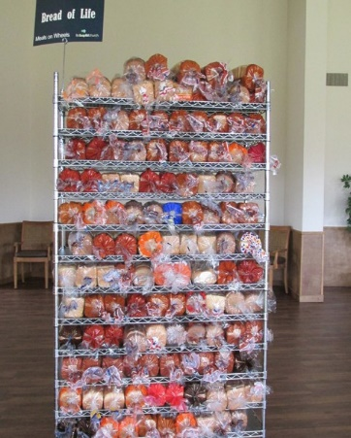
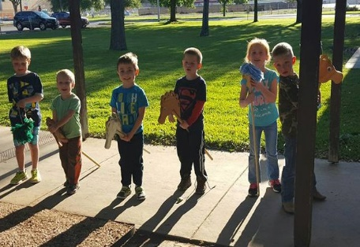
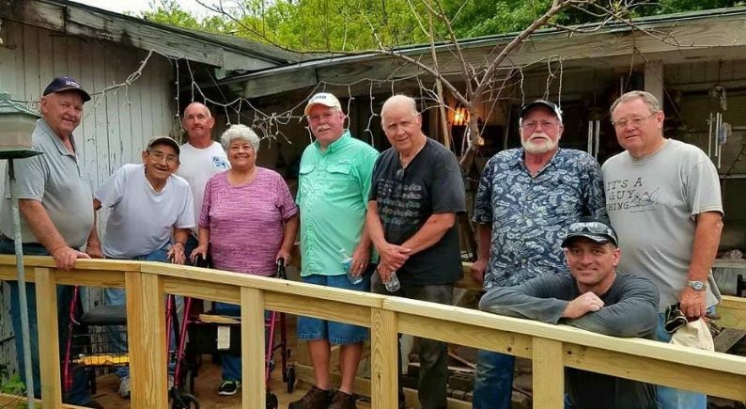
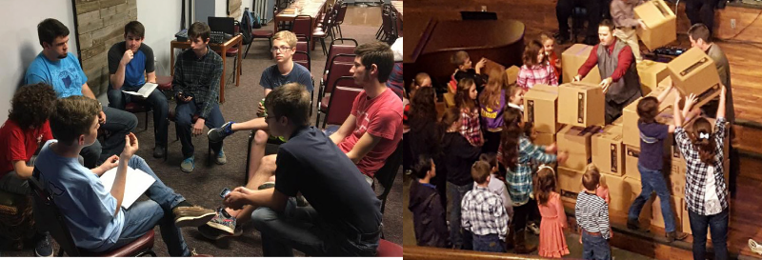
Welcome

www.fbcseguin.org
Pastor: Dr. Brice Mandaville
Associate Pastor: Josh Tylich
Minister of Music: Howard Hudiburg
Children’s/Volunteer Coordinator: Rhonda Hensarling

FIRST TIME HERE?
Text Welcome to
830-224-2046

MORNING SERVICE
March 04, 2018 10:30 am

OPEN UP THE HEAVENS Congregation

WELCOME/PRAYER

I’LL FLY AWAY Handbell Choir

EAST ST. LOUIS Video

WORSHIP MEDLEY Congregation
The Old Rugged Cross (Hymn #141)
Cornerstone

SCRIPTURE – Ezekiel 13:1-7 * Patrick Hamilton

MESSAGE: RECOGNIZING FALSE PROPHETS

RESPONDING TO GOD’S WORD Congregation
Jesus Is Tenderly Calling (Hymn #316)

Offering
Prayer Jim Ransdell
Our God Praise Team and Congregation

BENEDICTION

* Children 4 years old thru First Grade dismissed for children’s worship following this scripture reading

EVENING SERVICE
Please join us for a traditional service of hymns and verse by verse preaching. Bro. Josh will be looking into the book of Ruth.

WEEK OF PRAYER FOR NORTH AMERICAN MISSIONS
MARCH 4 - 11
Each Spring, we take up an offering in support of new church plants in North America, many of which are in areas that have no effective witness of the gospel. Enclosed is a prayer guide for the week and an offering envelope. Your prayers and financial support through the Annie Armstrong Easter Offering are important to these missionaries. Please be in prayer about what God would have you give to this important ministry.

ANNUAL DESSERT AUCTION
MARCH 25
In tandem with the Annie Armstrong Easter Offering, we will be holding a live auction of specialty desserts as a fun way to raise money toward such an important offering. If you would like to submit a dessert or pie for the auction, please sign up in the church foyer or in your Bible Fellowship Group class. Remember that you will need to bring 2 of each dessert or pie you wish to submit (one for trying, one for buying). Join us, Sunday evening March 25th, for this convention of culinary confections!

