SPRING BREAK
There will be an adult Bible study on Wednesday evening in the fellowship hall as usual, but there will be no choir practice, children’s activities or youth activities on Wednesday evening. We hope you enjoy Spring Break!

NORTH AMERICAN MISSIONS
Each Spring, we take up an offering in support of new church plants in North America, many of which are in areas that have no effective witness of the gospel. Your prayers and financial support through the Annie Armstrong Easter Offering are important to these missionaries. We will be collecting for this offering through the month of March. Please be in prayer about what God would have you give to this important ministry.

ISRAEL TRIP
MARCH 11 – 20
This week we are sending a team of men and women from the church to help with repairs to the life-sized Tabernacle in Israel. Please join us in praying for the team as this trip will be exhausting in many ways. Long flights and hot days in the sun doing manual labor! Please pray for their health and safety as they travel, for their endurance and safety as they work, and most importantly, for God to be glorified in their work! Thank you for your prayers.

LORD’S SUPPER
We will be observing the Lord’s Supper in the morning worship service on March 25th. All who have accepted Jesus Christ as their Savior and Lord are invited to participate with us in the taking of the elements.

MORE INFORMATION
If you would like more information about the church, please write your name and email address on one of the white cards in the pews and place in the offering plate. For more information about membership, baptism, or small groups, please fill out a yellow card.

1314 E. Cedar St. 830.379.4208
www.fbcseguin.org

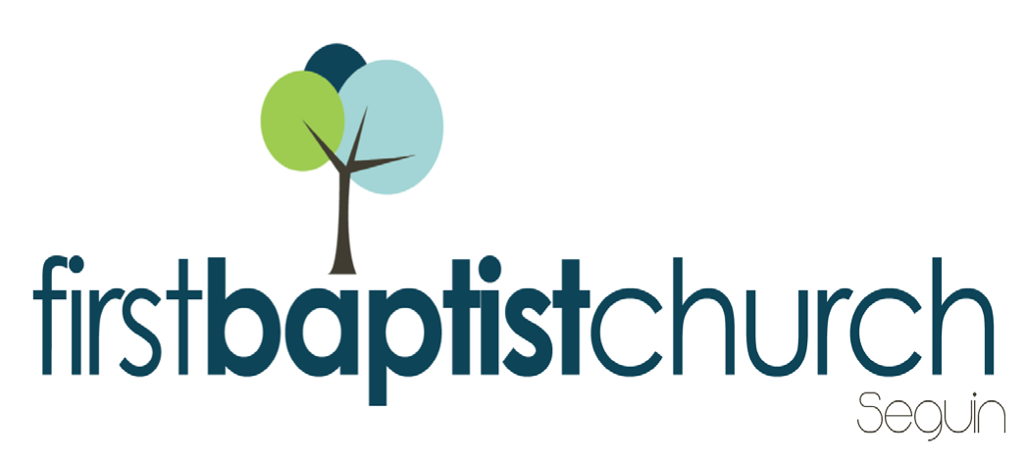
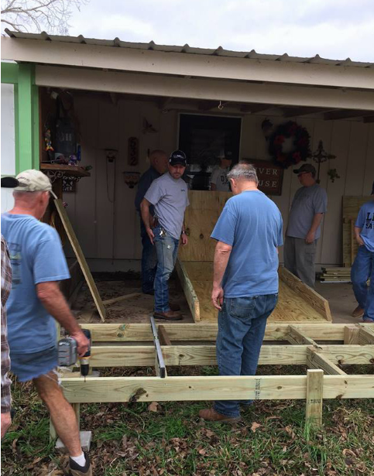
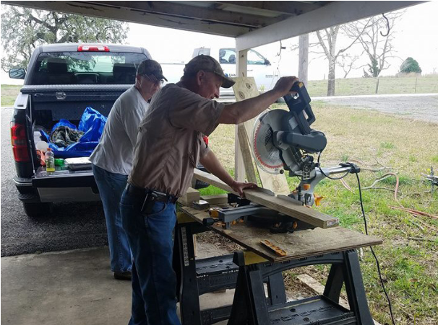
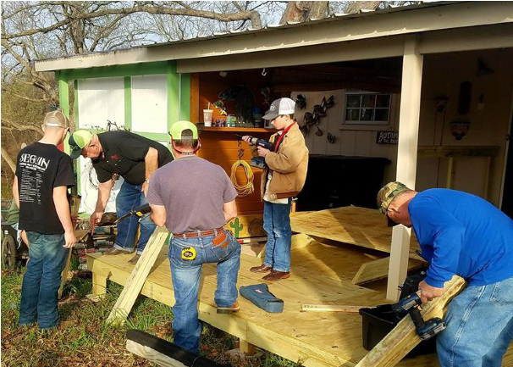
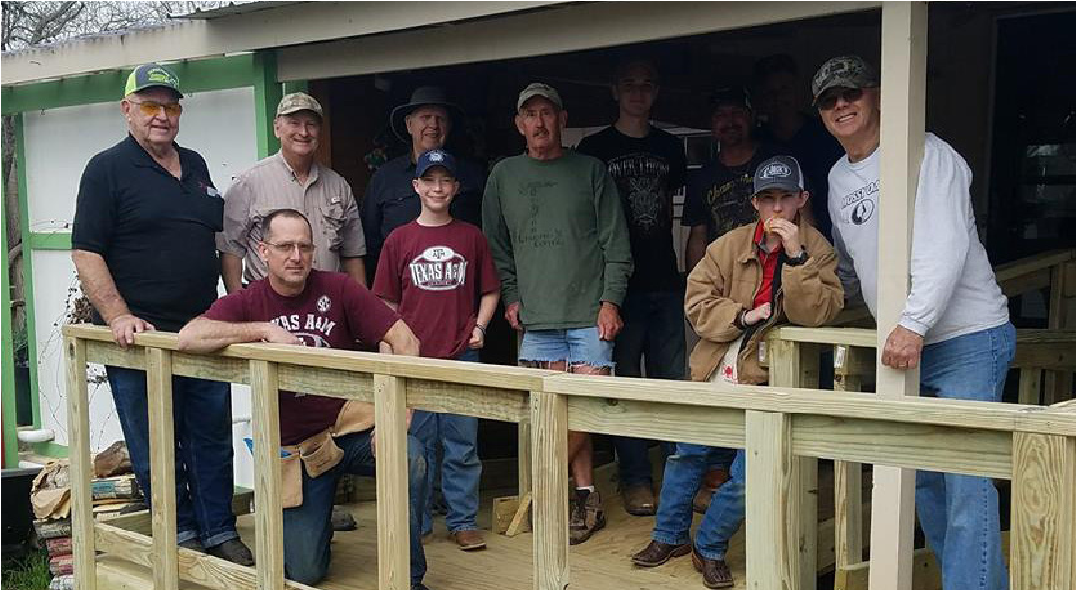
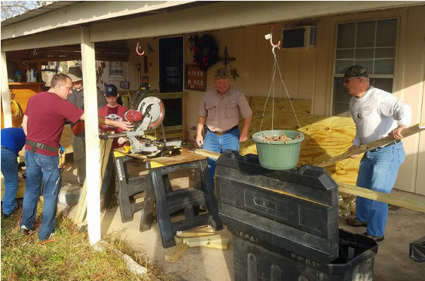
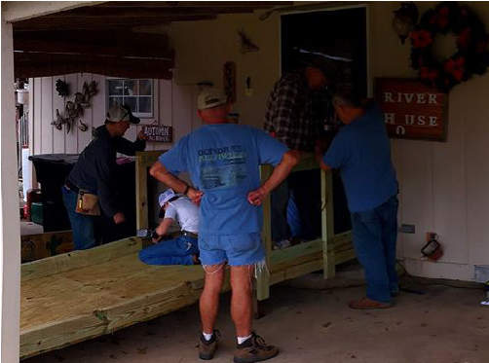

www.fbcseguin.org
Pastor: Dr. Brice Mandaville
Associate Pastor: Josh Tylich
Minister of Music: Howard Hudiburg
Children’s/Volunteer Coordinator: Rhonda Hensarling

FIRST TIME HERE?
Text Welcome to
830-224-2046

MORNING SERVICE
March 11, 2018 10:30 am

GREAT IS THE LORD (Hymn #12) Congregation

ABSOLUTELY NOTHIN’ Music Makers Choir

WELCOME/PRAYER

DETROIT Video

WORSHIP MEDLEY Congregation
The Lily of the Valley (Hymn #189)
Revelation Song
10,000 Reasons

SCRIPTURE – Ezekiel 17: 1-10 * Cheney Stephenson

MESSAGE: PARABLE OF THE TWO EAGLES

RESPONDING TO GOD’S WORD Congregation
In the Garden (Hymn #187)

Offering
Prayer Whitney Reese
The Lion and the Lamb Praise Team & Congregation

BENEDICTION

* Children 4 years old thru First Grade dismissed for children’s worship following this scripture reading

The flowers are placed today in loving memory of Dianne Mangum.
EVENING SERVICE
Please join us for a traditional service of hymns and verse by verse preaching. Bro. Josh will be preaching.

CELEBRATE THE RESSURECTION!
APRIL 1
We hope you and your family will join us Easter Morning for a service full of worship and wonder of our Lord, Jesus Christ. We would like to encourage you to invite a friend or family member to church that morning so that they may hear the Good news. Worship will begin at 10:30 AM and there will be no evening service that night.

ANNUAL DESSERT AUCTION
MARCH 25
In tandem with the Annie Armstrong Easter Offering, we will be holding a live auction of specialty desserts as a fun way to raise money toward such an important offering. If you would like to submit a dessert or pie for the auction, please sign up in the church foyer or in your Bible Fellowship Group class. Remember that you will need to bring 2 of each dessert or pie you wish to submit (one for trying, one for buying).

