ISRAEL TRIP
Please continue to pray for our team in Israel. They will be returning on Tuesday! Thank you for your prayers.

LORD’S SUPPER
We will be observing the Lord’s Supper in the morning worship service on March 25th. All who have accepted Jesus Christ as their Savior and Lord are invited to participate with us in the taking of the elements. There will be gluten free wafers available in the church foyer for those on restricted diets.

NORTH AMERICAN MISSIONS
Each Spring, we take up an offering in support of new church plants in North America, many of which are in areas that have no effective witness of the gospel. Your prayers and financial support through the Annie Armstrong Easter Offering are important to these missionaries. We will be collecting for this offering through the month of March. Please be in prayer about what God would have you give to this important ministry.

NEW BIBLE FELLOWSHIP GROUP OPPORTUNITY
Beginning April 1, we will be launching a new Bible Fellowship Group, taught by Ed & Frieda Savage and Jimmy & Cindy Jackson, in bldg. 3, room 306. They will be starting a year long journey through the study Disciple’s Path. This class will be geared toward parents of Elementary age children however, like all our Bible Fellowship Groups, this class will be open to all adults who wish to connect with a Sunday morning class. For more information, contact Ed Savage.

S. TX PREGNANCY CARE CENTER WALK FOR LIFE
APRIL 7
Can one person make a difference? Yes, and two can be amazing! Sign up today for the South Texas Pregnancy Care Center’s annual Walk for Life next month. Bring a friend and double the impact! If you would be interested in participating, please contact the center at 830.303.2151. Walk for Life to save a Life, because every life matters!

1314 E. Cedar St. 830.379.4208
www.fbcseguin.org

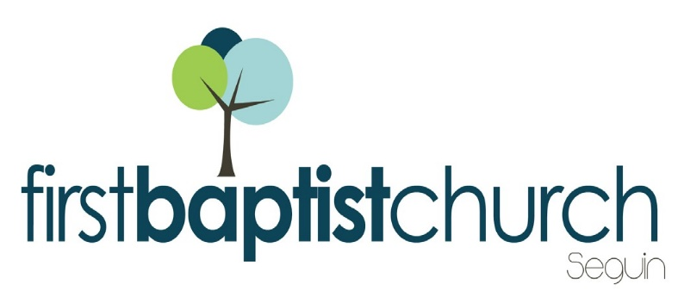
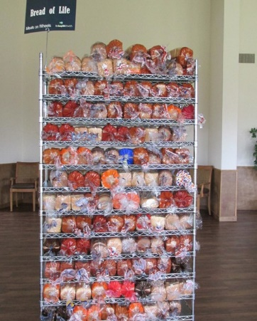
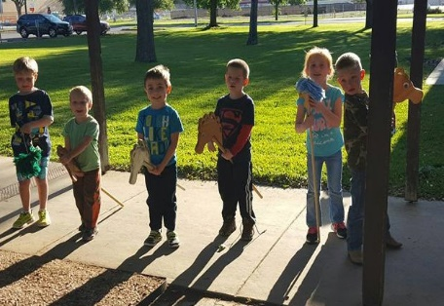
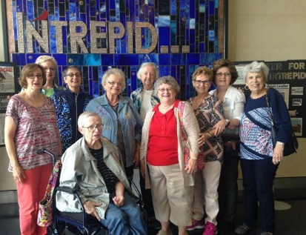
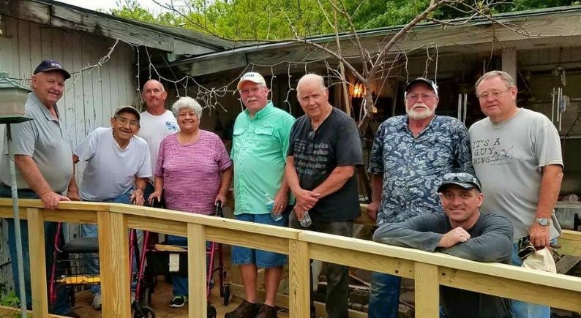
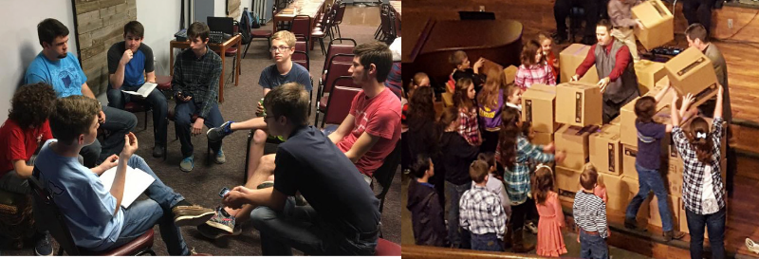
Welcome

www.fbcseguin.org
Pastor: Dr. Brice Mandaville
Associate Pastor: Josh Tylich
Minister of Music: Howard Hudiburg
Children’s/Volunteer Coordinator: Rhonda Hensarling

FIRST TIME HERE?
Text Welcome to
830-224-2046

MORNING SERVICE
March 18, 2018 10:30 am

JESUS PAID IT ALL (Hymn #134) Congregation

WELCOME/PRAYER Josh Tylich

THE MERCY TREE Howard Hudiburg

MY TESTIMONY Janice Bowman

WORSHIP MEDLEY Congregation
Since Jesus Came into My Heart (Hymn #441)
The Wonderful Cross
I Surrender All (Chorus)

SCRIPTURE – Matthew 23: 1-12 * Jimmy Jackson

MESSAGE: SECRET DISCIPLESHIP Robby Partain
Matthew 6: 1-6, 16-18

RESPONDING TO GOD’S WORD Congregation
Are You Washed in the Blood (Hymn #136)

Offering
Prayer Allen Rhodes
Stronger Praise Team & Congregation

BENEDICTION

* Children 4 years old thru First Grade dismissed for children’s worship following this scripture reading

EVENING SERVICE
Please join us for a traditional service of hymns and verse by verse preaching by Bro. Josh.

CELEBRATE THE RESURRECTION!
APRIL 1
We hope you and your family will join us Easter Morning for a service full of worship and wonder of our Lord, Jesus Christ. Invite a friend or family member to church that morning so that they may hear the Good News. Worship will begin at 10:30 AM and there will be no evening service that night.

ANNUAL DESSERT AUCTION
MARCH 25 6:00 PM
Today is the last day to sign up! If you would like to submit a dessert or pie for the auction, please sign up in the church foyer or in your Bible Fellowship Group class. Remember that you will need to bring 2 of each dessert or pie (one for trying, one for buying). For those of you participating, please have your submissions to the Fellowship Hall Kitchen by 4:00 PM on Sunday, March 25. We are looking forward to seeing you there.

MORE INFORMATION
If you would like more information about the church, please write your name and email address on one of the white cards in the pews and place in the offering plate. For more information about membership, baptism, or small groups, please fill out a yellow card.

