MIDDLE SCHOOL CONNECT REC
TONIGHT
For students 6th – 8th grade. As a reminder, all students wishing to participate in tonight’s evening extra must be present at Sunday Evening Worship, beginning at 6:00 PM. Students may be picked up at the Youth Bldg. at 9:00 PM.

KEENAGER’S LUNCHEON
APRIL 9
Fellowship and table games will begin at 10:00 AM with lunch at 11:30 AM. At noon, Bro. Brice will share about the recent Israel mission trip. You can sign up for the April luncheon in the church foyer.

FAMILY EVENT at ZDT’S
APRIL 15 2:00 – 6:00 PM
Join us Sunday, April 15, at 1218 N. Camp St., here in Seguin for fun and fellowship! Price per child/youth is $5.00. If, as a parent, you would like to participate, you will be responsible for your own admission. Please stop by the church foyer counter to sign up. Payment for all children/youth is due upon signup. We hope to see you there!

RENEW CONFERENCE AT ALTO FRIO
APRIL 23 – 26
We will once again have the church van available for all those who would like to attend the annual Renew Conference at Alto Frio. Information about the conference is available in the church foyer on the counter.

END of YEAR PROGRAM MISSION KIDS AND CHOIR
APRIL 29
On Sunday, April 29, the children will be presenting their year-end program for choir and missions. Our program this year will be a little different. At 6:00 PM in the sanctuary, the three choirs will present their concerts. Then everyone will be adjourned to Bldg. 1 (The Kid’s Bldg.) to the children’s rooms where they will present their missions program. Parents can move from room to room if they have children in different classes.

Please refer to all communications by Kay Rhodes for further instructions leading up to our program.

VACATION BIBLE SCHOOL 2018
JUNE 25 - 29
If you are interested in working with VBS, please contact Rhonda Hart, Jennifer Savage, or fill out the blue service connection card and drop it in the offering plate. It’s GAME ON, and we would like everyone to be a part of our team!!!

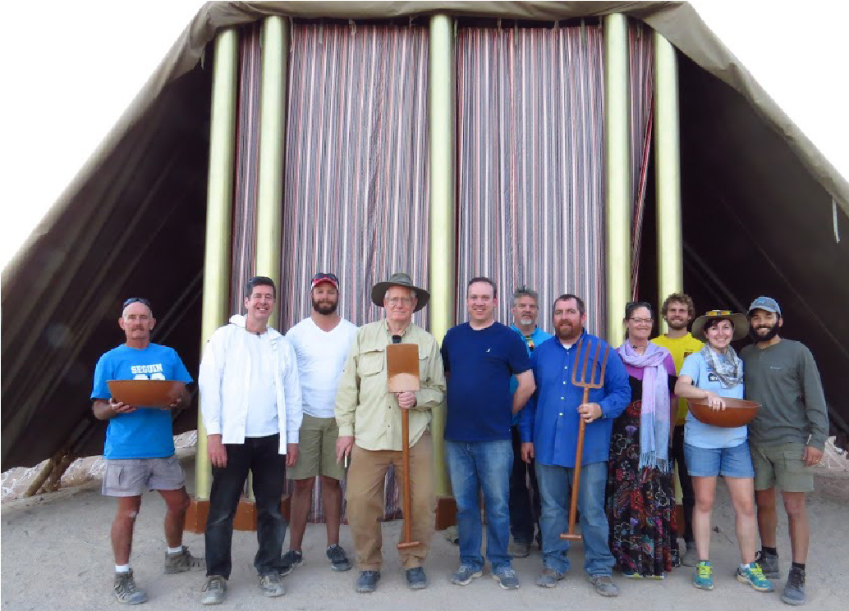
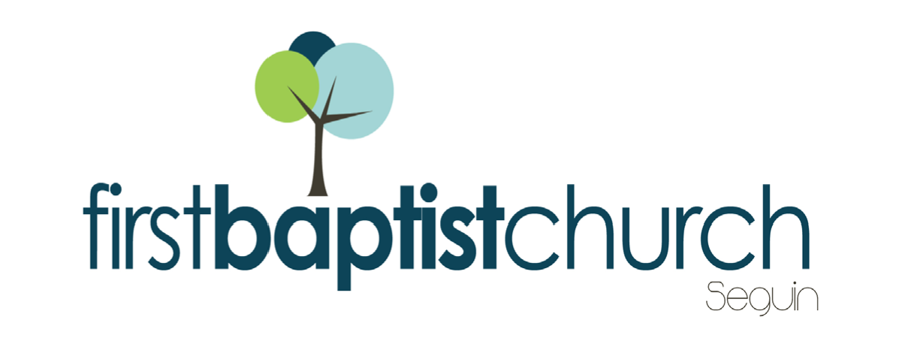
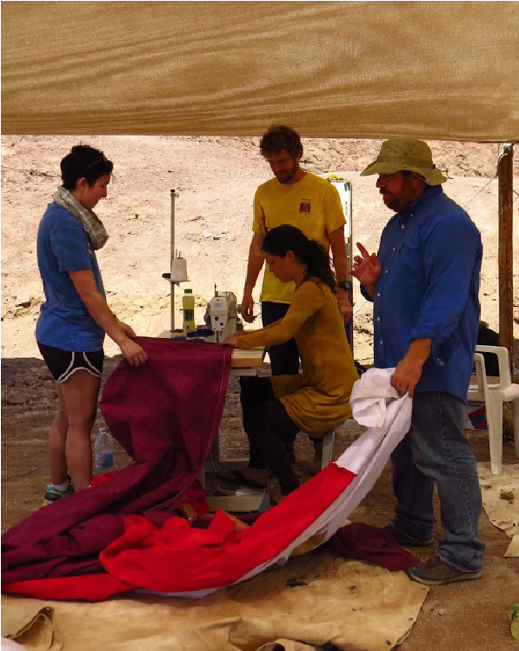
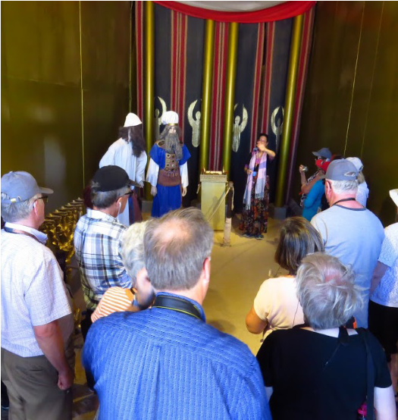
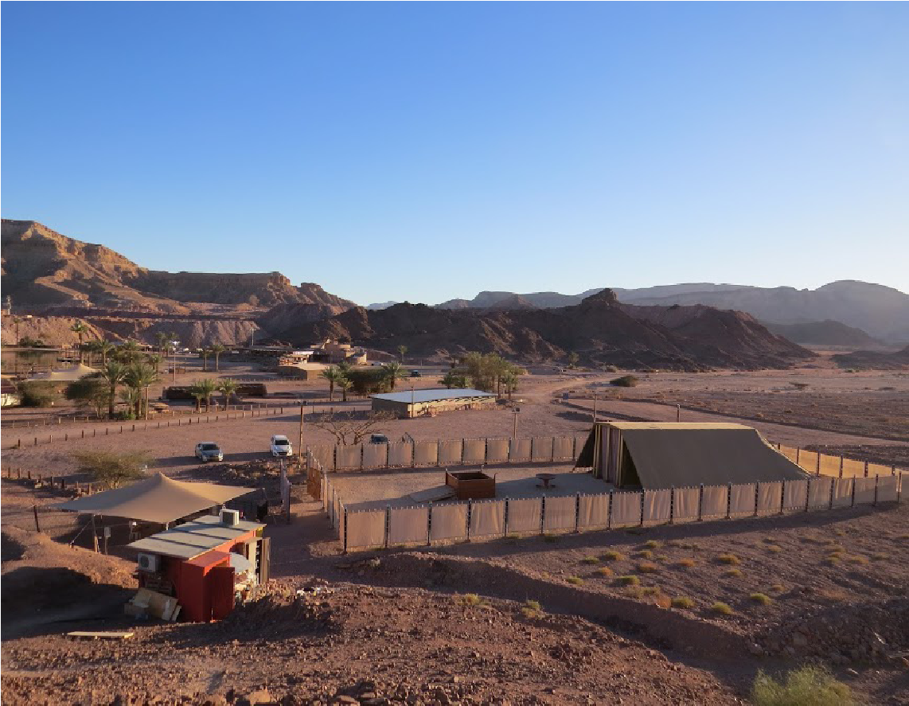
FIRST TIME HERE?
Text Welcome to
830-224-2046

Pastor: Dr. Brice Mandaville
Associate Pastor: Josh Tylich
Minister of Music: Howard Hudiburg
Children’s/Volunteer Coordinator: Rhonda Hensarling

1314 E. Cedar St. Seguin, Texas 78155 830.379.4208

MORNING SERVICE
April 8, 2018 10:30 am

DOXOLOGY (Hymn #253) Congregation

WELCOME

PRAYER

SERVE SEGUIN FBC Ramp Team

WORSHIP MEDLEY Congregation
There Is Power in the Blood (Hymn #132)
Before the Throne of God Above
Only King Forever

SCRIPTURE: Ezekiel 19:1-9* Kay Rhodes

MESSAGE: THE LIONS OF JUDAH

RESPONDING TO GOD’S WORD Congregation
The Nail-Scarred Hand (Hymn #318)

Offering
Prayer David Smith
Lord, You’re Beautiful Glory Singers

BENEDICTION

* Children 4 years old thru First Grade dismissed for children’s worship following this scripture reading

EVENING SERVICE
We hope you’ll join us tonight for a mission trip recap. Our team that recently went to Israel will be here and will be sharing about their experiences while assisting with the Tabernacle repairs.

BIBLE FELLOWSHIP GROUP CONFERENCE
APRIL 22
We would like to encourage all our Bible Fellowship Group & Sunday School teachers, co-teachers, substitutes, and Wednesday night workers and volunteers to sign up and attend this year’s conference and training on April 22nd from 1:00 PM to 2:00 PM. Immediately following the morning worship service we will have a church wide luncheon from 12:00 PM – 1:00 PM. The lunch is for everyone, even those who won’t be attending the conference. Afterward, we will break into age specific training sessions for all teachers. The adult session will be led by Phil Miller and the children’s session will be led by Jimmy Gunn. To register for the training portion of this event, please fill out and return your registration card to the church office. If you have any questions, please contact our Associate Pastor Josh Tylich (830) 379-4208 or (903) 658-3509.

MORE INFORMATION
If you would like more information about the church, please write your name and email address on one of the white cards in the pews and place in the offering plate. For more information about membership, baptism, or small groups, please fill out a yellow card.

