RENEW CONFERENCE AT ALTO FRIO
APRIL 23 – 26
We will once again have the church van available for all those who would like to attend the annual Renew Conference at Alto Frio. Information about the conference is available in the church foyer on the counter.

END of YEAR PROGRAM MISSION KIDS AND CHOIR
APRIL 29
On Sunday, April 29, the children will be presenting their year-end program for choir and missions. At 6:00 PM in the sanctuary, the three choirs will present their concerts. Then everyone will be adjourned to Bldg. 1 (The Kid’s Bldg.) to the children’s rooms where they will present their missions program. Please refer to all communications by Kay Rhodes for further instructions leading up to our program.

CHURCH PICNIC
MAY 6
Please mark your calendars to join us for our annual church picnic following the morning service on May 6. We will be out at Nolte Island again this year for food, fellowship and fun! Details are in the works, so stay tuned to future announcements for all the information.

CROSSOVER
MAY 18 – 19
This event is for 5th & 6th graders only! The cost per student will be $25 and all students will need to be signed up no later than May 9th. Please see Associate Pastor Josh Tylich for further information.

VACATION BIBLE SCHOOL MEETING
MAY 20
If you will be helping with VBS this coming June, please mark your calendars to attend this short informational meeting. Teachers will be getting their curriculum and schedules and you will have an opportunity to buy a shirt if you want one. Grab your whistles and lace up your shoes, our theme this year is GAME ON! Our kids will be looking to God and His ultimate playbook for the best game they will ever play.

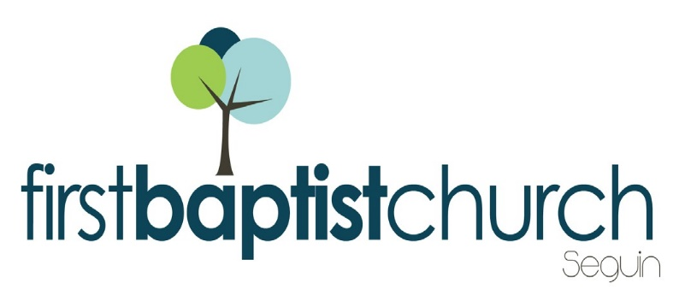
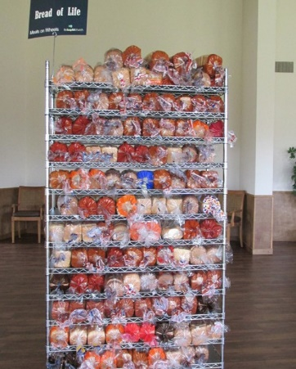
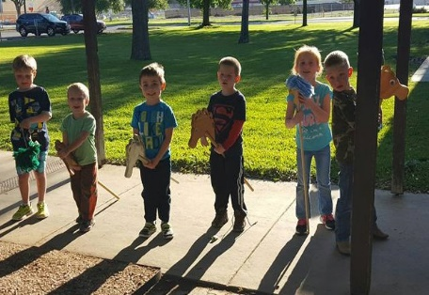
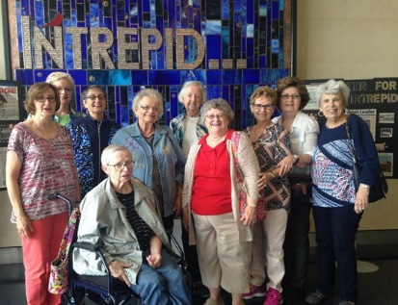
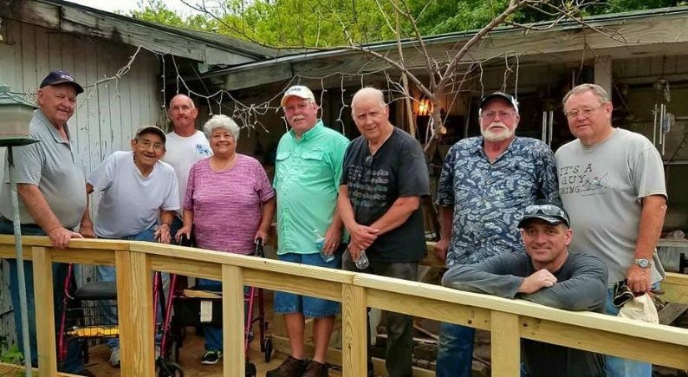
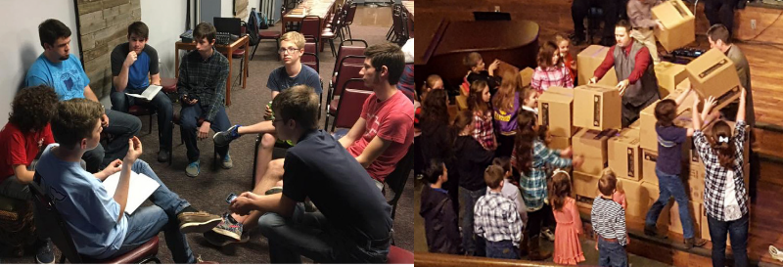
Welcome

FIRST TIME HERE?
Text Welcome to
830-224-2046
www.fbcseguin.org
Pastor: Dr. Brice Mandaville
Associate Pastor: Josh Tylich
Minister of Music: Howard Hudiburg
Children’s/Volunteer Coordinator: Rhonda Hensarling

MORNING SERVICE
April 15, 2018 10:30 am

DECLARATION OF PRAISE Congregation
Your Grace Finds Me
Overcome

WELCOME Pastor Brice

QUARTER IN REVIEW Pastor Brice

PRAYER

WORSHIP MEDLEY Congregation
Nothing but the Blood (Hymn #135)
Only King Forever

SCRIPTURE – Ezekiel 20:1-3 * Cody Hamilton

MESSAGE: PRAYING FOR A REBEL Pastor Brice

RESPONDING TO GOD’S WORD Congregation
Just As I Am (Hymn #307)

Offering
Prayer Bob Whitener
I Stand Amazed in the Presence (# 547) Praise Team

BENEDICTION

* Children 4 years old thru First Grade dismissed for children’s worship following this scripture reading

NO EVENING SERVICE

QUARTERLY BUSINESS MEETING
TONIGHT
We will have our quarterly business meeting tonight at 6:00 PM in the Fellowship Hall. Our team preparing for tonight’s meeting has dubbed it Soul Food Sunday. We hope you will join us for a delicious meal and a short recap of the previous quarter’s events, growth and financials. Your voice matters, we hope to see you there.

ALL CHURCH LUNCH & BIBLE FELLOWSHIP GROUP CONFERENCE
APRIL 22
Immediately following the morning worship service next Sunday, we will have a church wide luncheon from 12:00 PM – 1:00 PM. This luncheon is for everyone, even those who won’t be attending the conference. We will have hamburgers and hotdogs – all provided by the church. Afterward, those who have signed up for the conference will be dismissed to their training session locations around the campus. We are looking forward to having you there.

MORE INFORMATION
If you would like more information about the church, please write your name and email address on one of the white cards in the pews and place in the offering plate. For more information about membership, baptism, or small groups, please fill out a yellow card.

