END of YEAR PROGRAM MISSION KIDS AND CHOIR
APRIL 29
Next Sunday at 6:00 PM we will have the year-end program for choir and mission kids of Wednesday nights. This Wednesday, April 25, the children will go to the sanctuary at 5:30 PM to rehearse the choir part of the program. Please drop them off there and then pick them up in their rooms in Building 1 at 7:00 PM. Next Sunday, please have your children in the sanctuary no later than 5:45 PM.

CROSSOVER
MAY 18 – 19
This event is for students who will complete 5th & 6th grade this year! Our theme is GLOW: Light Shines in the Darkness. The cost per student will be $25 and all students will need to be signed up no later than May 9th. Crossover is designed to help students become better acquainted with the youth group. Not just in looking forward, but to interact with current youth group students. We will have testimonies, worship, food, as well as lots and lots of fun! Don’t miss it.

GRADUATION RECOGNITION
MAY 20
On Sunday, May 20, during the morning worship service, we will be taking some time to recognize all our 2018 Seniors and will be putting together a slide show for the occasion. If you have a senior this year that you would like to see honored, please email the following information to Ryan Ayotte at ayotte.ryan@gmail.com, not later than May 13.
- Name
- 3 pictures (1 baby, 1 middle years, 1 senior)
- Name of school graduating from
- Future plans (what they will do following graduation)
All high school seniors will need to meet Bro. Josh in the foyer of the Auditorium on that morning at 9:15 AM.

VACATION BIBLE SCHOOL MEETING
MAY 20 5:00 PM FBC LIBRARY
If you will be helping with VBS this coming June, please mark your calendars to attend this informational meeting. Teachers will be getting their curriculum and schedules and you will have an opportunity to buy a shirt if you want one. Grab your whistles and lace up your shoes, our theme this year is GAME ON! Our kids will be looking to God and His ultimate playbook for the best game they will ever play.

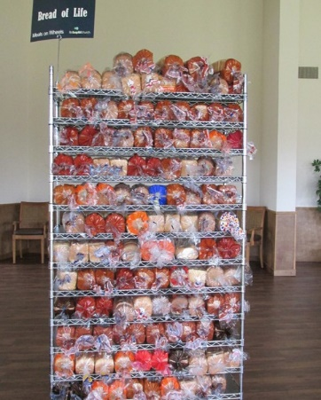
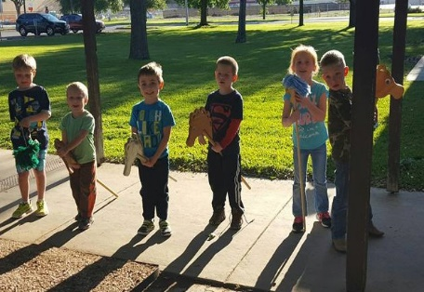
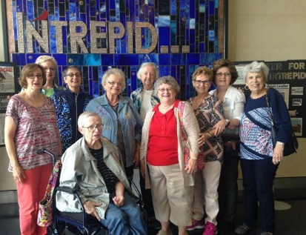
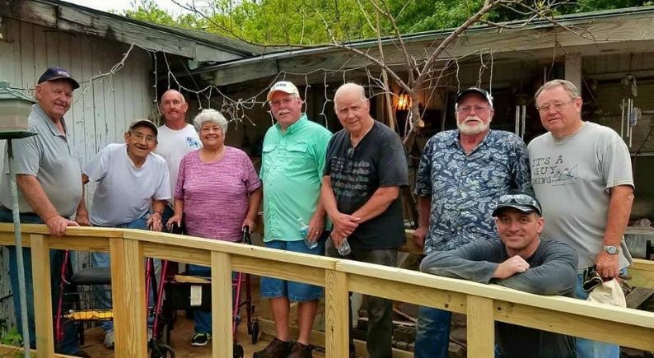
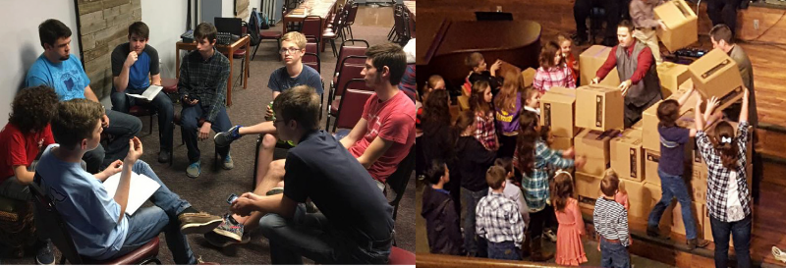
Welcome

FIRST TIME HERE?
Text Welcome to
830-224-2046
www.fbcseguin.org
Pastor: Dr. Brice Mandaville
Associate Pastor: Josh Tylich
Minister of Music: Howard Hudiburg
Children’s/Volunteer Coordinator: Rhonda Hensarling

MORNING SERVICE
April 22, 2018 10:30 am

WELCOME Pastor Brice

DECLARATION OF PRAISE Congregation
This Is Amazing Grace
He Hideth My Soul (Hymn #340)

SCRIPTURE – 2 Timothy 3:16-17 Lance Birdsong

PRAYER

WORSHIP MEDLEY Congregation
I Can Only Imagine
For You Are Holy

MESSAGE: BIBLE STUDY TRANSFORMATION
Phil Miller

RESPONDING TO GOD’S WORD Congregation
Only Trust Him (Hymn #317)

Offering
Prayer Bruce Allen
Your Love Never Fails Praise Team

BENEDICTION

* Children 4 years old thru First Grade dismissed for children’s worship following this scripture reading

ALL CHURCH LUNCH & BIBLE FELLOWSHIP GROUP CONFERENCE
TODAY
Please welcome Phil Miller, the Director of Discipleship for the Texas Baptist Convention, to the pulpit this morning. He will also be leading our Adult training session this afternoon. Immediately following the worship service this morning, we invite everyone to a church wide luncheon from 12:00 PM – 1:00 PM in the Fellowship Hall. We will have hamburgers, hotdogs and all the fixins. Afterward, those who have signed up for the conference will be dismissed to their training session locations around the campus. If you teach or co-teach a Bible Fellowship Class, a homegroup or a Sunday School class, there is a spot for you at this conference. We are looking forward to having you there. We will not have an evening service tonight.

CHURCH PICNIC
MAY 6
Please mark your calendars to join us for our annual church picnic following the morning service on May 6. We will be out at Nolte Island again this year for food, fellowship and fun! The church will be providing the meat for our lunch and the Bible Fellowship Groups will be handling the sides. If you are not connected to a Bible Fellowship Group, we encourage you to bring a dessert or a gallon of tea or lemonade. Please plan to bring your lawn chairs, maybe a blanket for a picnic, and any sports equipment that you would enjoy for an afternoon. Maps will be provided in the foyer on the morning of the picnic.

