CROSSOVER
MAY 18 – 19
This event is for students who will complete 5th & 6th grade this year! Our theme is GLOW: Light Shines in the Darkness. The cost per student is $25 and all students will need to be signed up no later than May 9th. Crossover is designed to help students become better acquainted with the youth group. We will have testimonies, worship, food, as well as lots and lots of fun!

GRADUATION RECOGNITION
MAY 20
On Sunday, May 20, during the morning worship service, we will be taking some time to recognize all our 2018 Seniors and will be putting together a slide show for the occasion. If you have a senior this year that you would like to see honored, please email the following information to Ryan Ayotte at ayotte.ryan@gmail.com, not later than May 13: Name, 3 pictures (1 baby, 1 middle years, 1 senior), Name of school graduating from, Future plans. All high school seniors will need to meet Bro. Josh in the foyer of the Auditorium on that morning at 9:15 AM. There will be a reception, to which the whole church is invited, following the morning service to celebrate these graduates and their achievement.

VACATION BIBLE SCHOOL MEETING
MAY 20 5:00 PM FBC LIBRARY
Grab your whistles and lace up your shoes, our theme this year is GAME ON! Our kids will be looking to God and His ultimate playbook for the best game they will ever play. If you will be helping with VBS this coming June, please mark your calendars to attend an informational meeting Sunday, May 20th. Teachers will be getting their curriculum and schedules and you will have an opportunity to buy a shirt if you want one. We are still looking for helpers and teachers for this year’s VBS. If you would be interested in helping, please fill out the blue service card in the Sanctuary pew and place it in the offering.

FIRST BAPTIST CHURCH SECURITY TEAM
We are looking for a few more volunteers to help with our newly formed Security Team. Volunteers will need to procure the following to be considered for the team: a license to carry, FEMA online course completion and must submit to a background check. If you would be interested, please fill out the blue service card in the pew and place it in the offering plate.

Funeral Services:
Patsy Long today at 2 PM Zoeller Funeral Home, NB
Linda Dwyer tomorrow at 4 PM Lifegate Church, Seguin

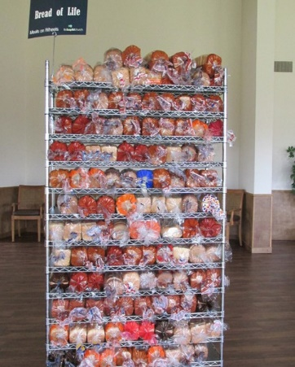
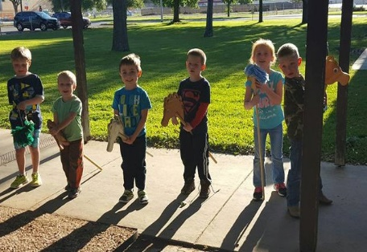
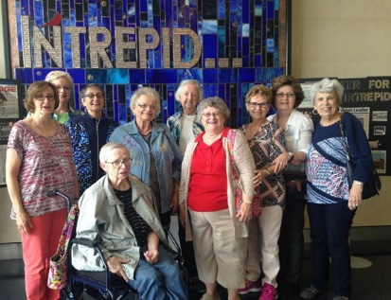
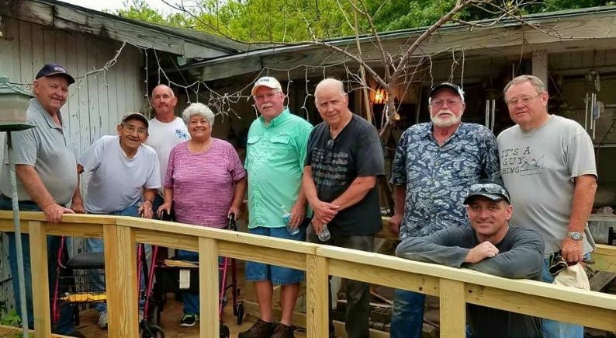
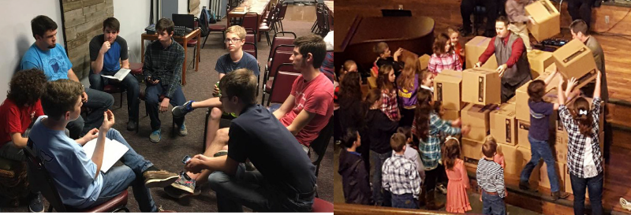
Welcome

FIRST TIME HERE?
Text Welcome to
830-224-2046
www.fbcseguin.org
Pastor: Dr. Brice Mandaville
Associate Pastor: Josh Tylich
Minister of Music: Howard Hudiburg
Children’s/Volunteer Coordinator: Rhonda Hensarling

MORNING SERVICE
April 29, 2018 10:30 am

WELCOME Pastor Brice

BECAUSE HE LIVES Handbell Choir

PRAYER Justus Savage

SCRIPTURE - John 1:1-5 Jack Savage

DECLARATION OF PRAISE Congregation
Revive Us Again (Hymn #469)
Praise to the Lord, the Almighty (Hymn #14)

THE MUMMY’S SECRET

WORSHIP MEDLEY Congregation
Open Up the Heavens
We Fall Down

MESSAGE: IN HIM IS LIFE Pastor Brice

RESPONDING TO GOD’S WORD Congregation
Softly and Tenderly (Hymn #312)

Offering
Prayer Eddie Brown
Good, Good Father Praise Team

BENEDICTION

All Children four years and older remain in worship today

END of YEAR PROGRAM MISSION KIDS / CHILDRENS CHOIR
TONIGHT
We hope you will join us tonight at 6:00 PM for the year-end program for choir and mission kids of Wednesday nights. All the children’s choirs will perform tonight in the Sanctuary. After they have finished, we will all head over to the Kid’s Bldg. for the Missions presentations. Parents will be able to move between the different classrooms if they have children in multiple Missions classes. Parents, please have your children in the sanctuary no later than 5:45 PM.

CHURCH PICNIC
MAY 6
Please mark your calendars to join us for our annual church picnic following the morning service on May 6. We will be out at Nolte Island again this year for food, fellowship and fun! The church will be providing the meat for our lunch and the Bible Fellowship Groups will be handling the sides. If you are not connected to a Bible Fellowship Group, we encourage you to bring a dessert or a gallon of tea or lemonade. Please plan to bring your lawn chairs, maybe a blanket for a picnic, and any sports equipment that you would enjoy for an afternoon (don’t forget the insect repellant). Maps will be provided in the foyer on the morning of the picnic.

MORE INFORMATION
If you would like more information about the church, please write your name and email address on one of the white cards in the pews and place in the offering plate. For more information about membership, baptism, or small groups, please fill out a yellow card.

