KEENAGER’S LUNCHEON
TOMORROW
Table games and fellowship will start at 10:00 AM, with lunch at 11:30 AM. Beginning at noon we will have Lisa Whittemore with the Texas A&M Agri Life Extension Program here.

FBC GAME NIGHT
MAY 10
Are you a board/card game player? Then we have a spot for you at FBC Game Night. We meet at 6:00 PM in the Fellowship Hall for food, games, and fellowship! All are welcome to join in the fun.

CROSSOVER
MAY 18 – 19
The cost per student is $25 and all students will need to be signed up no later than May 9th. Be sure to stop by the Kid’s Bldg. (Bldg. 1) for a registration packet. For more information, please see Josh Tylich or Rhonda Hensarling.

GRADUATION RECOGNITION
MAY 20
We will be taking some time to recognize all our 2018 Seniors and will be putting together a slide show for the occasion. If you have a senior you would like to see honored, please email the following information to Ryan Ayotte at ayotte.ryan@gmail.com, not later than May 13: Name, 3 pictures (1 baby, 1 middle years, 1 senior), Name of school graduating from, and their future plans. All high school seniors need meet with Bro. Josh in the foyer of the Auditorium at 9:15 AM that morning. There will be a reception, to which the whole church is invited, following the morning service to celebrate these graduates and their achievements.

VACATION BIBLE SCHOOL MEETING
MAY 20 5:00 PM FBC LIBRARY
If you will be helping with VBS this coming June, please mark your calendars to attend an informational meeting Sunday, May 20th. Teachers will be getting their curriculum and schedules and you will have an opportunity to buy a shirt if you want one.

FIRST BAPTIST CHURCH SECURITY TEAM
We are looking for a few more volunteers to help with our newly formed Security Team. Volunteers will need to procure the following to be considered for the team: a license to carry, FEMA online course completion and must submit to a background check. If you are interested, please fill out the blue service card in the pew and place it in the offering plate.

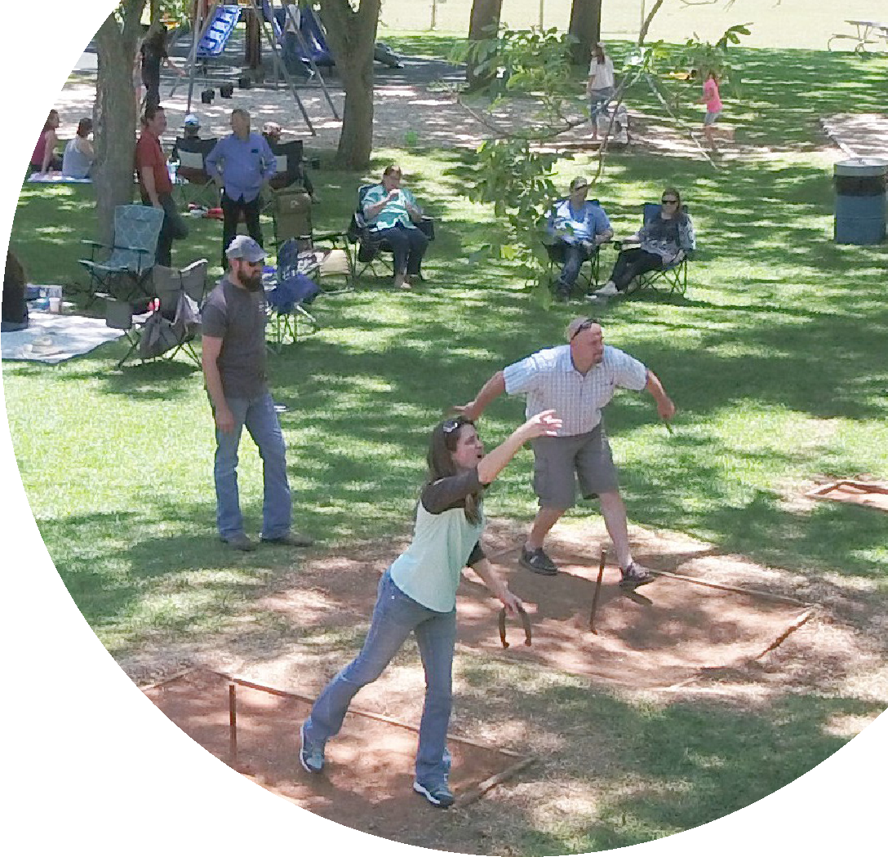
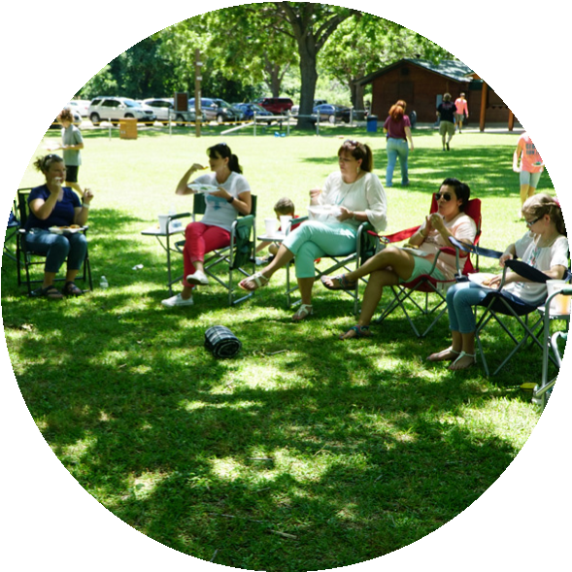
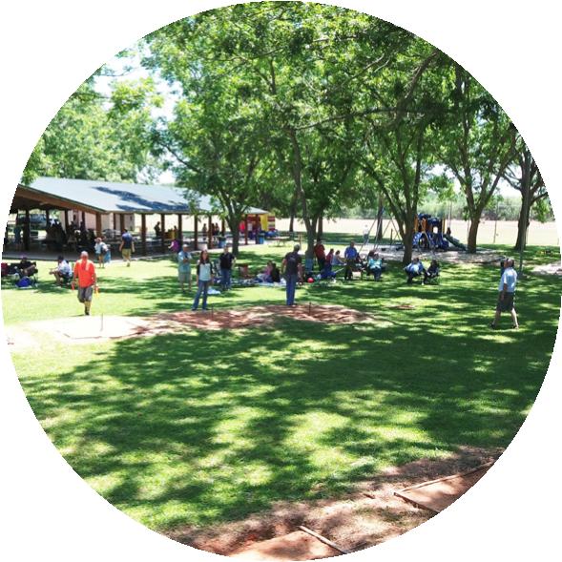

FIRST TIME HERE?
Text Welcome to
830-224-2046
www.fbcseguin.org
Pastor: Dr. Brice Mandaville
Associate Pastor: Josh Tylich
Minister of Music: Howard Hudiburg
Children’s/Volunteer Coordinator: Rhonda Hensarling

MORNING SERVICE
May 6, 2018 10:30 am

WELCOME/PRAYER Pastor Brice

DECLARATION OF PRAISE Congregation
Surely Goodness and Mercy (Hymn #422)
Holy Spirit

SCRIPTURE - John 1: 6-14 Cody Wilson

MY TESTIMONY Brook Brown

WORSHIP MEDLEY Congregation
The Lion and the Lamb
Mercy *

MESSAGE Pastor Brice
“BELIEVING + RECEIVING = BECOMING”

RESPONDING TO GOD’S WORD Congregation
Jesus Is Lord of All (Hymn #296)

Offering
Prayer Richard Bailey
O Come to the Altar Praise Team

BAPTISM

BENEDICTION

* Children 4 years old thru First Grade dismissed for children’s worship following this song

The flowers are placed today in honor of Rebecca Rhodes 14th birthday by her grandparents Allen & Kay.
CHURCH PICNIC
TODAY
Following this morning’s service, we will head out to Nolte Farms for our annual church picnic. The church has provided the meat for our lunch and the Bible Fellowship Groups have provided the sides. We hope everyone will join us! Be sure to bring your lawn chairs, maybe a blanket for a picnic, and any sports equipment that you would enjoy for the afternoon and don’t forget the insect repellent. The volleyball and basketball courts will be open to us, as will the playground. Maps are available in the foyer. There will be no evening service tonight.

MOTHER’S DAY SERVICE
MAY 13
We invite you to join us for a very special Mother’s Day service, Sunday May 13. We will be honoring a mother of our church that morning with a special gift. We will also have a beautiful photo booth set up in the foyer for you to make a memory with your mom. Join us as we say thank you to all our mothers.

“She is clothed in strength and dignity, and she laughs without fear of the future.” Proverbs 31:25

MORE INFORMATION
If you would like more information about the church, please write your name and email address on one of the white cards in the pews and place in the offering plate. For more information about membership, baptism, or small groups, please fill out a yellow card.

