CROSSOVER
MAY 18 – 19
There is still time to get your 5th or 6th grader signed up for Crossover. The weekend will be filled with youth testimonies, worship, study and FUN! We have planned quite a few awesome activities for your student, including a glow-in-the-dark dance party! Please see Rhonda Hensarling or Bro. Josh Tylich for more information.

VACATION BIBLE SCHOOL MEETING
MAY 20 5:00 PM FBC LIBRARY
If you will be helping with VBS this coming June, please mark your calendars to attend an informational meeting Sunday, May 20th.

HIGH SCHOOL SNAC & MIDDLE SCHOOL CONNECT REC
MAY 20
Next Sunday will be our youth Sunday night activities for students 7th – 12th grade. Middle schoolers will be headed out to the Sheffler house and high schoolers will head over to the Savage house. Remember: all students who would like to participate in the evening extra must be present at the evening service, beginning at 6:00 PM. Parents, please drop your child off at the sanctuary. You can pick them up at the Youth bldg. at 9:00 PM.

SURESH VENULAPALLI
MAY 27 6:00PM
Sunday Evening, May 27, we will welcome Suresh Venulapalli back to our church for a presentation of how his ministry has grown in the last year. Suresh is a civil engineer from India, who answered the call to ministry and began India Village Ministries in South India, an umbrella of ministries including a children’s home, a pastor’s school, an emergency aid ministry, and many others. We are looking forward to an evening of encouraging testimony.

PRETEEN CAMP
JULY 13 – 16
Preteen Camp is right around the corner. If your child would be interested in attending, please stop by the church office. There will be worship and study, as well as games and outdoor fun! The cost per child is $250 and $25 reserves your spot. As always, we do NOT want money to be the reason your child cannot experience this camp. Please see Rhonda Hensarling in the church office for more details. If you would be interested in helping send a child to preteen camp, please write “Preteen Scholarship” on the white envelope and place it in the offering plate.

Don’t forget to pick up any dishes/utensils that were brought for the church picnic last Sunday. They are in the church kitchen.

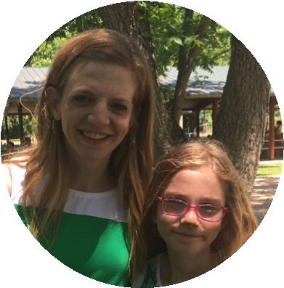
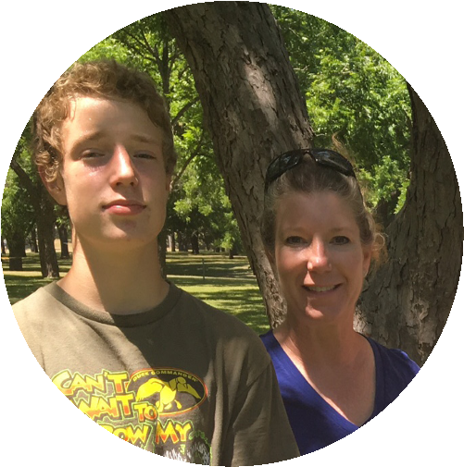
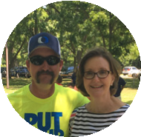
www. fbcseguin.org
FIRST TIME HERE?
Text Welcome to
830-224-2046

MORNING SERVICE
May 13, 2018 10:30 am

A MOTHER’S DAY BLESSING

PRAYER/WELCOME Pastor Brice

DECLARATION OF PRAISE Congregation
How Majestic Is Your Name (Hymn #29)
This I Believe (The Creed)

RECOGNIZING A MOTHER TO THE CHURCH

TESTIMONY Alisha Ayotte

WORSHIP MEDLEY Congregation
Sweet, Sweet Spirit (Hymn #243)
God on the Mountain *

SCRIPTURE – Luke 1:39-45* Hannah Fees

MESSAGE: A MOTHER’S PRAYER Pastor Brice

RESPONDING TO GOD’S WORD Congregation
Have Thine Own Way, Lord (Hymn #294)

Offering
Prayer David Arnold
O Come to the Altar Praise Team

BENEDICTION

* Children 4 years old thru First Grade dismissed for children’s worship following this scripture.
HAPPY MOTHER’S DAY
Thank you for being here! We have a beautiful photo booth set up in the foyer for you to make a memory with your mom as well as small, special gift for all moms which the Deacons will be handing out.

“She is clothed in strength and dignity, and she laughs without fear of the future.” Proverbs 31:25

EVENING SERVICE
We hope you will join us this evening for a traditional service of hymns and verse by verse preaching. Bro. Brice will be in the book of Proverbs.

GRADUATION RECOGNITION
MAY 20
If you have a senior you would like to see honored, please email the following information to Ryan Ayotte at ayotte.ryan@gmail.com: Name, 3 pictures (1 baby, 1 middle years, 1 senior), Name of school graduating from, and their future plans. This information is due today. All high school seniors need meet with Bro. Josh in the foyer of the Auditorium at 9:15 AM that morning. There will be a reception, to which the whole church is invited, following the morning service to celebrate these graduates and their achievements.

MORE INFORMATION
If you would like more information about the church, please write your name and email address on one of the white cards in the pews and place in the offering plate. For more information about membership, baptism, or small groups, please fill out a yellow card.

