VACATION BIBLE SCHOOL MEETING
TODAY 5:00 PM FBC LIBRARY
If you will be helping with VBS next month, we hope to see you at our informational meeting this afternoon. Teachers will be getting their materials and schedules and t-shirts will be available for purchase, should you want one.

HIGH SCHOOL SNAC & MIDDLE SCHOOL CONNECT REC
TONIGHT
Middle schoolers will be out to the Sheffler house and high schoolers will head over to the Savage house. Remember: all students who would like to participate in the evening extra must be present at the evening service, beginning at 6:00 PM. Parents, please drop your child off at the sanctuary. You can pick them up at the Youth bldg. at 9:00 PM.

SURESH VENULAPALLI
MAY 27 6:00PM
Sunday Evening, May 27, we will welcome Suresh Venulapalli back to our church for a presentation of how his ministry has grown in the last year. Suresh is a civil engineer from India, who answered the call to ministry and began India Village Ministries in South India, an umbrella of ministries including a children’s home, a pastor’s school, an emergency aid ministry, and many others. We are looking forward to an evening of encouraging testimony.

KEENAGER’S LUNCHEON
JUNE 4
Don’t forget to sign up for the June KeenAger’s Luncheon. The signup sheet is on the counter in the foyer. These are catered luncheons, so please be sure to sign up early!

PRETEEN CAMP
JULY 13 – 16
Preteen Camp is right around the corner. If your child would be interested in attending, please stop by the church office. There will be worship and study, as well as games and outdoor fun! The cost per child is $250 and $25 reserves your spot. Be sure to see Rhonda Hensarling for details.

PRETEEN CAMP SCHOLARSHIP
As always, we do NOT want money to be the reason your child cannot experience this camp. We have scholarships available for those who may need them. Please see Rhonda Hensarling in the church office. If you would be interested in helping send a child to preteen camp, please write “Preteen Scholarship” on the white envelope and place it in the offering plate.

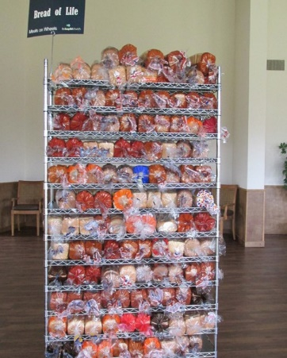
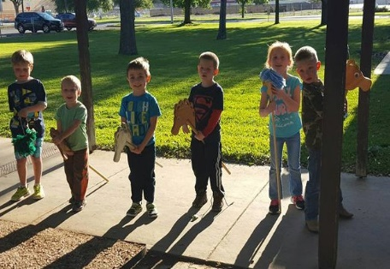
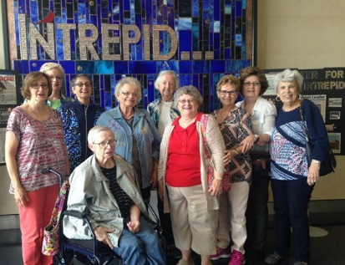
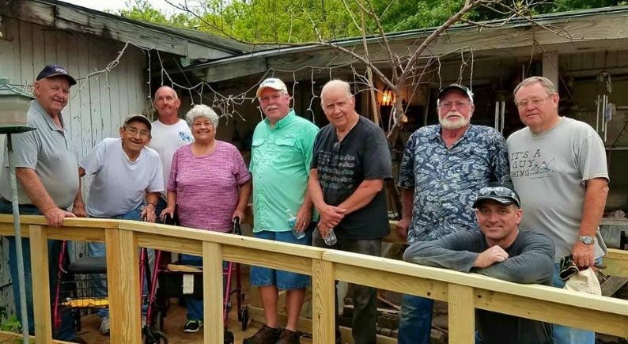
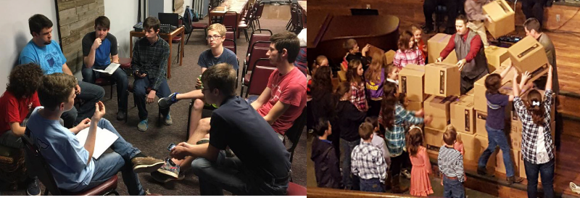
Welcome

www.fbcseguin.org
Pastor: Dr. Brice Mandaville
Associate Pastor: Josh Tylich
Minister of Music: Howard Hudiburg
Children’s/Volunteer Coordinator: Rhonda Hensarling
FIRST TIME HERE?
Text Welcome to
830-224-2046

MORNING SERVICE
May 20, 2018 10:30 am

WELCOME/PRAYER Pastor Josh

DECLARATION OF PRAISE Congregation
Count Your Blessings (Hymn #644)
The Way of the Lord

GRADUATE RECOGNITION

WORSHIP MEDLEY Congregation
Always
Revelation Song
O Come to the Altar

SCRIPTURE - Isaiah 6: 1-8 * Tanner Beedy

MESSAGE: “I SAW THE LORD” J. K. Minton

RESPONDING TO GOD’S WORD Congregation
Take My Life, Lead Me, Lord (Hymn #287)

Offering
Prayer Eric Brittain
I’ll Fly Away The Knights

BENEDICTION

* Children 4 years old thru First Grade dismissed for children’s worship following this scripture.

J.K. MINTON
Please join us in welcoming J.K. Minton back to the pulpit this morning.

EVENING SERVICE
We hope you will join us this evening for a traditional service of hymns and verse by verse preaching. Bro. Josh will be preaching out of the book of Luke.

SENIOR RECOGNITION
Please join us in congratulating all the high school and college seniors of 2018.

High School Graduates:
- Brayden Boultinghouse
- Jacob Castro
- Emily Dziuban
- Faith Erwin
- Sierra Knight
- Josh Polcyn
- April Flor Ramirez
- Leah Schriewer
- Chelsea Sestak

College Graduates:
- Allison Bodle
- Rachel Cramblitt
- Ryan McGary
- Daniel Timmerman
- Savannah Knight

Be sure to join us in the Fellowship Hall following the service this morning. We are having a small reception of sandwiches and cupcakes for our graduates, to which all are invited.

