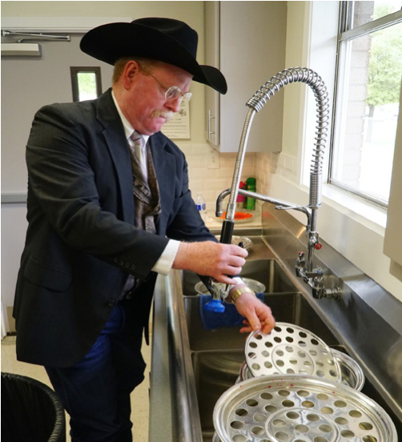
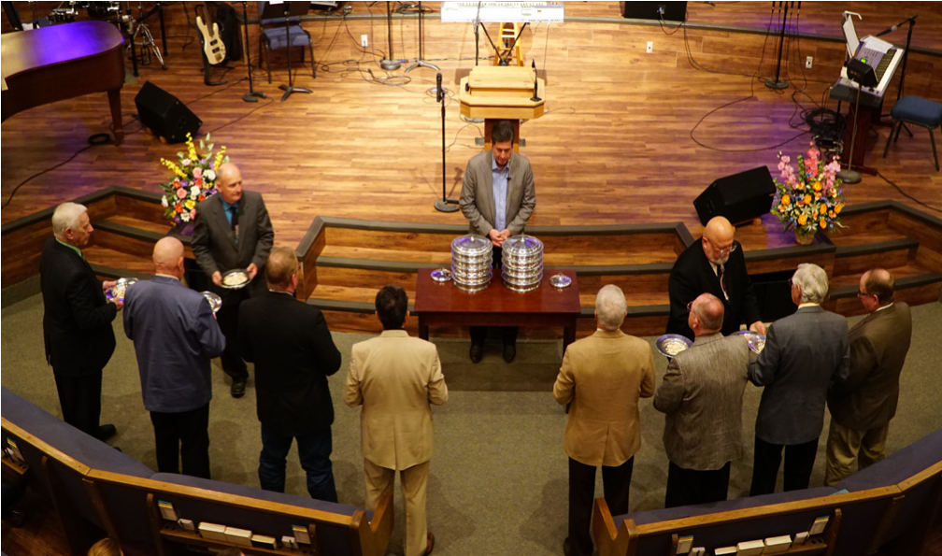
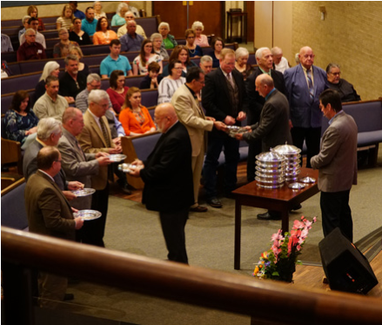
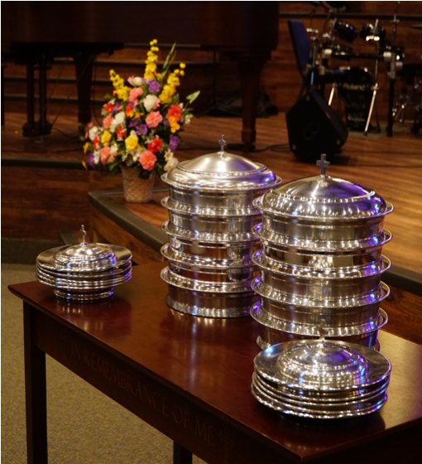
Welcome
GAME NIGHT
JUNE 14 6:00 PM
We invite you all to join us in the Fellowship Hall, this Thursday evening for Game Night. We play all kinds of games, eat and fellowship. Bring your favorite board or card game and an appetizer to share to participate. Hope to see you there.

FATHER’S DAY
JUNE 17
We hope you will join us next Sunday for a special service dedicated to the dads of FBC. We will be honoring one dad in the congregation that morning with a special surprise. We invite all dads to come celebrate the morning with your church family.

MAIN EVENT YOUTH OFF CAMPUS ACTIVITY
JUNE 20 3:00 PM – 5:00 PM
This event is for Youth 7th – 12th grade. Cost per student is $17. Parents, please have your children to the church by 1:30 PM. We will be taking the church van into San Antonio. See Bro. Josh for more information.

PRETEEN CAMP
JULY 13 – 16
If your child is interested in attending, please stop by the church office. There will be worship and study, as well as games and outdoor fun! The cost per child is $250 and $25 reserves their spot.

PRETEEN CAMP SCHOLARSHIP
If you are interested in helping send a child to preteen camp, please write “Preteen Scholarship” on the white envelope and place it in the offering plate.

DRIVERS FOR MEALS ON WHEELS
We have been offered the opportunity to help out with the Meals on Wheels program serving Seguin and the surrounding areas. They are looking for drivers to deliver food. If you would be interested in helping with this ministry, please stop by the church office to collect your volunteer form and informational packet.

VACATION BIBLE SCHOOL REGISTRATION
TODAY – VBS
We will be out at the foyer counter today, before and after the morning service, to register your children, grandchildren, nieces, nephews and friends for Vacation Bible School. There will also be t-shirts and music CDs available for purchase (t-shirts are $10, CDs are $5).

www.fbcseguin.org
Pastor: Dr. Brice Mandaville
Associate Pastor: Josh Tylich
Minister of Music: Howard Hudiburg
Children’s/Volunteer Coordinator: Rhonda Hensarling
FIRST TIME HERE?
Text Welcome to
830-224-2046

MORNING SERVICE
June 10, 2018 10:30 am

PRAYER/ WELCOME Pastor Brice

DECLARATION OF PRAISE Congregation
The Lion and the Lamb
It Is Well with My Soul (Hymn #410)

WONDERFUL TO ME Worship Choir

WORSHIP MEDLEY Congregation
We Are Climbing Jacob’s Ladder
Be Unto Your Name

SCRIPTURE – John 1:43-51 * Cody Hamilton

MESSAGE: JACOB’S LADDER

RESPONDING TO GOD’S WORD Congregation
Just As I Am (Hymn #307)

Offering
Prayer Miguel Garcia
Come As You Are Praise Team

CELEBRATION OF THE LORD’S SUPPER

BENEDICTION

* Children 4 years old thru First Grade dismissed for children’s worship following this scripture.

The flowers are placed today in celebration of Frieda & Ed Savage’s 50th Wedding Anniversary.
THE LORD’S SUPPER
TODAY
All who have accepted Jesus Christ as their Savior and Lord are invited to participate with us in the taking of the elements. There are gluten free wafers in the church foyer for those on restricted diets.

EVENING SERVICE
Join us this evening for a traditional service of verse by verse preaching and hymns. Bro. Brice will be preaching out of the book of Proverbs and we will taking some time to pray for and over our Bounce Mission Team.

BOUNCE PRAYER CARDS
Our Bounce Team will leave tomorrow morning. Students and chaperones are headed to the Golden Triangle to help with Hurricane Harvey recovery projects. The Missions Committee would like to ask that you join them in prayer for all involved in this mission trip. We have prayer cards for each team member out on the counter in the foyer and encourage you to stop by to pick up a few. Join us as we pray for the opportunities God would make available for everyone as well as their health and safety as they travel and work.
“Therefore, … pray for one another, so that you may be healed.” – James 5:16

MORE INFORMATION
For more information about the church, please write your name and email address on one of the white cards in the pews and place in the offering plate. For more information about membership, baptism, or small groups, please fill out a yellow card.

