GAME NIGHT
THURSDAY 6:00 PM
Join us here at the church in the Fellowship Hall for game night this Thursday. Bring a small appetizer to share and your favorite board or card game. That’s it. We hope you’ll join us.

MEN’S PRAYER BREAKFAST
JULY 14 HILLCREST CHURCH
The Seguin Area Men’s Prayer Breakfast will be held at Hillcrest Church beginning at 8:00 AM. There will be food, worship and prayer. Fathers bring your sons, sons bring your fathers.

BABY SHOWER BENEFITING THE So. TEXAS PREGNANCY CARE CENTER
TUESDAY JULY 17
Faith Lutheran Church is hosting a salad luncheon and “Baby Shower” to benefit the So. Texas Pregnancy Care Center. Suggested items to bring are (gender neutral) onesies, diapers (size newborn), car key rattles & pacifiers. The luncheon will begin at noon in the Activity Center at Faith Lutheran Church. Please bring a salad of sorts to share and your baby gift (it does not have to be wrapped) for the fellowship.

CHRISTMAS IN JULY!
JULY 29
The Missions Committee would like you to come and enjoy Christmas cookies in July! They will be in the foyer July 29th with fresh cookies and coin jars as a reminder to fill your jars for the Lottie Moon Missions offering in December! If you need a collection jar we will have extras on the table. Also, on display will be Worldcraft catalogs for Christmas gift ideas that help impoverished peoples around the world.

LADIES WEDNESDAY NIGHT BIBLE STUDY
The Ladies Wednesday Night Bible taught by Frieda Savage will not meet for the remainder of the summer. They will pick up their study in September.

NURSING HOME MINISTRY
We need volunteers to help with our Nursing Home Ministry. The program consists of a brief worship music service and devotional. If interested, please write “Nursing Home” on the blue “Serving” card and place it in the offering plate.

DISH PICK UP
Please be sure to stop by the church kitchen to pick up any dishes brought for Vacation Bible School.

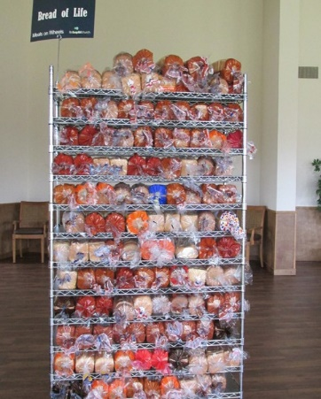
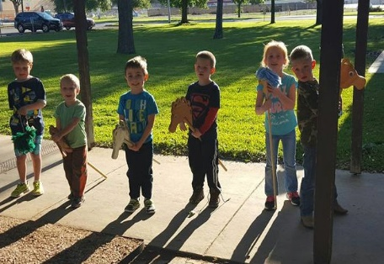
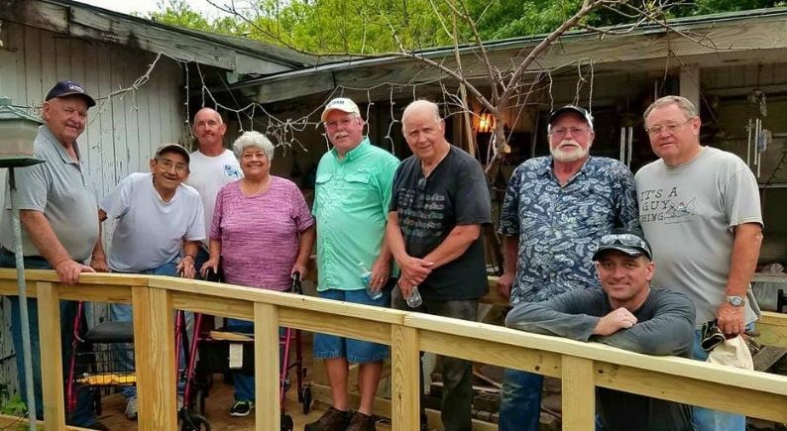
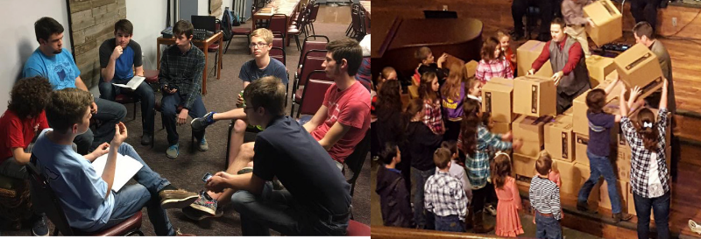
Welcome

www.fbcseguin.org
Pastor: Dr. Brice Mandaville
Associate Pastor: Josh Tylich
Minister of Music: Howard Hudiburg
Children’s/Volunteer Coordinator: Rhonda Hensarling
FIRST TIME HERE?
Text Welcome to
830-224-2046

MORNING SERVICE
July 8, 2018 10:30 am

DECLARATION OF PRAISE Congregation
Down at the Cross (Hymn #140)
Forever Reign

WELCOME/PRAYER Pastor Josh

WORSHIP MEDLEY Congregation
Praise to the Lord, the Almighty (Hymn #14)
O Come to the Altar

SCRIPTURE: Acts 11: 25-26 Tenley Jackson

WHAT DEFINES A CHRISTIAN
Bro. Herman Cramer

RESPONDING TO GOD’S WORD Congregation
At the Cross (Hymn #139)

Offering
Prayer Stan Jackel
Who You Say I Am Lupe Gonzales

BENEDICTION

* Children 4 years old thru First Grade dismissed for children’s worship following this scripture.

EVENING SERVICE
6:00 PM
Join us tonight for a traditional service of verse by verse preaching and our continued trek through the hymnal. Bro. Herman will be preaching tonight, out of the book of Mark. We will also have Ryan & Chelsea Farran here with an update on their work in Papua, New Guinea.

TLU POOL PARTY
JULY 22 – in place of evening service
We hope you will join us for a splashing good time at the TLU Mabee Pool, Sunday, July 22 at 6:00 PM. We have reserved the pool for our church family and their guests to enjoy. The gate will open at 6:00 PM, and the church will provide a light meal of hotdogs, chips, drinks and cookies! Bring your lawn chairs and towels, pool toys and floaties!

YOUTH DIRECTOR POSITION
We are currently seeking a part-time, 20 hours per week, youth director to oversee our youth ministry. A job description, expectations and compensation are available in the church office and on the church website. If you know of someone interested, please have them contact the pastor or send information to info@fbcseguin.org.

MORE INFORMATION
For more information about the church, please write your name and email address on one of the white cards in the pews and place in the offering plate.

