CHRISTMAS IN JULY!
JULY 29
The Missions Committee would like you to come and enjoy Christmas cookies in July! They will be in the foyer July 29th with fresh cookies and coin jars as a reminder to fill your jars for the Lottie Moon Missions offering in December! If you need a collection jar we will have extras on the table.

Also available will be WorldCraft catalogs and information. WorldCraft is an organization through Women’s Missionary Union that helps men and women earn a living and escape the grip of poverty. All items are holistic and handmade and would make a wonderful and encouraging Christmas gift. We hope you’ll stop by.

BUSINESS MEETING AND DINNER
JULY 29 6:00 PM
We will have a business meeting and dinner in place of our Sunday evening service on July 29 in the Fellowship Hall. Dinner will begin at 6:00 PM followed by a recap of the previous quarter.

KEENAGER’S LUNCHEON
AUGUST 6 10:00AM
Be sure to stop by the counter in the foyer to sign up for this month’s luncheon. Table games and fellowship will start at 10:00 AM and lunch will be served at 11:30 AM followed by a presentation by Lisa Robbins and Judy Morgan-Allen at noon. They will be giving a recap of their recent trip to Israel.

YOUTH DIRECTOR POSITION
We are currently seeking a part-time, 20 hours per week, youth director to oversee our youth ministry. A job description, expectations and compensation are available in the church office and on the church website. If you know of someone interested, please have them contact the pastor or send information to info@fbcseguin.org.

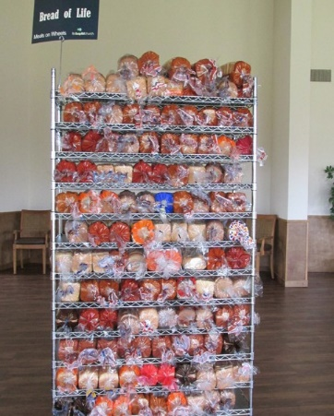
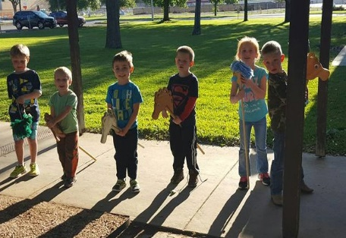
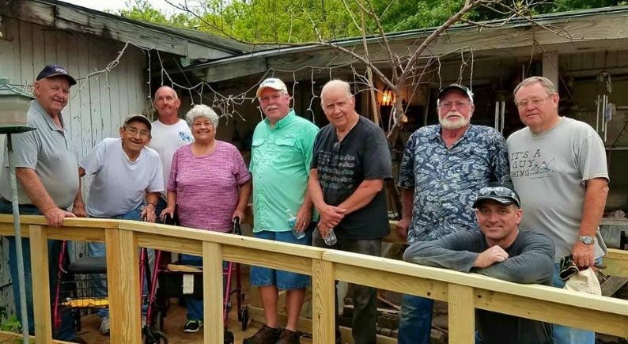
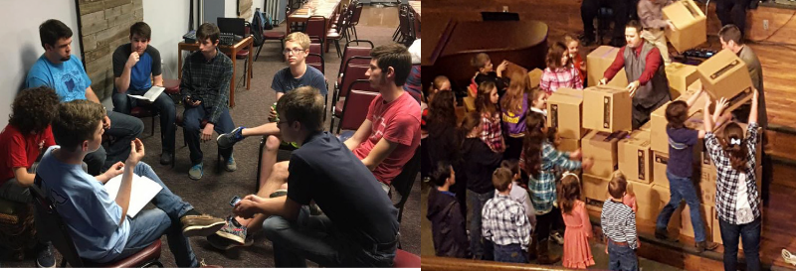
Welcome

www.fbcseguin.org
Pastor: Dr. Brice Mandaville
Associate Pastor: Josh Tylich
Minister of Music: Howard Hudiburg
Children’s/Volunteer Coordinator: Rhonda Hensarling
FIRST TIME HERE?
Text Welcome to
830-224-2046

MORNING SERVICE
July 22, 2018 10:30 am

WELCOME TO OUR CHURCH

DECLARATION OF PRAISE Congregation
This Is Amazing Grace
Amazing Grace (My Chains Are Gone)

PRAYER/WELCOME Pastor Brice

TESTIMONY David Arnold

SCRIPTURE –John 3:22-30 Rebecca Rhodes

WORSHIP MEDLEY Congregation
The Lion and the Lamb
Leaning on the Everlasting Arms (Hymn #333)*

HE MUST INCREASE, I MUST DECREASE Pastor Brice

RESPONDING TO GOD’S WORD Congregation
At the Cross (Hymn #139)

Offering
Prayer Ken Mangum
Holy Spirit Rebecca Rhodes

BENEDICTION

* Children 4 years old thru First Grade dismissed for children’s worship following this hymn.

TLU POOL PARTY
TONIGHT IN PLACE OF EVENING SERVICE
We have reserved the pool for our church family and their guests to enjoy. The gate will open at 6:00 PM, and the church will provide a light meal of hotdogs, chips, drinks and cookies! Bring your lawn chairs and towels, pool toys and floaties! We hope to see you there.

ONE NIGHT OF WORSHIP
AUGUST 12
Join us at ZDT’s Amusement Park, located at 301 W. Kingsbury St. here in Seguin, for a day of fun and a night of worship. All day passes, and half day passes are available. Passes include unlimited access to all rides, water play and video games in the park. Beginning at 8:00 PM we will have the James Curlin Band in concert as well as Lo Alaman, from San Antonio, here to kick off our night of worship. The concert will run until 10:00 PM. Sign up in the foyer no later than August 8. Drop off and pick up will be at the park, the church will not provide transportation.

MORE INFORMATION
For more information about the church, please write your name and email address on one of the cards in the pews and place in the offering plate.

