CHRISTMAS IN JULY!
TODAY
The Missions Committee would like you to come and enjoy Christmas cookies in July! They are out in the foyer this morning with fresh cookies and coin jars as a reminder to fill your jars for the Lottie Moon Missions offering in December! If you need a collection jar there are extras on the table.

Also available are WorldCraft catalogs and information. WorldCraft is an organization through Women’s Missionary Union that helps men and women earn a living and escape the grip of poverty. All items are handmade and would make a wonderful and encouraging Christmas gift. We hope you’ll stop by.

BIBLE FELLOWSHIP GROUP TEACHER TRAINING
AUGUST 5
This training is for Adult Bible Fellowship Group teachers/leaders. Training will be led by Hollas Hoffman, a ministry connector for the convention for many years. He will be talking about how to grow your Sunday school class. The training will be held in the fellowship hall and will start right after church. We will wrap it all up around 1:30 PM. The church will provide lunch for all adult Sunday School teachers who attend. You can sign up in the church office. See Bro. Josh Tylich for more details.

KEENAGER’S LUNCHEON
AUGUST 6 10:00AM
Be sure to stop by the counter in the foyer to sign up for this month’s luncheon. Table games and fellowship will start at 10:00 AM and lunch will be served at 11:30 AM followed by a presentation by Lisa Robbins and Judy Morgan-Allen at noon. They will be giving a recap of their recent trip to Israel.

YOUTH DIRECTOR POSITION
We are currently seeking a part-time, 20 hours per week, youth director to oversee our youth ministry. A job description, expectations and compensation are available in the church office and on the church website. If you know of someone interested, please have them contact the pastor or send information to info@fbcseguin.org.

MEALS ON WHEELS VOLUNTEERS
St. Andrew’s Episcopal church is looking for more volunteers to be drivers for the Meals on Wheels program. If you are interested in volunteering, please stop by the church office for an informational packet.

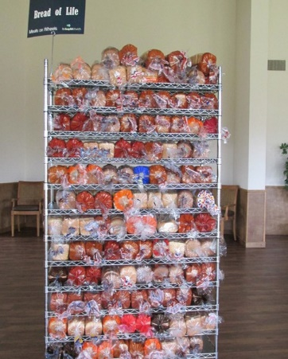
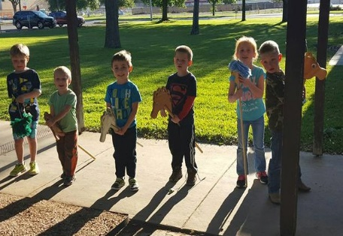
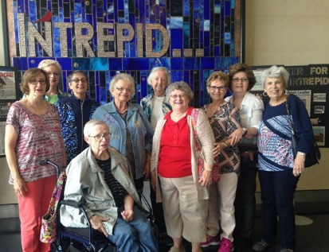
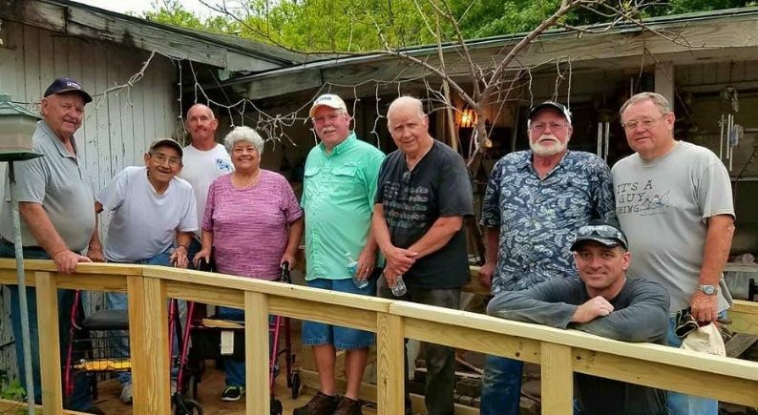
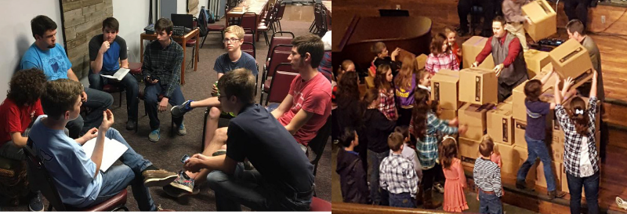
Welcome

www.fbcseguin.org
Pastor: Dr. Brice Mandaville
Associate Pastor: Josh Tylich
Minister of Music: Howard Hudiburg
Children’s/Volunteer Coordinator: Rhonda Hensarling
FIRST TIME HERE?
Text Welcome to
830-224-2046

MORNING SERVICE
July 29, 2018 10:30 am

WELCOME Pastor Brice

DECLARATION OF PRAISE Congregation
O Come, All Ye Faithful (Hymn #89)
Higher Ground (Hymn #484)

SCRIPTURE –John 4:1-10 Camdyn Mikes

PRAYER Lailah Day

The Woman at the Well Pastor Brice

WORSHIP MEDLEY Congregation
Only King Forever
In Christ Alone*

LIVING WATER Pastor Brice

RESPONDING TO GOD’S WORD Congregation
At the Cross (Hymn #139)

Offering
Prayer Miguel Garcia
Living Hope Leah Amaro

BENEDICTION

* Children 4 years old thru First Grade dismissed for children’s worship following this hymn.

BUSINESS MEETING AND DINNER
TONIGHT 6:00 PM
We will have a business meeting and dinner in place of our evening service tonight in the Fellowship Hall. Dinner will begin at 6:00 PM followed by a recap of the previous quarter.

ONE NIGHT OF WORSHIP
AUGUST 12
Join us at ZDT’s Amusement Park, located at 301 W. Kingsbury St. here in Seguin, for a day of fun and a night of worship. All day passes, and half day passes are available. Passes include unlimited access to all rides, water play and video games in the park. Beginning at 8:00 PM we will have the James Curlin Band in concert as well as Lo Alaman, from San Antonio, here to kick off our night of worship. The concert will run until 10:00 PM. Sign up in the foyer no later than August 8. Drop off and pick up will be at the park, the church will not provide transportation.

MORE INFORMATION
For more information about the church, please write your name and email address on one of the cards in the pews and place in the offering plate.

