SEGUIN YOUTH SERVICES BACKPACKS
For the 11th year, First Baptist Church members have the opportunity to give a backpack filled with basic school supplies to a student who participates in the Seguin Youth Services after-school program. Today through August 12th, student names will be available in the foyer before and after morning worship service. When you sign up for a student, you will be given the list of basic school supplies to purchase and instructions on how to fill your backpack. All filled backpacks must be back at church by Sunday morning, August 19th. On Monday, August 20, between 5:00 and 6:00 PM, Seguin Youth Services will host a back-to-school party where the backpacks will be given to the students. All church members are invited to attend and those who donated a backpack will have the chance to give their backpack to their student. Seguin Youth Services is located at 901 N. Guadalupe St.

KEENAGER’S LUNCHEON
TOMORROW 10:00AM
Table games and fellowship will start at 10:00 AM and lunch will be served at 11:30 AM followed by a presentation by Lisa Robbins and Judy Morgan-Allen at noon. They will be giving a recap of their recent trip to Israel.

END OF SUMMER BASH
SEGUIN WAVE POOL THIS FRIDAY - AUGUST 10
We hope you’ll join us at the Seguin Wave Pool, located at 1 Wave Pool Drive, here in Seguin, for our end of summer bash. School starts this month, so we have rented the entire facility for our church families to enjoy for the evening. The gate will open at 7:15 PM and we will have the run of the pool until 9:15 PM. Bring your lawn chairs, towels, and something to snack on. We are looking forward to a really fun evening.

YOUTH DIRECTOR POSITION
We are still accepting applications for a part-time, 20 hours per week, youth director to oversee our youth ministry. A job description, expectations and compensation are available in the church office and on the church website. Please contact the pastor or send information to info@fbcseguin.org if interested.

MEALS ON WHEELS VOLUNTEERS
St. Andrew’s Episcopal church is looking for more volunteers to be drivers for the Meals on Wheels program. Please stop by the counter in the foyer for an informational packet if interested.

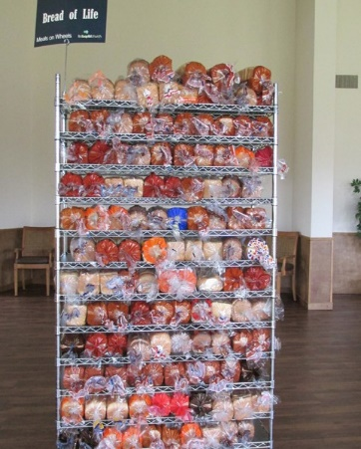
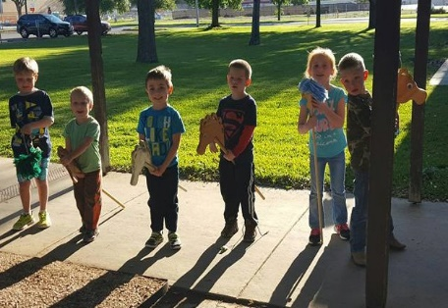
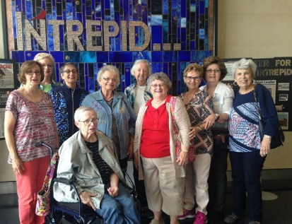
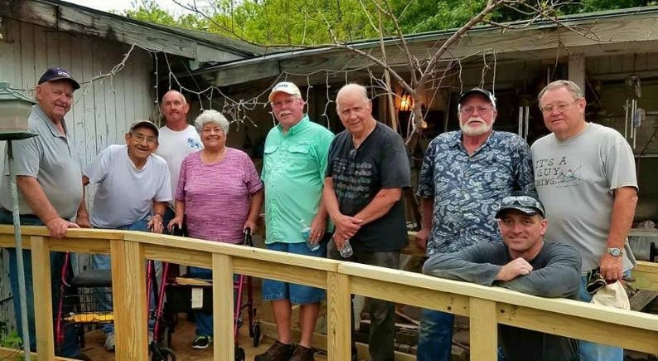
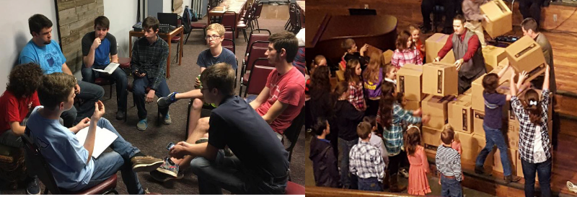
Welcome

www.fbcseguin.org
Pastor: Dr. Brice Mandaville
Associate Pastor: Josh Tylich
Minister of Music: Howard Hudiburg
Children’s/Volunteer Coordinator: Rhonda Hensarling
FIRST TIME HERE?
Text Welcome to
830-224-2046

MORNING SERVICE
August 5, 2018 10:30 am

DECLARATION OF PRAISE Congregation
Open Up the Heavens
Trust and Obey (Hymn #447)

SCRIPTURE - John 4: 16-26 Jackson Shanafelt

WELCOME/PRAYER Pastor Brice

SCHOOL BACKPACK PROJECT Video

WORSHIP MEDLEY Congregation
Come As You Are
Stronger *

MESSAGE: WORSHIPPING IN SPIRIT AND TRUTH

RESPONDING TO GOD’S WORD Congregation
At Calvary (Hymn #138)

Offering
Prayer Don Page
This Old House Dewey Coley

BAPTISM

BENEDICTION

* Children 4 years old thru First Grade dismissed for children’s worship following this song.

EVENING SERVICE
6:00 PM
Please join us for a traditional service of hymns and verse by verse preaching by Bro. Josh.

BIBLE FELLOWSHIP GROUP TEACHER TRAINING
TODAY
This training is for Adult Bible Fellowship Group teachers/leaders. Head to the fellowship hall following the morning worship service for lunch followed by a great training session. We will finish around 1:30 PM. See Bro. Josh Tylich for more details.

ONE NIGHT OF WORSHIP
AUGUST 12
Join us at ZDT’s Amusement Park, located at 301 W. Kingsbury St. here in Seguin, for a day of fun and a night of worship. Everyone in the park at closing will be invited and encouraged to attend a summer concert featuring the James Curlin Band and Lo Alaman. The concert will run until 10:00 PM. Sign up in the foyer no later than August 8 for an all-day pass. Money is due upon sign up. Drop off and pick up will be at the park, the church will not provide transportation.

MORE INFORMATION
For more information about the church, please write your name and email address on one of the cards in the pews and place in the offering plate.

