SEGUIN YOUTH SERVICES BACKPACKS
Thank you to all who bought backpacks and supplies. Tomorrow evening, August 20, at 5:00 PM, Seguin Youth Services will host a back-to-school party where the backpacks will be given to the students. All church members are invited to attend and those who donated a backpack will have the chance to give their backpack to their student. Seguin Youth Services is located at 901 N. Guadalupe St.

SERVING SEGUIN
We are in need of individuals for several local service projects. If you can assist with one of them, please use one of the blue Service cards in the pews to indicate which project you would like to help with and place it in the offering plate.
- Windshield Cleaning - Friday Aug 31 from 7:00 - 8:30 PM. During the first Seguin home football game, we will clean windshields of cars parked in our church parking lots and leave a card on them about the church.
- Meals on Wheels - picking up around six hot lunches and delivering them to the homes of assigned elderly and disabled individuals, on a one-time basis or a weekly basis.
- Reading with Children - reading with children or helping them with homework after school at Seguin Youth Services, either on a one-time basis or a weekly basis.

WEDNESDAY NIGHT CHOIR AND MISSIONS KICKOFF
SEPTEMBER 5
Join us under the big tent as we kick off our choir and missions year on Wednesday Sept. 5th from 5:30 to 7:00 PM. Preschool will be in bldg. 1 and Elementary in the fellowship hall. Preschool is 4 years (must be 4 by Sept. 1, 2018) through kinder. Elementary is grades 1-6. Parents must remain with elementary kids. We are looking forward to a wonderful year as we learn and sing about the work the Lord is doing! Questions? Call Kay at 401-4664.

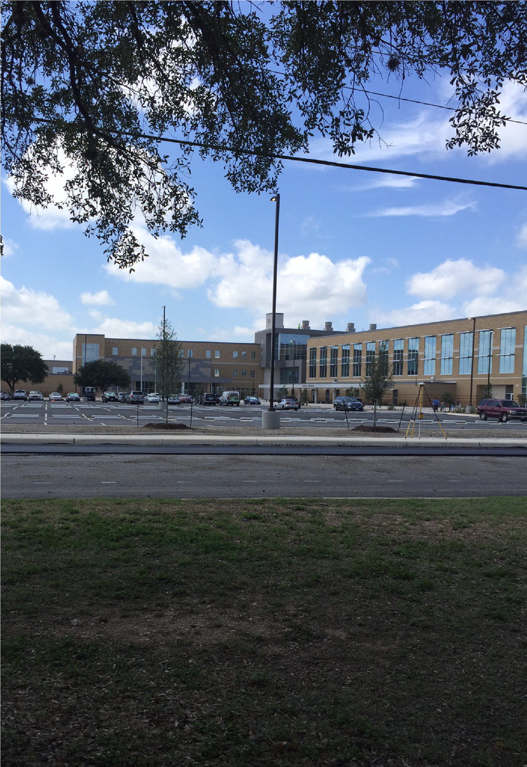
Then he said to them, “The harvest truly is
great, but the laborers are few; therefore, pray
to the Lord of the harvest to send out laborers
into His harvest.” Luke 10:2
FIRST TIME HERE?
Text Welcome to
830-224-2046

www.fbcseguin.org
Pastor: Dr. Brice Mandaville
Associate Pastor: Josh Tylich
Minister of Music: Howard Hudiburg
Children’s/Volunteer Coordinator: Rhonda Hensarling
FIRST TIME HERE?
Text Welcome to
830-224-2046

MORNING SERVICE
August 19, 2018 10:30 am

WELCOME Pastor Brice

WORSHIP MEDLEY Congregation
Revelation Song
Mercy

SCRIPTURE - John 4:46-54 Eric Brittain

PRAYER FOR THE SCHOOL YEAR Pastor Brice

WORSHIP MEDLEY Congregation
O Praise the Name
Be Thou My Vision (Hymn #60)*

TAKING JESUS AT HIS WORD Pastor Brice

RESPONDING TO GOD’S WORD Congregation
At Calvary (Hymn #138)

Offering
Prayer Joe Peoples
It Is Well/I Hear Thy Welcome Voice
Lance Birdsong & Jack Kuo

BENEDICTION

* Children 4 years old thru First Grade dismissed for children’s worship following this hymn.

EVENING SERVICE
6:00 PM
Please join us for a traditional service of hymns and verse by verse preaching by Bro. Josh.

PRAYER WALK at SEGUIN HIGH SCHOOL
TODAY
We hope you will join us for a prayer walk on the Seguin High School campus after the morning worship service this moring. This is our opportunity to pray for the faculty, staff and the students. SISD school year begins Thursday, August 23rd. Please also remember Navarro ISD starting school tomorrow, August 20th and Lifegate school who began August 16th. Prayers for a safe and fruitful school year!

MORE INFORMATION
For more information about the church, please write your name and email address on one of the cards in the pews and place in the offering plate. If you have a prayer request, please write it on the back of the white Information card in the pew. If you are ready to take a next step in your faith, whether that is to be baptized or join a Bible Fellowship Group, we encourage you to fill out the yellow Next Steps pew card and place it in the offering plate.

