WEDNESDAY NIGHT CHOIR AND MISSIONS KICKOFF
SEPTEMBER 5
Join us under the big tent as we kick off our choir and missions year on Wednesday Sept. 5th from 5:30 to 7:00 PM. Preschool will be in bldg. 1 and Elementary in the fellowship hall. Preschool is 4 years (must be 4 by Sept. 1, 2018) through kinder. Elementary is grades 1-6. Parents must remain with elementary kids. We are looking forward to a wonderful year as we learn and sing about the work the Lord is doing! Questions? Call Kay at 401-4664.

LADIES BIBLE STUDIES
Ladies, Fall Bible studies are just around the corner. Thursday evening study with Rhonda Hart has begun and meets at 6:30 PM, in the youth bldg. Thursday morning study with Kay Rhodes will begin Sept. 6 at 9:30 AM in bldg. 3. Wednesday evening study with Frieda Savage will begin Sept. 12 at 6:00 PM in bldg. 3. Tuesday morning study with Lisa Robbins will begin Sept. 18 at 9:00 AM in the fellowship hall. If you are interested in attending any of these studies, please see the leader of the study for a book.

KEENAGER’S LUNCHEON
SEPTEMBER 10 10:00AM
Be sure to stop by the counter in the foyer to sign up for the September luncheon. Table games and fellowship will start at 10:00 AM followed by lunch at 11:30 AM. At noon, Debbie Dossey will give a presentation over her work with Mosaic Homes – a faith-based organization serving people with intellectual disabilities.

CHURCH ENSEMBLES “Fall” BACK INTO SCHEDULE
Ensemble schedules will resume as follows:
FBC Glory Singers – Monday, Sept. 10, 5-6 pm
FBC Handbell Choir – Monday, Sept. 10, 6:15-7:15 pm
FBC Worship Choir - Wednesday, Sept. 12, 6-7 pm
(Nursery is available)
If you are interested in joining one of our church choirs, contact Bro. Howard at howardh@fbcseguin.org.

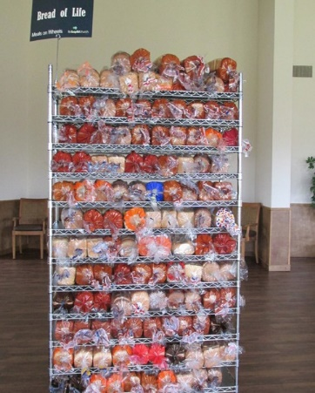
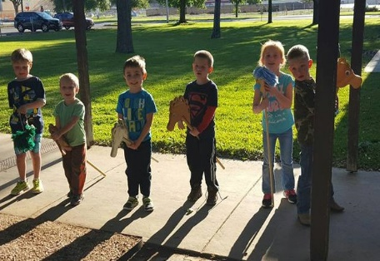
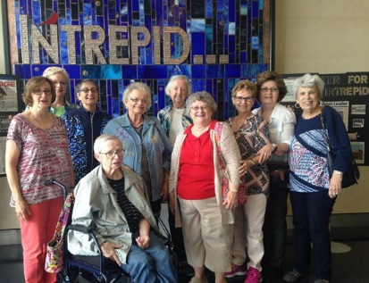
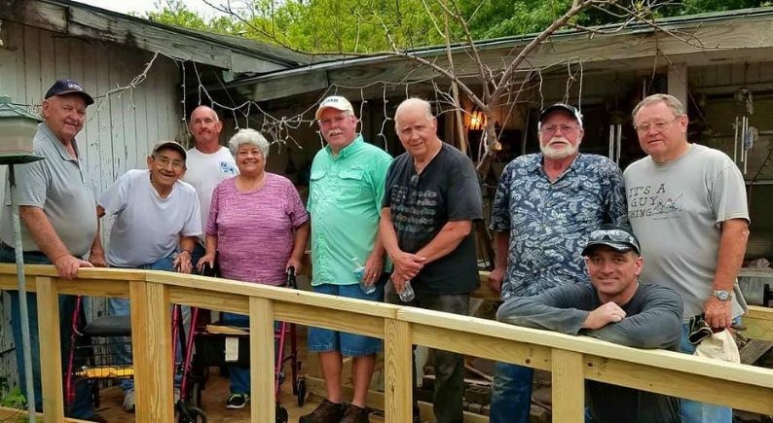
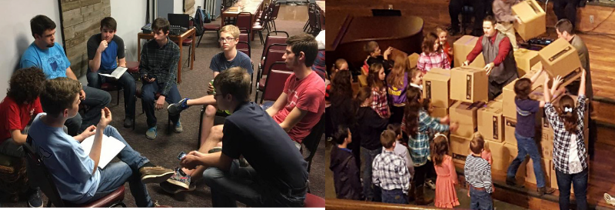
Welcome

www.fbcseguin.org
Pastor: Dr. Brice Mandaville
Associate Pastor: Josh Tylich
Minister of Music: Howard Hudiburg
Children’s/Volunteer Coordinator: Rhonda Hensarling
FIRST TIME HERE?
Text Welcome to
830-224-2046

MORNING SERVICE
August 26, 2018 10:30 am

DECLARATION OF PRAISE Congregation
Revive Us Again (Hymn #469)
Christ Is Risen

SCRIPTURE: John 5:1-14 Cheney Stephenson

EMBRACE GRACE Catherine Page

WORSHIP MEDLEY Congregation
Days of Elijah
Our God*

YOU CAN CHANGE Pastor Brice

RESPONDING TO GOD’S WORD Congregation
At Calvary (Hymn #138)

Offering
Prayer Travis Phillips
Throne Room Holly Brown

BENEDICTION

* Children 4 years old thru First Grade dismissed for children’s worship following this hymn.

The flowers are placed today in memory of Frank Pearson

EVENING SERVICE
6:00 PM
We hope you will join us tonight for a special presentation by Jonathan and Emily. They will be speaking about their work in North Africa.

MEN’S PRAYER GROUP
AUGUST 28 6:30AM
Men: we would like to invite you to join Bro. Brice here at the church Fellowship Hall for a time of prayer and meditation on God’s word. We will meet only on even numbered Tuesdays. There will be a light breakfast followed by a devotional, sharing and prayer.

MORE INFORMATION
For more information about the church, please write your name and email address on one of the cards in the pews and place in the offering plate. If you have a prayer request, please write it on the back of the white Information card in the pew. If you are ready to take a next step in your faith, whether that is to be baptized or join a Bible Fellowship Group, we encourage you to fill out the yellow Next Steps pew card and place it in the offering plate.

