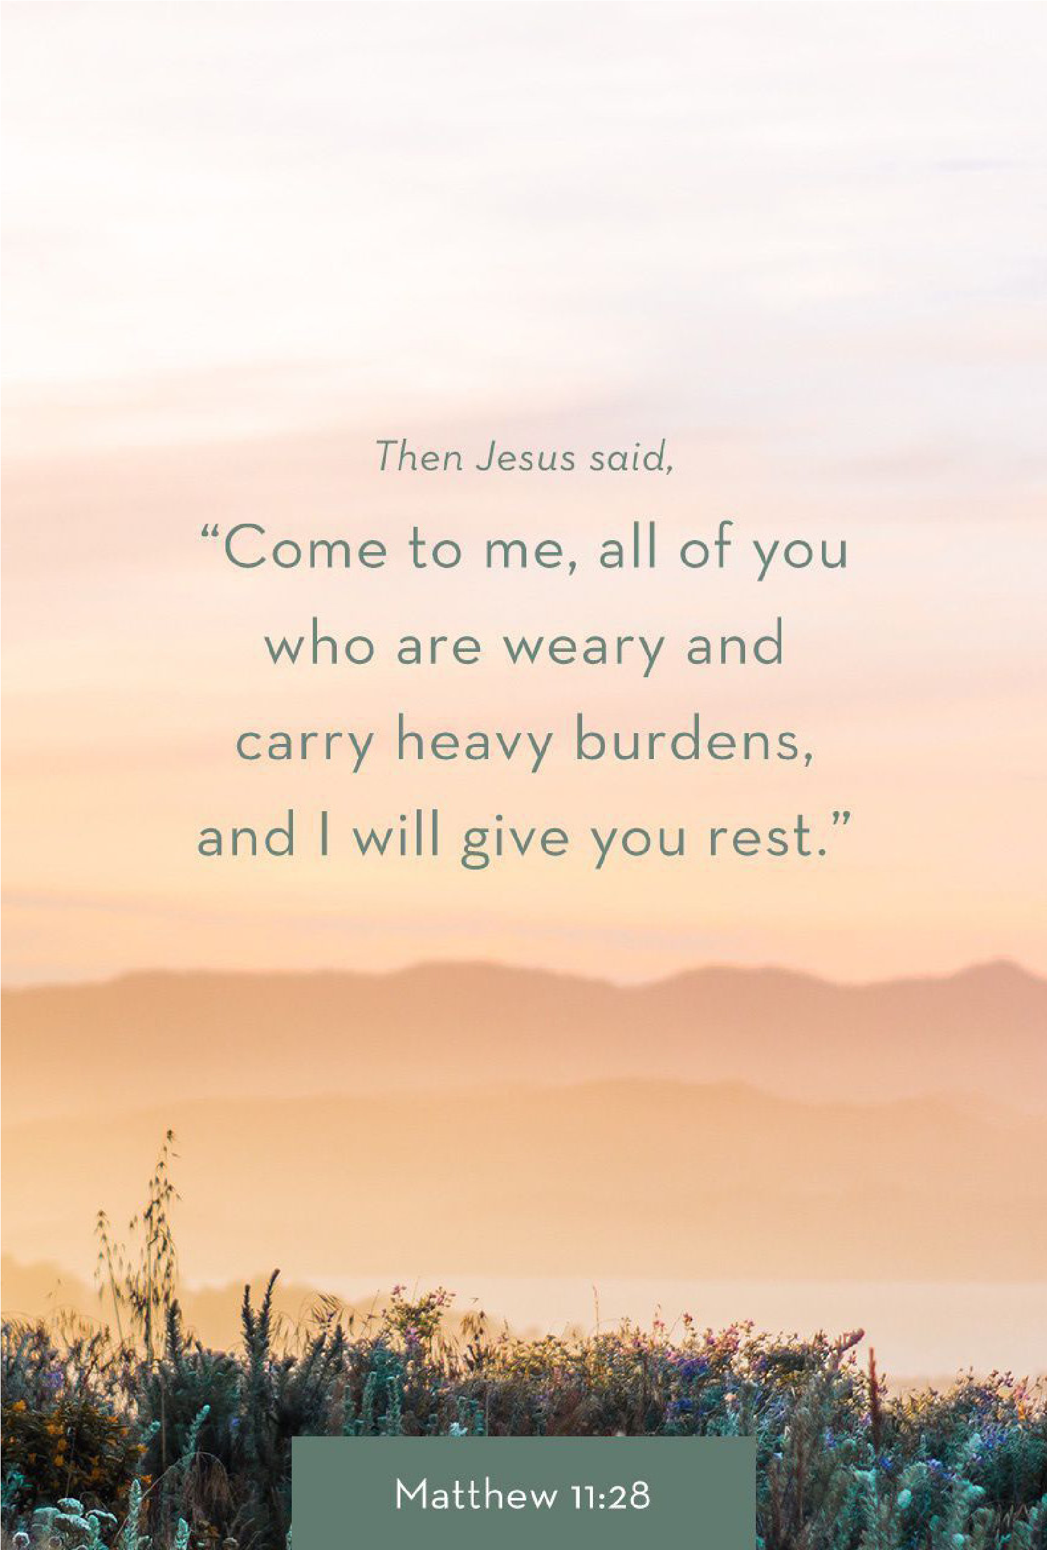
1314
E. Cedar Seguin, Tx
78155 830-379-4208
www. fbcseguin.org
WEDNESDAY NIGHT CHOIR AND MISSIONS KICKOFF
SEPTEMBER 5 5:30 to 7:00 PM
Join us, this Wednesday, as we kick off our choir and missions year. Preschool will be in bldg. 1 and Elementary in the fellowship hall. Preschool is 4 years (must be 4 by Sept. 1, 2018) through kinder. Elementary is grades 1-6. Parents must remain with elementary kids. We are looking forward to a wonderful year.

MEN’S PRAYER BREAKFAST
SEPTEMBER 8 8:00 – 10:00 AM
The Seguin Area Men’s September Prayer Breakfast will be held at The Silver Center, located at 510 E. Court St., here in Seguin. Breakfast will begin at 8:00 AM followed by a time of worship and prayer. Fathers bring your sons, sons bring your fathers.

KEENAGER’S LUNCHEON
SEPTEMBER 10 10:00 AM
There is still time to sign up for the September KeenAger’s luncheon. Stop by the counter in the foyer. Table games and fellowship will start at 10:00 AM followed by lunch at 11:30 AM. At noon, Debbie Dossey will give a presentation over her work with Mosaic Homes – a faith-based organization serving people with intellectual disabilities.

BAPTIST STUDENT MINISTRY LUNCHEON
SEPTEMBER 19
Every September, our church hosts a sloppy joe luncheon in San Marcos for the students of the Baptist Student Ministry. We would like to ask that you, the church, help us out with homemade cookies to show our appreciation to their studies. There will be signup sheets available, in the Sunday School boxes as well as the church foyer, for those who would like to bake a batch for this luncheon. Please have all cookies to the church kitchen no later than Sept. 17th!

So. TX PREGNANCY CARE CENTER ANNUAL BANQUET
SEPTEMBER 27
The So. TX Pregnancy Care Center (STPCC) would like to invite you to join them for their annual banquet. This year’s guest speaker is Dr. Ron Archer, a best-selling author, NFL consultant, and military leadership consultant, among many other distinguished titles. The banquet will be held at the Seguin Events Center/Coliseum. You can register for the banquet by calling the STPCC office at 830.433.0367 or online at www.southtexaspregnancycarecenter.com. Deadline to register for the banquet is September 10.

First Time Visitor? Text “Welcome” to 830.224.2046

www.fbcseguin.org
Pastor: Dr. Brice Mandaville
Associate Pastor: Josh Tylich
Minister of Music: Howard Hudiburg
Children’s/Volunteer Coordinator: Rhonda Hensarling
FIRST TIME HERE?
Text Welcome to
830-224-2046

MORNING SERVICE
September 2, 2018 10:30 am

WELCOME Pastor Brice

DECLARATION OF PRAISE Congregation
Great Is Thy Faithfulness (Hymn #54)
Were You There (Hymn #156)

SCRIPTURE – John 5:16-23 Ruth Anderson

SERVICE PROJECTS THIS WEEK Video

WORSHIP MEDLEY Congregation
Only King Forever
Overcome*

DID JESUS CLAIM TO BE GOD? Pastor Brice

RESPONDING TO GOD’S WORD Congregation
The Old Rugged Cross (Hymn #141)

Offering
Prayer Jim Ransdell
Good, Good Father Praise Team
BAPTISM

BENEDICTION

* Children 4 years old thru First Grade dismissed for children’s worship following this hymn.

The flowers are placed today in celebration of Georgia & Larry Speir’s 53rd Wedding Anniversary.
EVENING SERVICE
6:00 PM
Please join us for a traditional service of hymns and verse by verse preaching by Bro. Josh.

MEN’S PRAYER GROUP
SEPTEMBER 4
Men: we would like to invite you to join Bro. Brice here at the church Fellowship Hall, this Tuesday, for a time of prayer and meditation on God’s word. There will be a light breakfast followed by a devotional, sharing and prayer.

BIBLE FELLOWSHIP GROUP FALL COWBOY KICKOFF
SEPTEMBER 16 8:15 – 9:15 AM
If you are a member of one of our Sunday School classes or Bible Fellowship Groups, we would like to invite you to celebrate with us as we kick off our fall session with breakfast in the court yard. If you’re not currently connected with one of our groups at FBC Seguin come and check them out. There will be breakfast tacos, juice & coffee, free family photos, train rides, and live entertainment.

MORE INFORMATION
For more information about the church, please write your name and email address on one of the cards in the pews and place in the offering plate. If you have a prayer request, please write it on the back of the white information card in the pew.

The church campus and office will be closed tomorrow in observance of Labor Day.

