“THE GREATEST GIFT” CHILDREN’S CHRISTMAS EVENT
DECEMBER 9 6:00 PM
Come journey with us as we discover our Greatest Gift. On the evening of December 9, we will be telling the story of the birth of Christ through the eyes of those that were there. Our journey will begin in the Sanctuary and will wind through the church campus, ending in the fellowship hall for crafts and refreshments. This is a children’s event, but everyone is invited to come along on the journey of discovering our Greatest Gift!

MESSIAH – A MUSICAL GOSPEL MESSAGE
DECEMBER 16 6:00 PM
Together with Studio Orchestra, the FBC Worship Choir and Praise Team will be performing a two part concert on the evening of December 16. Part one will consist of excerpts from Handel’s Messiah, sung in the traditional and original style. Part two will consist of contemporary songs and soloists. We encourage you to invite friends or family members to join you in hearing the Good News of the Gospel message that is embedded in the music; from birth, to cross, to grave, to the resurrection and looking toward the second coming. This will be a reverent night of worship and everyone is invited.

POINSETTIAS
The Seguin High School ROTC is again offering poinsettias through their fall fundraiser. This year, poinsettias are $12 each. If you would like to purchase a poinsettia, please make your check out to First Baptist Church, write “poinsettias” on your envelope and place it in the offering plate. We will make a large order for the church after Thanksgiving. The poinsettias will then be on display on the stage through Christmas Eve. You may pick up your poinsettias after the evening service on Christmas Eve.

CHURCH BUILDING USE
The holiday season is upon us and with that come holiday parties and cookie exchanges. In past years, we have allowed our church members to use our facilities for these holiday parties. However, the buildings will not be available for use on December 1, 16 – 30.

MORE INFORMATION
For more information about the church, please write your name and email address on one of the cards in the pews and place in the offering plate. If you have a prayer request, please write it on the back of the white information card in the pew.

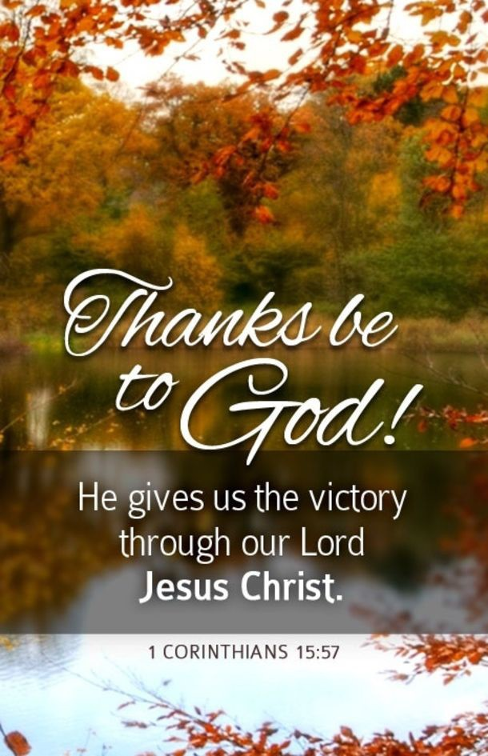
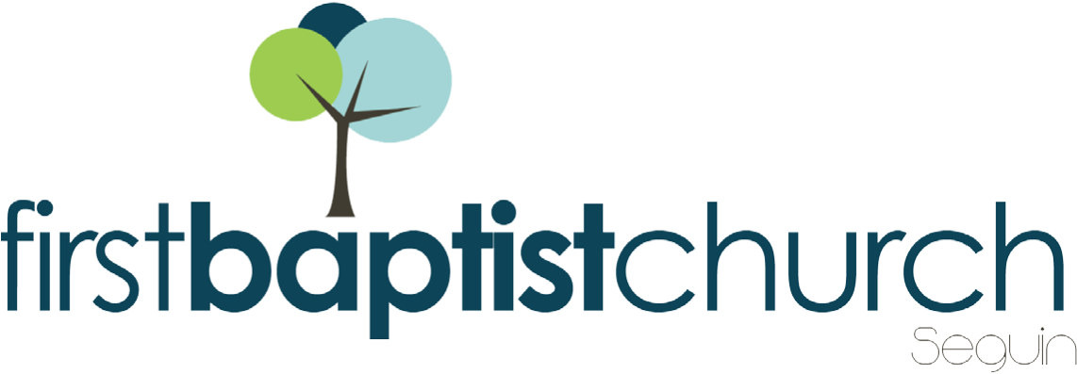
FIRST TIME HERE? Text Welcome to 830-224-2046

MORNING SERVICE
November 25, 2018 10:30 AM

DECLARATION OF PRAISE Congregation
Be Unto Your Name
Wonderful Grace of Jesus (Hymn #328)

WELCOME Pastor Brice

PRAYER Pastor Brice

SCRIPTURE – John 11:1-3, 17-26 Cody Hamilton

WORSHIP MEDLEY Congregation
This I Believe (The Creed)
For the Beauty of the Earth (Hymn #44)*

LIFE AFTER DEATH Pastor Brice

RESPONDING TO GOD’S WORD Congregation
At the Cross (Hymn #139)

Offering
Prayer Eddie Brown
My Tribute (Hymn #153) Praise Team

BENEDICTION

* Children 4 years old thru First Grade dismissed for children’s worship following this hymn.

EVENING SERVICE
6:00 PM
Join us tonight for a traditional service of hymns and verse by verse preaching by Bro. Josh.

2019 BUDGET
Be sure to stop by the counter in the foyer to pick up a copy of the 2019 Budget. We will have a presentation and discussion over the budget on December 2 at 6:00 PM. Your opinion and voice matter. Please make plans to attend. We will vote (without discussion) on the budget at the end of the morning service on December 9.

MISSIONS FAIR
NEXT SUNDAY NOON – 1:30 PM
Mark your calendars for our Missions Fair, December 2. This will be a morning focused on and celebrating World Missions. Immediately following the morning service, we will head to the fellowship hall for lunch. After lunch we hope you will stop by our various booths for information and activities. Come learn about Lottie Moon and dig in to what our very own church families are doing out in the field. The big red tub will be ready for you to empty your Lottie Moon change jars. Don’t miss it!

YOUTH MINISTER SEARCH
If you, or someone you know, would like to apply for the position, please visit www.fbcseguin.org.

