ANGEL TREE
DECEMBER 2 – 9
Every year, FBC partners with local nursing homes to bring Christmas gifts to those who are unable to be with their families during the Christmas season. In our foyer you will find a tree dedicated to these Angels. Please stop by the tree and pick an angel from the tree. On the angel you will find the name of a nursing home bound person, and a list of two to three items that they would like for Christmas. Please do not bring your gifts to the church office, instead return all gifts to the foyer and place them in their respective bins, sorted by nursing home, no later than December 9.

“THE GREATEST GIFT” CHILDREN’S CHRISTMAS EVENT
DECEMBER 9 6:00 PM
Come journey with us as we discover our Greatest Gift. On the evening of December 9, we will be telling the story of the birth of Christ through the eyes of those that were there. Our journey will begin in the Sanctuary and will wind through the church campus, ending in the fellowship hall for crafts and refreshments. This is a children’s event, but everyone is invited to come along on the journey of discovering our Greatest Gift!

MESSIAH – A MUSICAL GOSPEL MESSAGE
DECEMBER 16 6:00 PM
Together with Studio Orchestra, the FBC Worship Choir and Praise Team will be performing a two part concert on the evening of December 16. Part one will consist of excerpts from Handel’s Messiah, sung in the traditional and original style. Part two will consist of contemporary songs and soloists. We encourage you to invite friends or family members to join you in hearing the Good News of the Gospel message. This will be a reverent night of worship and everyone is invited.

LORD’S SUPPER
DECEMBER 9
We will be observing the Lord’s Supper at the end of service Sunday, December 9. All those who have made the decision to follow Jesus Christ as their personal Lord and Savior are welcome to partake. There will be gluten free wafers available for those on a restricted diet on the counter in the foyer.

CHILDREN’S CHOIR & MISSIONS
DECEMBER 12
Children’s choirs and missions will wrap up for the year on Wednesday, December 12. We will resume our program January 9, 2019. We wish you a Merry Christmas and a Happy New Year with your family.

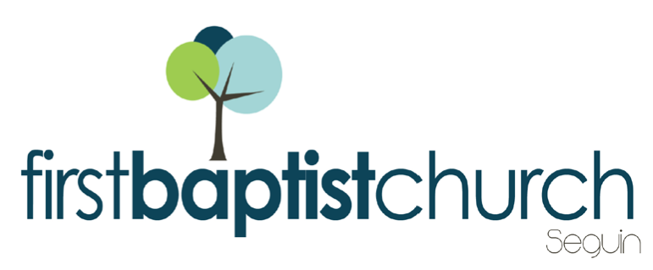
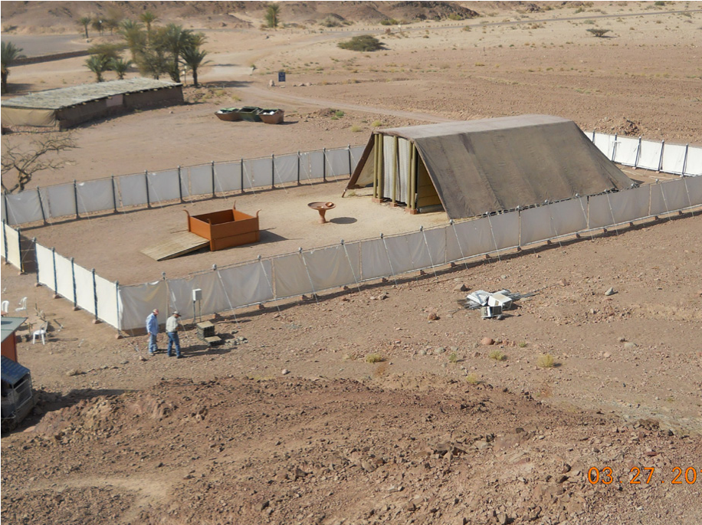
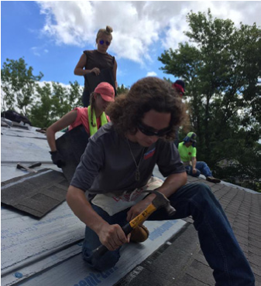
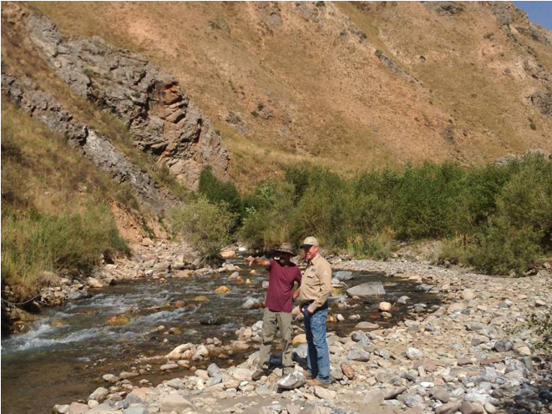
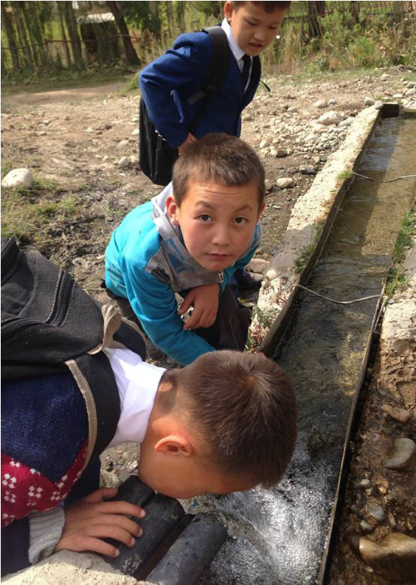
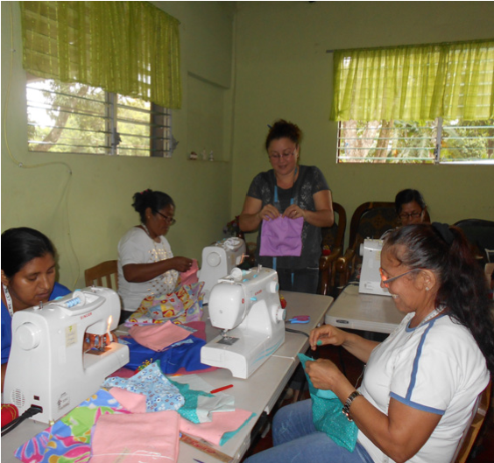
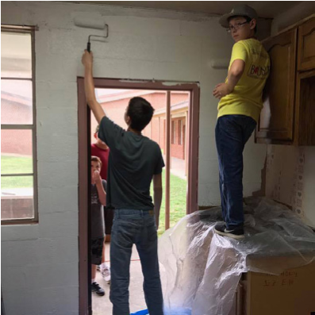
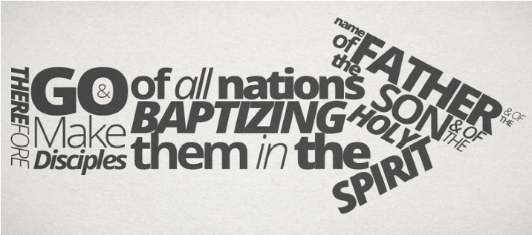
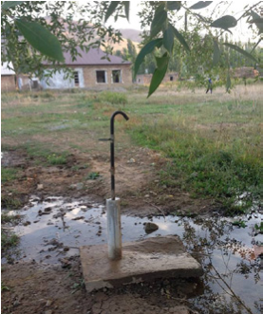
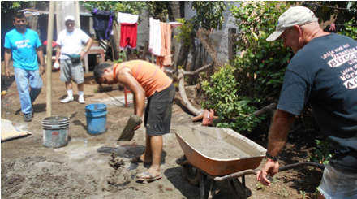
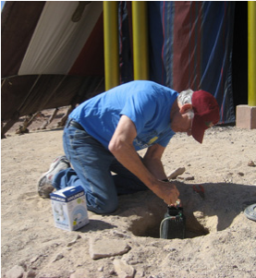
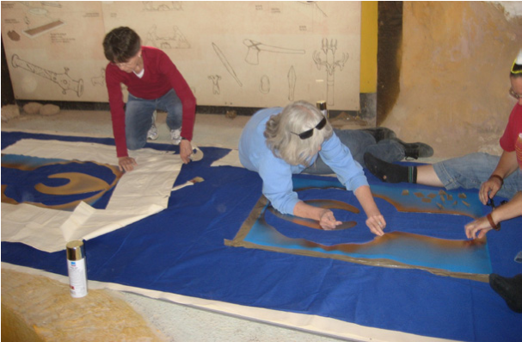
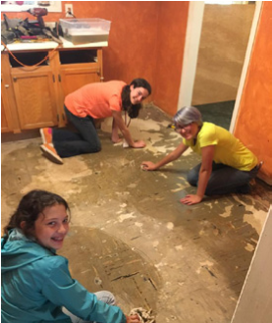
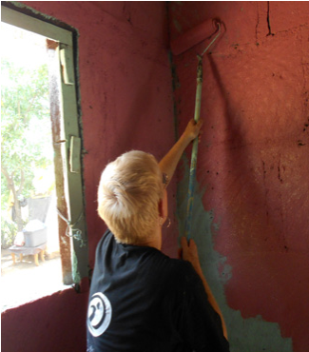
Pastor: Dr. Brice Mandaville
Associate Pastor: Josh Tylich
Minister of Music: Howard Hudiburg
Children’s/Volunteer Coordinator:
Rhonda Hensarling
www. fbcseguin.org
FIRST TIME HERE?
Text Welcome to
830-224-2046

MORNING SERVICE
December 2, 2018 10:30 am

LOTTIE MOON OFFERING Children

I HEARD THE BELLS ON CHRISTMAS DAY
Handbell Choir

PRAYER/WELCOME Pastor Brice

DECLARATION OF PRAISE Congregation
Come, Thou Long-Expected Jesus (Hymn #77)
Come As You Are

REACHING TANZANIA Video

WORSHIP MEDLEY Congregation
God of This City
O Come, O Come, Emmanuel (Hymn #76)*

LIVE FROM THE FIELD

RESPONDING TO GOD’S WORD Congregation
O Come, All Ye Faithful (Hymn #89)

Offering
Prayer Eddie Brown
Go, Tell It on the Mountain (Hymn #95) Praise Team

BENEDICTION

* Children 4 years old thru First Grade dismissed for children’s worship following this hymn.

MISSIONS FAIR
TODAY
Join us in the fellowship hall immediately following the morning service. We will be serving a lunch of sub sandwiches and chips with a variety of sides. After lunch, we encourage you to stop by our various booths to learn about the IMB and how our church is involved. We hope to see you there.

BUDGET DISCUSSION
6:00 PM
Tonight, in place of our traditional service of hymns and preaching, we will have a presentation and discussion over the proposed budget for next year. You can pick up a copy of the 2019 Budget from the counter in the foyer. Please make plans to attend. We will vote (without discussion) on the budget at the end of the morning service on December 9.

YOUTH MINISTER SEARCH
If you, or someone you know, would like to apply for the position, please visit www.fbcseguin.org.

MORE INFORMATION
For more information about the church, please write your name and email address on one of the cards in the pews and place in the offering plate. If you have a prayer request, please write it on the back of the white information card in the pew.

