MESSIAH – A MUSICAL GOSPEL MESSAGE
DECEMBER 16 6:00 PM
Together with Studio Orchestra, the FBC Worship Choir and Praise Team will be performing a two part concert on the evening of December 16. Part one will consist of excerpts from Handel’s Messiah, sung in the traditional and original style. Part two will consist of contemporary songs and soloists. We encourage you to invite friends or family members to join you in hearing the Good News of the Gospel message. This will be a reverent night of worship and everyone is invited.

ANGEL TREE
DUE TODAY
Please do not bring your gifts to the church office, instead return all gifts to the foyer and place them in their respective bins, sorted by nursing home.

KEENAGERS LUNCHEON
TOMORROW
We are looking forward to tomorrows luncheon. If you are attending, please bring a small gift (no more than $10) for our gift exchange that begins at 10:00 AM. Lunch will be served at 11:30 AM and at noon, Marianne and Howard Hudiburg will be performing a few Christmas and seasonal songs.

CHILDREN’S CHOIR & MISSIONS
DECEMBER 12
Children’s choirs and missions programs will wrap up for the year this Wednesday, December 12. We will resume our program January 9, 2019. We wish you a Merry Christmas and a Happy New Year with your family.

MORE INFORMATION
For more information about the church, please write your name and email address on one of the cards in the pews and place in the offering plate. If you have a prayer request, please write it on the back of the white information card in the pew.

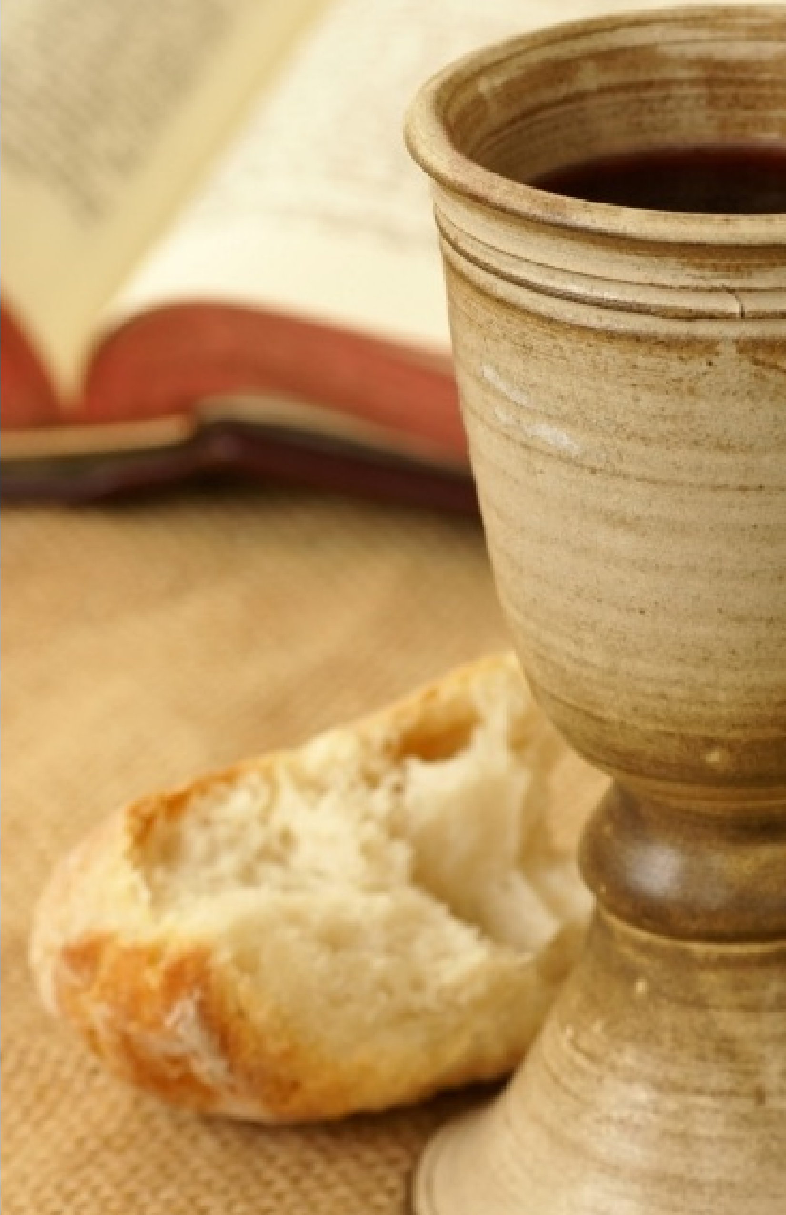
FIRST TIME HERE? Text Welcome to 830-224-2046

MORNING SERVICE
December 9, 2018 10:30 am

CELEBRATE THE BIRTH OF JESUS Music Makers

WELCOME/PRAYER Pastor Brice

SCRIPTURE: JOHN 11:45-57 Susian Parsons

MEDLEY OF PRAISE & WORSHIP Congregation
What Child Is This? (Hymn #118)
The First Noel (Hymn #85)
Away in a Manger (Hymn #103)

REACHING THE UKRAINE Video

CHORAL MEDLEY Glory Singers
All Is Well
Creation Sings, with Joy Has Dawned
In the Bleak Mid-Winter, with Ella Shanafelt*

ACCEPTING JESUS AS YOUR KING

RESPONDING TO GOD’S WORD Congregation
O Come, All Ye Faithful (Hymn #89)

Offering
Prayer Doug Harding
Joy to the World! (Hymn #87) Praise Team

THE LORD’S SUPPER

BENEDICTION

* Children 4 years old thru First Grade dismissed for children’s worship following this hymn.
LORD’S SUPPER
We will be observing the Lord’s Supper at the end of service this morning. All those who have made the decision to follow Jesus Christ as their personal Lord and Savior are welcome to partake. There are gluten free wafers available for those on a restricted diet on the counter in the foyer.

2019 BUDGET VOTE
We are voting, this morning, (without discussion) on the 2019 Budget. If you haven’t picked up a copy already, you can find a copy of the 2019 Budget on the counter in the foyer. Please fill out the enclosed ballot and drop it in the offering plate.

“THE GREATEST GIFT” CHILDREN’S EVENT
TONIGHT 6:00 PM
Come journey with us as we discover our Greatest Gift. This evening, we will be telling the story of the birth of Christ through the eyes of those that were there. Our journey will begin in the Sanctuary and will wind through the church campus, ending in the fellowship hall for crafts and refreshments. This is a children’s event, but everyone is invited to come along on the journey of discovering our Greatest Gift!

LOTTIE MOON DECEMBER OFFERING
Don’t forget, we will be collecting for the Lottie Moon Christmas Offering the whole month of December. This past week we collected just under $9,000. Our church goal is $35,000. Please be in prayer about what the Lord would have you give.

WEDNESDAY NIGHT MEALS
Don’t forget to sign up for this week’s meal. A menu and sign up sheet can be found in the foyer.

