GOOD FRIDAY SERVICE
APRIL 19
This Friday, we will present a dramatic portrayal of the crucifixion and burial of Jesus. We encourage you to invite at least one person to join you in attending.

CELEBRATE EASTER
APRIL 21
Following the Good Friday presentation of Jesus’ crucifixion, we will celebrate the good news that is Jesus’ resurrection during the Morning Service on Easter Sunday. We ask that you encourage those who come to the Good Friday service, to return Sunday morning for a time of celebrating our risen Savior.

FIELDS OF FAITH @ SEGUIN HIGH SCHOOL S.A.C. BLDG.
APRIL 24 4:30 – 6:30 PM
Students 7th – 12th grade are encouraged to join us on the Seguin High School (SHS) Campus for Fields of Faith. This is a time of student-led worship, testimony and prayer. We will be in the SHS Student Activity Center (SAC), with pizza and live music. Students are welcome to meet at the church, and we will walk over to the campus as a group around 4:00 PM. There will be no Wednesday Youth activities here on campus that evening. Please pick up your student at SHS.

PRETEEN CAMP & SCHOLARSHIPS
July 13-16
Registration is still available for Camp Tejas Preteen Camp. A $25.00 deposit will reserve your spot. Forms are available in the children’s building. If you would like to help sponsor a child for preteen camp, please write preteen camp on an envelope with your donation; any amount will help. The cost is $250.00 per student.

WEDNESDAY MEALS
Wednesday meals will break for the summer, April 24 and will resume in September. Sign up today for some good home cooking while it lasts.
CAMPUS CLOSED
APRIL 19
The church office and campus will be closed Friday April 19 in observance of Good Friday. We will be open regular hours Monday, April 22.

THANK YOU TO ALL WHO PARTICIPATED IN THE DESSERT AUCTION. IT WAS A SPECTACULAR SUCCESS! WE RAISED $7,102 TOWARD NORTH AMERICAN MISSIONS. TO GOD BE THE GLORY!

www.fbcseguin.org

April 14, 2019
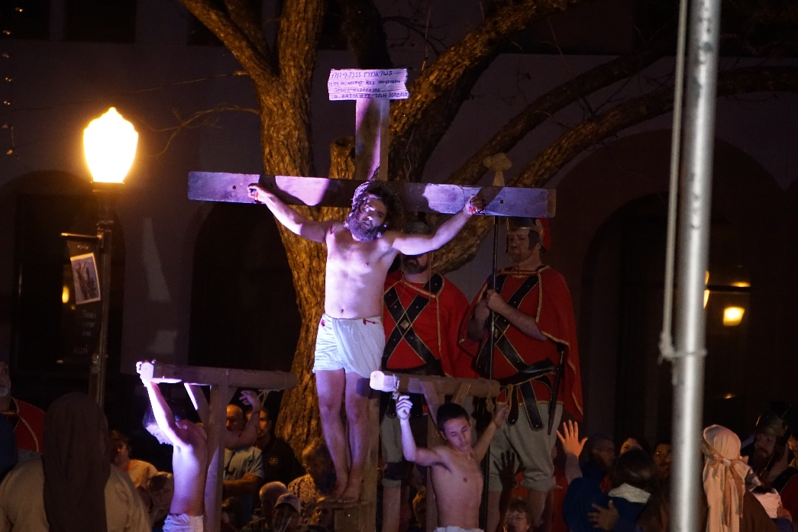

Good Friday Drama
Friday, April 19 7:00 PM
FBC Auditorium

MINISTERIAL STAFF

Pastor: Brice Mandaville
Associate Pastor: Josh Tylich
Youth Minister: Josh Graham
Minister of Music: Howard Hudiburg
Children’s/Volunteer Coordinator:
Rhonda Hensarling

First Time Here?
Text “Welcome” to 830-224-2046
MORNING SERVICE
April 14, 2019 10:30 am

DECLARATION OF PRAISE Congregation
Nothing But the Blood (Hymn #135)
The Wonderful Cross

SCRIPTURE – John 12:12-19 Allen Rhodes

WELCOME/PRAYER Pastor Brice

WORSHIP MEDLEY Congregation
Were You There (Hymn #156)
Above All*

Preparing for Easter
Pastor Brice

RESPONDING TO GOD’S WORD Congregation
The Old Rugged Cross (Hymn #141)

Offering
Prayer David Anderson
For I Am Crucified with Christ Worship Choir
Rachel Shanafelt, solo

OBSERVANCE OF THE LORD’S SUPPER

BENEDICTION

* Children 4 years old thru First Grade dismissed for children’s worship following this song.

LORD’S SUPPER
We will observe the Lord’s Supper at the conclusion of this morning’s Worship service. All who have accepted Jesus Christ as their Savior are encouraged to participate. Gluten-free wafers are available on the counter in the foyer for those on restricted diets.

EVENING SERVICE
6:00 PM
Join us tonight for a traditional service of hymns, sung directly out of the hymnal, and verse by verse preaching by Bro. Josh Tylich.

ZDT FAMILY EVENT
TODAY 2:00 PM – 6:00 PM
We hope you’ve made plans to join us this afternoon at ZDT’s here in Seguin. This event is for children and youth ages 2 – 18 yrs. Cost per child/youth is only $5. Parents are welcome to come sit and fellowship with each other or participate. Those that choose to participate will need to purchase their own ticket at the door for $14, or you can purchase a Go-Cart only ticket! Smaller children are permitted to ride the Go-Carts with an adult. Socks and sneakers should be worn for the various rides, swim suits for any water rides and smaller children should be accompanied by an adult at all times. There is still time to sign up! Please stop by the church foyer counter to sign up. Payment is due upon sign up. Rhonda Hensarling will meet everyone at the door this afternoon at 2:00 PM.

MORE INFORMATION
If you would like more information about the church or have a prayer request, please fill out the white card in the pew and place it in the offering plate. All prayer requests may be written on the back.

