ADULT BIBLE FELLOWSHIP LEADERSHIP LUNCH
TODAY
All leadership involved with our Adult Bible Fellowship Groups are encouraged to attend our quarterly luncheon and training session immediately following this morning’s service. We will be in the Fellowship Hall.

OFFICE/CAMPUS CLOSED
MAY 27
In observance of Memorial Day, the church office and campus will be closed Monday, May 27. We will back in office Tuesday morning at 8:00 AM.

VACATION BIBLE SCHOOL REGISTRATION
TODAY - VBS
Vacation Bible School (VBS) is for children who have completed pre-K through 5th grade. Our theme this year is “In the Wild” and registration has begun. Stop by the counter in the foyer to fill out a form and pick up a t-shirt ($10) and music CD ($5). You may also register in the church office but please note, the office will not have the t-shirts or CD’s to purchase. You will need to purchase those at the counter in the foyer with the VBS directors.

FIELD OF HONOR
JUNE 29 - JULY 6
This summer, Faith Lutheran Church will be hosting the "Field of Honor" in which American flags will be posted in their field adjacent to the highway in memory/honor of those in the military and first responders. If you would like to sponsor a flag for the event ($30), you may go to www.healingfield.org/seguin19/ or pick up an order form from the counter in the foyer. All proceeds from the sale of flags go to help SS American Memorial's "Camp Wounded Warrior" here in Seguin, a camp which hosts veterans from SAAMC and which we have assisted in the past.

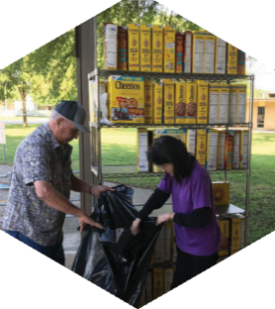

Pastor: Brice Mandaville
Associate Pastor: Josh Tylich
Youth Minister: Josh Graham
Minister of Music: Howard Hudiburg
Children’s/Volunteer Coordinator: Rhonda Hensarling

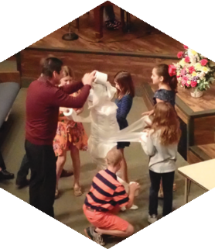
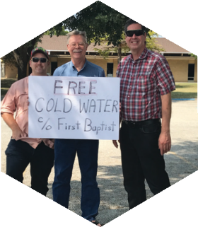

FIRST TIME HERE?
Text Welcome to
830-224-2046

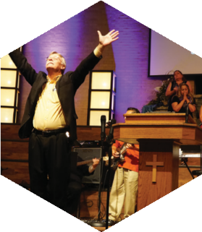

www.fbcseguin.org
830.379.4208
1314 E. Cedar St.

MORNING SERVICE
May 26, 2019 10:30 am

WELCOME/PRAYER Pastor Brice

DECLARATION OF PRAISE Congregation
Mine Eyes Have Seen the Glory (Hymn #633)
God of Our Fathers (Hymn #629)

SCRIPTURE – John 15: 1-8 Katy Hagerup

BLADES OF GRASS AND PURE WHITE STONES
Worship Choir

WORSHIP MEDLEY Congregation
This Is Amazing Grace
I Will Wait For You*

LESSONS FROM THE VINEYARD
Pastor Brice

RESPONDING TO GOD’S WORD Congregation
Softly and Tenderly (Hymn #312)

Offering
Prayer Greg Doss
O Praise the Name (Anástasis) Praise Team
BENEDICTION

* Children 4 years old thru First Grade dismissed for children’s worship following this song.

EVENING SERVICE
6:00 PM
Join us tonight for a traditional service of hymns and verse by verse preaching by Bro. Brice.

PROMOTION SUNDAY
JUNE 2
All children’s Sunday School classes will promote to the Next Grade, next Sunday! Students will need to be dropped off at their new class that morning. Please see the below criteria to familiarize yourself with where you student will need to be.
- One year olds to Two year old class if 2 by 09/01/2019
- Two year olds to Three year old class if 3 by 09/01/2019
- Three year olds to Four year old class if 4 by 09/01/2019
- Four year olds to Kinder class if the are beginning the school year.
All Kinder through Fifth grade students will promote to the next grade level according to their school grade level (i.e. second graders to the third grade class, etc.). Fifth graders will promote to Club 6 which meets in the Youth Building. Please see Rhonda Hensarling with any questions.

Congratulations, students, on another year well finished!

MORE INFORMATION
For more information about the church, please write your name and email address on one of the cards in the pews and place in the offering plate.

