GAME NIGHT
JUNE 13
Be sure to join us every second Thursday of the month for Game Night! We meet in the fellowship hall at 6:00 PM for games, food and fun. Bring your favorite card or board game, an entrée or appetizer to share and your game face! See you there.

BOUNCE 2019
Bounce is a student led recovery ministry helping those who have been affected by disaster. A group of youth and sponsors from our church are leaving tomorrow for the Houston area to help with the ongoing recovery from Hurricane Harvey. Please be in prayer this week for our students and sponsors as they travel, as they expose themselves to the possibly dangerous debris and as they work diligently. May they find a multitude of opportunities to share the Good News of Jesus Christ amongst the work.

VBS WORKER SNACK SHACK
JUNE 17 – 21
If you would like to provide snacks for the Vacation Bible School workers, please sign up on the sheet in the church foyer or in your Bible Fellowship Group. We need finger sandwiches, chips, dips, cookies, veggies, fruit, 2-liter sodas, bottled water, etc. You may bring the snacks to Room 200 (right across the hall from the kitchen) beginning on Sunday, June 16. If you put something in the kitchen, please label it "VBS Workers."

FIELD OF HONOR
JUNE 29 - JULY 6
This summer, Faith Lutheran Church will be hosting the "Field of Honor" in which American flags will be posted in their field adjacent to the highway in memory/honor of those in the military and first responders. If you would like to sponsor a flag for the event ($30), you may go to www.healingfield.org/seguin19/ or pick up an order form from the counter in the foyer. All proceeds from the sale of flags go to help SS American Memorial's "Camp Wounded Warrior" here in Seguin, a camp which hosts veterans from SAAMC and which we have assisted in the past.

PRETEEN CAMP @ CAMP TEJAS
JULY 13 – 16
Registration for Preteen Camp ends next Sunday, June 16. Be sure to stop by the counter in the kids building or see Rhonda Hensarling to have your child signed up! Final payments for Preteen camp will be due by Sunday, June 30, at the mandatory parents meeting. As always, we DO NOT want money to be the reason your child cannot experience this camp. Scholarships are available through the church office. Please see Rhonda Hensarling in the church office for more details.

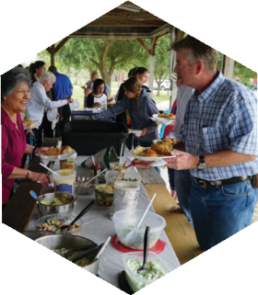
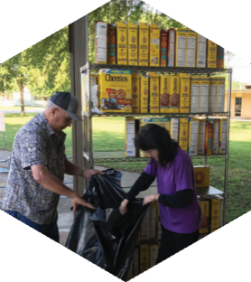

Pastor: Brice Mandaville
Associate Pastor: Josh Tylich
Youth Minister: Josh Graham
Minister of Music: Howard Hudiburg
Children’s/Volunteer Coordinator: Rhonda Hensarling

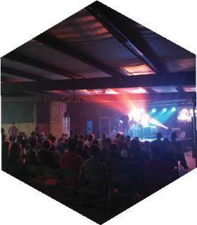
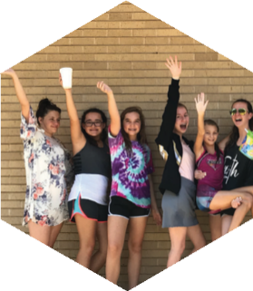
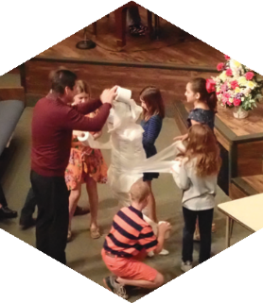
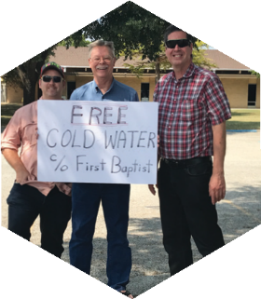

FIRST TIME HERE?
Text Welcome to
830-224-2046

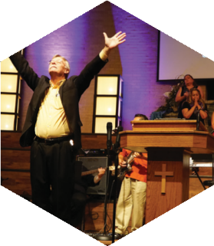

www.fbcseguin.org
830.379.4208
1314 E. Cedar St.

MORNING SERVICE
June 9, 2019 10:30 am

INTO THE WILD Video

WELCOME/PRAYER Pastor Brice

DECLARATION OF PRAISE Congregation
Open Up the Heavens
Revive Us Again (Hymn #469)

SCRIPTURE – John 6: 16 - 21 Josh Graham

GIDEONS BIBLE MINISTRY Milt Watson

WORSHIP MEDLEY Congregation
Open Up Our Eyes
Only King Forever*

MESSAGE: WHEN IS JESUS COMING BACK?
Pastor Brice

RESPONDING TO GOD’S WORD Congregation
Lord, I’m Coming Home (Hymn #309)

Offering
Prayer Ronnie Humphrey
Build My Life Lupe Gonzales
BENEDICTION

* Children 4 years old thru First Grade dismissed for children’s worship following this song.
Please join Holly Wrinkle and the praise team as they lead our worship this morning!

EVENING SERVICE
6:00 PM
We hope you will join us tonight for a traditional service of hymns and verse by verse preaching by Bro. Josh Tylich.

GIDEON BIBLE MINISTRY
We hare pleased to welcome back the Gideons to our church this morning to give a short presentation on their Bible Ministry. We will take an offering for them today and any loose cash in the offering plate will go toward the purchase of Bibles.

VACATION BIBLE SCHOOL
JUNE 17 - 21
Vacation Bible School (VBS) is for children who have completed pre-K through 5th grade. Our theme this year is “In the Wild” and registration has begun. There is still time to stop by the table in the foyer to fill out a form and pick up a t-shirt ($10) and music CD ($5). You can also register in the church office but please note, the office will not have the t-shirts or CDs to purchase. You will need to purchase those at the table in the foyer with the VBS directors.

FATHER’S DAY SERVICE
JUNE 16
We hope you will join us next Sunday for a special service dedicated to the dads of FBC. We will be honoring one dad in the congregation that morning with a special surprise. We invite all dads to come celebrate the morning with your church family.

For more information, write your name & email on the white card found in the few and place in the offering plate.

