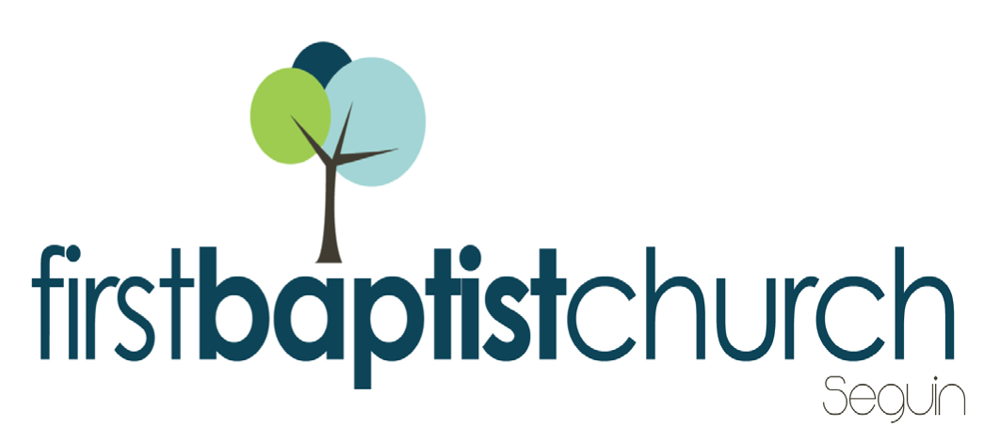
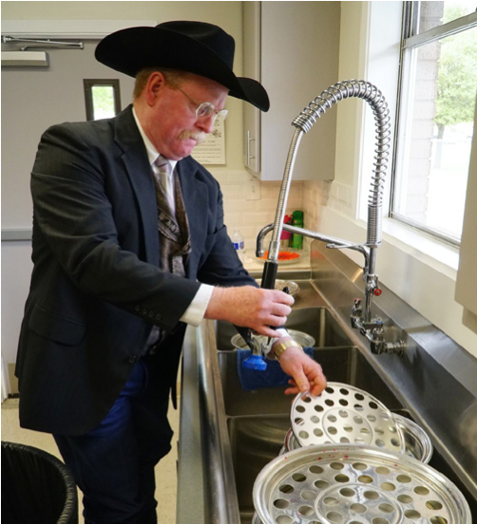
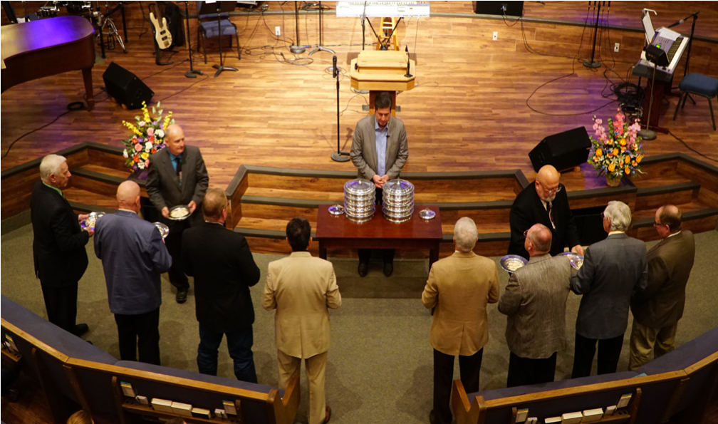
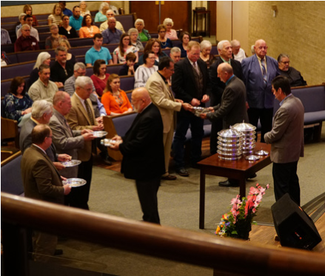
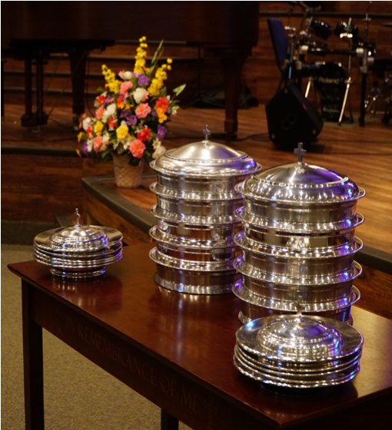
Welcome
WELCOME BACK CAMPERS!

LORD’S SUPPER
We will observe the Lord’s Supper (communion) at the end of the service this morning. All who have accepted Jesus Christ as their Savior are encouraged to participate. Gluten-free wafers are available in the foyer for those on restricted diets.

YOUTH MOVIE NIGHT
TOMORROW
Our trek through Disney’s greatest movies will resume tomorrow. All youth are welcome to come hang out and, yes, friends are welcomed (and encouraged) to join in the fun! Youth movie nights will continue through August 19. The youth Wednesday night program will begin after the start of the school year.

YOUTH SCHLITTERBAHN EVENT
JULY 27
The youth are headed to Schlitterbahn on the 27th of July! We have the potential for a group discount but will need to plan accordingly and in advance. A head count is needed no later than Wednesday, July 24. Please contact Joshua Graham if your students plan to attend. Students must come prepared to pay for their own ticket at regular price if we do not have enough people for the group discount. Appropriate swim attire will be required to be worn at all times for this church youth event. This means a one piece bathing suit for girls and proper swim trunks for boys (no blue jean cutoff shorts). Students will need to bring enough money for their ticket, and their own lunch/snacks, or money, to eat at the park. Contact Bro. Graham with any clarification questions and/or concerns.

KEENAGER’S LUNCHEON
AUGUST 5
Be sure to stop by the counter in the foyer to sign up for the August KeenAger’s luncheon. For anyone 55+, we meet every first Monday of the month in the fellowship hall for fun, fellowship and food! Table games and fellowship begin at 10:00 AM. A catered lunch is served at 11:30 AM followed by a short presentation by Karen Wallock with Meals on Wheels.

FIRST TIME HERE?
Text Welcome to
830-224-2046
www.fbcseguin.org
Pastor: Dr. Brice Mandaville
Associate Pastor: Josh Tylich
Minister of Music: Howard Hudiburg
Children’s/Volunteer Coordinator: Rhonda Hensarling

MORNING SERVICE
July 21, 2019 10:30 AM

WELCOME/PRAYER Pastor Brice

DECLARATION OF PRAISE Congregation
Revelation Song
Mighty to Save

SCRIPTURE - John 19: 31-37 Annabelle Bailey

HE NEVER LEFT ME Vincent Montez

WORSHIP MEDLEY Congregation
You Are My King
This I Believe (The Creed) *

THE SPEAR
Pastor Brice

RESPONDING TO GOD’S WORD Congregation
Have Thine Own Way, Lord (Hymn #294)

Offering
Prayer Joe Peoples
Offertory Medley Beth Henry

OBSERVANCE OF THE LORD’S SUPPER

BENEDICTION

* Children 4 years old thru First Grade dismissed for children’s worship following this song.
EVENING SERVICE
6:00 PM
Join us for a traditional service of hymns and verse by verse preaching tonight. Bro. Josh Graham will bring the message.

BUSINESS MEETING & ICE CREAM SOCIAL
NEXT SUNDAY
We will have a quarterly business meeting in place of our evening service, at 6:00 PM July 28, to discuss new members and the previous quarter’s financials. You are invited to join us for a time of fellowship over ice cream and a recap of the Lord’s work in and through our church.

ADULT SUNDAY SCHOOL TRAINING
AUGUST 10 & 11
Adult Sunday School leaders: mark your calendars, our next quarterly training will be held on August 11. We will gather in the Fellowship Hall for lunch following the morning worship service. The training, led by Ken Brady, Manager of Ongoing Bible Studies Groups Ministry for Lifeway, will begin shortly after noon. Ken will be showing us how we can breathe life back into our Sunday School Groups. Please note that this training is for Adult Bible Fellowship Group leaders only.

MORE INFORMATION
For more information about the church, please write your name and email address on one of the cards in the pews and place in the offering plate.

