GRAIN OFFERING
AUGUST 4
Make yourself a note! We will collect boxes of Cheerios the first Sunday in August – that is next Sunday – for the Christian Cupboard of Seguin. Each month we strive to donate a “grain offering” of 100 boxes of Cheerios to stock the shelves at the Cupboard as part of our continued outreach to the city of Seguin. You can bring one (or two) boxes of Cheerios and place them on the available shelves in the foyer to be delivered Monday, August 5.

KEENAGER’S LUNCHEON
AUGUST 5
Stop by the counter in the foyer to sign up for the August KeenAger’s luncheon. For anyone 55+, we meet every first Monday of the month in the fellowship hall for fun, fellowship and food! Table games and fellowship begin at 10:00 AM. A catered lunch is served at 11:30 AM followed by a short presentation by Karen Wallock with Meals on Wheels.

ADULT SUNDAY SCHOOL TRAINING
AUGUST 11
Adult Sunday School leaders: mark your calendars, our next quarterly training will be held on August 11. We will gather in the Fellowship Hall for lunch following the morning worship service. The training, led by Ken Brady, Manager of Ongoing Bible Studies Groups Ministry for Lifeway, will begin shortly after noon. Ken will be showing us how we can breathe life back into our Sunday School Groups. Please note that this training is for Adult Bible Fellowship Group leaders only.

BACK TO SCHOOL SPLASH
AUGUST 11 7:15 PM – 9:15 PM
We hope you will join us as we close out the summer in style! We have reserved the Seguin Wave Pool, located at 1 Wave Pool Drive, for our church families and guests. We encourage everyone to grab a friend and meet us there. The gate will open at 7:15 PM. Bring your lawn chairs and towels and don’t forget to bring something to snack on.

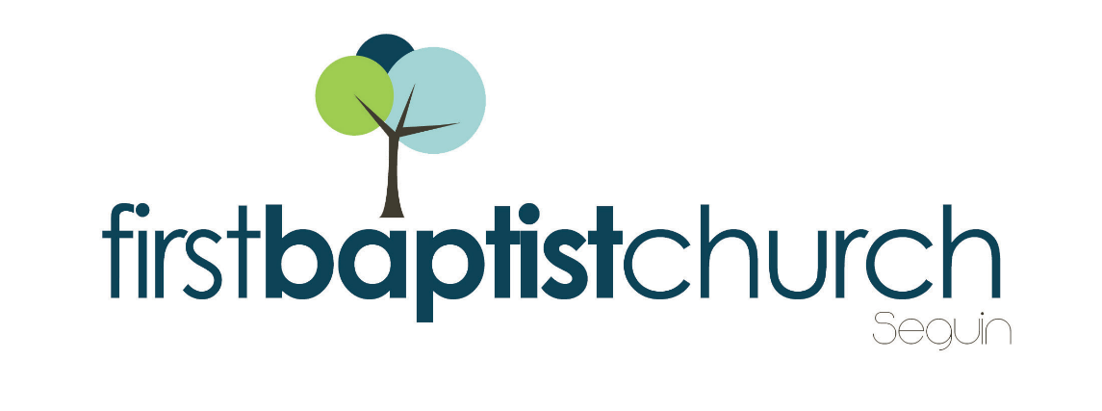
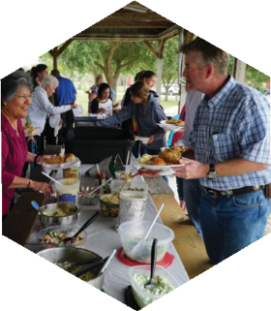
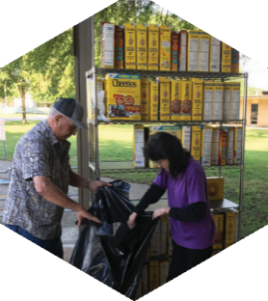

Pastor: Dr. Brice Mandaville
Associate Pastor: Josh Tylich
Minister of Music: Howard Hudiburg
Children’s/Volunteer Coordinator: Rhonda Hensarling

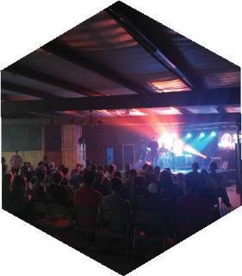
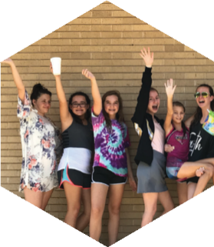
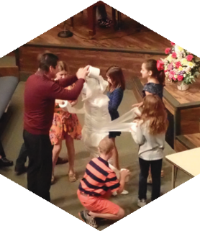
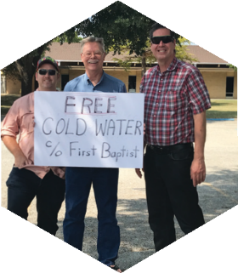

FIRST TIME HERE?
Text Welcome to
830-224-2046

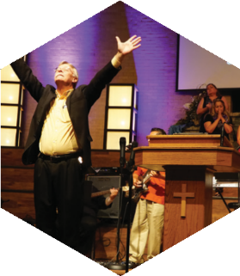

www.fbcseguin.org
830.379.4208
1314 E. Cedar St.

MORNING SERVICE
July 28, 2019 10:30 am

DECLARATION OF PRAISE Congregation
A Mighty Fortress Is Our God (Hymn #8)
Amazing Grace (My Chains Are Gone)

WELCOME/PRAYER Bro. Josh Tylich

SCRIPTURE - Philippians 4: 6-7 Garrett Sartain

WORSHIP MEDLEY Congregation
O Praise the Name (Anástasis)
Christ Is Risen *

OLD PRAYERS
Bro. Robby Partain

RESPONDING TO GOD’S WORD Congregation
Wherever He Leads I’ll Go (Hymn #285)

Offering
Prayer Travis Phillips
Hermoso Nombre Elisabet Doss

BENEDICTION

* Children 4 years old thru First Grade dismissed for children’s worship following this song.

BUSINESS MEETING & ICE CREAM SOCIAL
TONIGHT 6:00 PM
Please bring some homemade or store-bought ice cream tonight and join us in the Fellowship Hall. In place of our evening service, we will have our quarterly business meeting. Join us for a time of fellowship as we recap the Lord’s work in and through our church.

SEGUIN YOUTH SERVICES BACKPACK AND SUPPLIES
AUGUST 4 – 11
For the 12th year, First Baptist Church members have the opportunity to give a backpack filled with basic school supplies to a student who participates in the Seguin Youth Services (SYS) after-school program. On Sunday, August 4 and 11, student names will be available for signup in the foyer before and after the morning worship service. When you sign up for a student, you will be given a list of basic school supplies to purchase and instructions on how to complete your backpack donation. All completed backpacks must be back to the church by Sunday morning, August 18. On Monday, August 19, at 3:00 PM, SYS will host a back-to-school party where the backpacks will be given to the students. All church members are invited to attend and those who donated a backpack will have the chance to give that backpack to their student. SYS is located at 901 N. Guadalupe St.

MORE INFORMATION
For more information about the church, please write your name and email address on one of the cards in the pews and place in the offering plate.

