GRAIN OFFERING
You may place your boxes of Cheerios on the available shelves in the foyer. Thank you!

KEENAGER’S LUNCHEON
TOMORROW
Table games and fellowship begin at 10:00 AM. A catered lunch will be served at 11:30 AM, followed by a presentation at noon by Karen Wallock with Meals on Wheels.

GAME NIGHT
AUGUST 8 6:00 PM
We hope you will join us this Thursday for FBC Game night. Please bring an appetizer or entrée to share and your favorite board or card game. We play, we eat, we fellowship! Everyone is welcome! We hope to see you there.

BACK TO SCHOOL SPLASH
NEXT SUNDAY NIGHT 7:15 PM – 9:15 PM
We have reserved the Seguin Wave Pool, located at 1 Wave Pool Drive, for our church families and guests. We encourage everyone to grab a friend and meet us there. The gate will open at 7:15 PM. Bring your lawn chairs and towels and don’t forget to bring something to snack on.

YOUTH SUNDAY SCHOOL TRAINING
AUGUST 18
We will have a training session for all youth teachers, Sunday, August 18, immediately following the morning service. We will meet in the Youth building for lunch then enjoy Rick Henderson, Student Minister at First Baptist Church in San Antonio, as he leads the training portion of our afternoon. Please contact Bro. Josh Graham for more information.

FIRST BAPTIST CHURCH ENSEMBLES STARTUP
They’re back! The Ensembles of FBC will “fall” back into practice the first week of August! If you have a desire to make a joyful noise to the Lord, please consider one of the following ensembles to join.

Glory Singers (ages 55+) Monday, August 5 5:00 PM
Handbells (all ages) Monday, August 5 6:15 PM
Worship Choir Wed., August 7 6:00 PM
(High School+)

MORE INFORMATION
For more information about the church, please write your name and email address on one of the white cards in the pews and place in the offering plate. Any prayer requests may be written on the back.

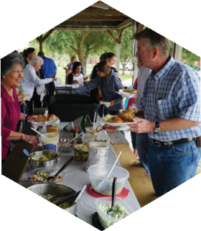
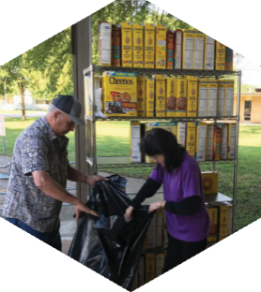

Pastor: Dr. Brice Mandaville
Associate Pastor: Josh Tylich
Youth Minister: Josh Graham
Minister of Music: Howard Hudiburg
Children’s/Volunteer Coordinator: Rhonda Hensarling

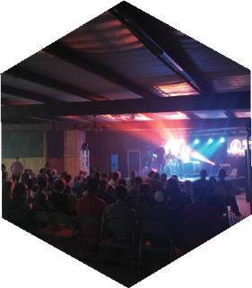
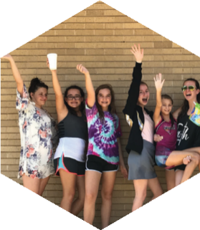
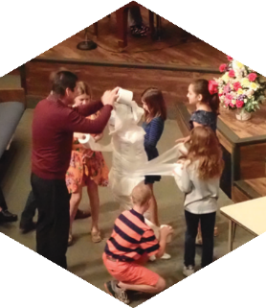
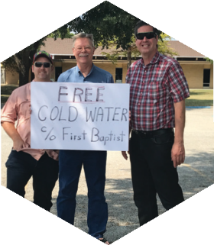

FIRST TIME HERE?
Text Welcome to
830-224-2046

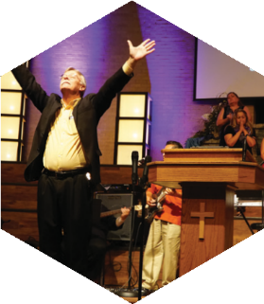

www.fbcseguin.org
830.379.4208
1314 E. Cedar St.

MORNING SERVICE
August 4, 2019 10:30 am

WELCOME/PRAYER Pastor Brice

DECLARATION OF PRAISE Congregation
Only King Forever
How Great Thou Art (Hymn #10)

SCRIPTURE – John 20:18-23 Bob Moore

BAPTISM

WORSHIP MEDLEY Congregation
Your Grace Finds Me
Good, Good Father *

I HAVE SEEN THE LORD Pastor Brice

RESPONDING TO GOD’S WORD Congregation
Jesus Is Tenderly Calling (Hymn #316)

Offering
Prayer Jim Ransdell
Always Praise Team

BENEDICTION

* Children 4 years old thru First Grade dismissed for children’s worship following this song.

EVENING SERVICE
6:00 PM
Join us tonight for a traditional service of hymns and verse by verse preaching. Bro. Brice will be beginning a three sermon series on the role of women in the church.

SEGUIN YOUTH SERVICES BACKPACK AND SUPPLIES
TODAY – AUGUST 18
For the 12th year, First Baptist Church members have the opportunity to give a backpack filled with basic school supplies to a student who participates in the Seguin Youth Services (SYS) after-school program. Today and next Sunday, student names will be available for signup in the foyer before and after the morning worship service. When you sign up for a student, you will be given a list of basic school supplies to purchase and instructions on how to complete your backpack donation. All completed backpacks must be back to the church by Sunday morning, August 18. On Monday, August 19, at 3:00 PM, SYS will host a back-to-school party where the backpacks will be given to the students. All church members are invited to attend to meet and give your chosen student their backpack. SYS is located at 901 N. Guadalupe St.

ADULT SUNDAY SCHOOL TRAINING
AUGUST 11
Adult Sunday School leaders: mark your calendars, our next quarterly training will be held next Sunday. We will gather in the Fellowship Hall for lunch following the morning worship service. The training, led by Ken Brady, Manager of Ongoing Bible Studies Groups Ministry for Lifeway, will begin shortly after noon. Please note that this training is for Adult Bible Fellowship Group leaders only.

