ADULT SUNDAY SCHOOL TRAINING
TODAY
We will gather in the Fellowship Hall for lunch following the morning worship service. The training, led by Ken Brady, Manager of Ongoing Bible Studies Groups Ministry for Lifeway, will begin shortly after noon. Please note that this training is for Adult Bible Fellowship Group leaders only.

YOUTH SUNDAY SCHOOL TRAINING
AUGUST 18
We will have a training session for all youth teachers, next Sunday immediately following the morning service. We will meet in the Youth building for lunch and Rick Henderson, Student Minister at First Baptist Church in San Antonio will be our speaker. Please contact Bro. Josh Graham if you cannot attend.

YOUTH EVENT AT FIESTA TEXAS
AUGUST 17
The youth are planning a summer close out trip to Six Flags Fiesta Texas this Saturday, August 17. This will be another all day event. Chaperones are always encouraged and needed. If you and/or your student would like to participate, please call, text or email Bro. Graham (joshgraham@fbcseguin.org / 713-299-7665). With 15 people or more, we will qualify for the group discount on tickets, so the more the merrier. We will meet at the main gate at 10:30 AM in San Antonio. Please bring money for your ticket and for food inside (coolers/picnics are not permitted). We will be staying only in the theme park areas – no bathing suits needed.
Students please be aware that a dress code is in place for this event as per the park rules but also as a representative of our church. Guys: no graphic tees or cut up clothing; Ladies: no graphic tees, no cut up clothing & no undergarment revealing shirts or excessively short shorts. Wear comfortable footwear and bring your sunscreen! We are looking forward to seeing you there! You may contact Bro. Josh Graham with any questions or concerns.

BACK TO SCHOOL
We encourage everyone to be in prayer for the students, faculty and staff returning to school in the coming weeks. Please be in prayer for a fantastic and safe school year!

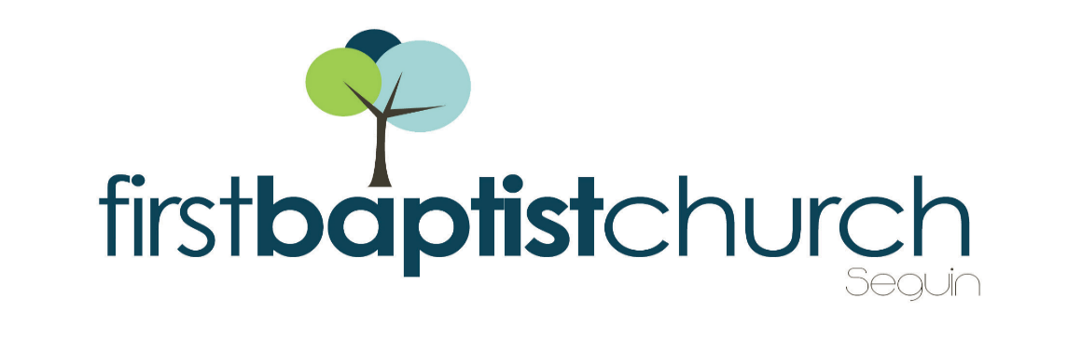
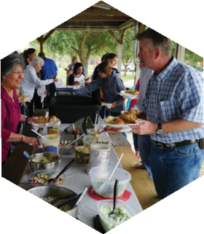
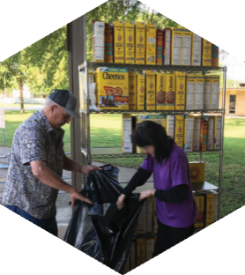
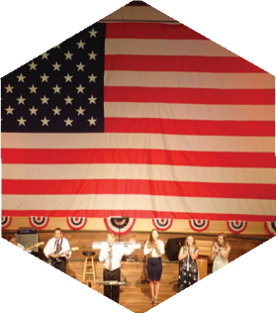

Pastor: Dr. Brice Mandaville
Associate Pastor: Josh Tylich
Youth Minister: Josh Graham
Minister of Music: Howard Hudiburg
Children’s/Volunteer Coordinator: Rhonda Hensarling

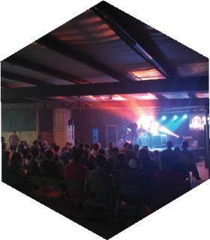
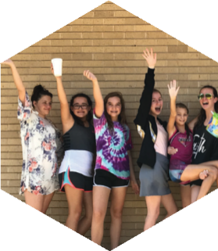
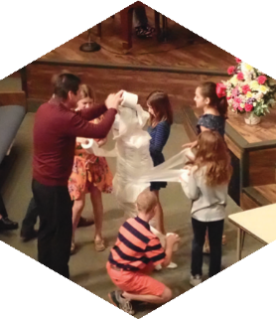
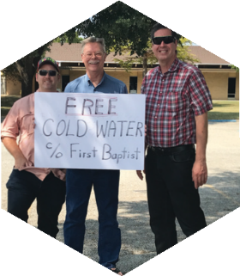

FIRST TIME HERE?
Text Welcome to
830-224-2046

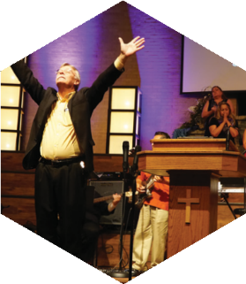

www.fbcseguin.org
830.379.4208
1314 E. Cedar St.

MORNING SERVICE
August 11, 2019 10:30 am

DECLARATION OF PRAISE Congregation
Better Is One Day
Stronger

SCRIPTURE – John 21:15-22 Travis Phillips

VIDEO: “We are immortal until our task is done”

WELCOME/PRAYER Pastor Brice

WORSHIP MEDLEY Congregation
Great Is the Lord (Hymn #12)
Mercy *

MESSAGE: Following Jesus when It becomes Costly
Pastor Brice

RESPONDING TO GOD’S WORD Congregation
Just As I Am (Hymn #307)

Offering
Prayer Whitney Reese
Jesus Paid It All (Hymn #134) Praise Team

BENEDICTION

* Children 4 years old thru First Grade dismissed for children’s worship following this song.

NO EVENING SERVICE

BACK TO SCHOOL SPLASH
TONIGHT 7:15 PM – 9:15 PM
We hope you will us join this evening as we close out the summer in style! We have reserved the Seguin Wave Pool, located at 1 Wave Pool Drive, for our church families and guests. We encourage everyone to grab a friend and meet us there. The gate will open at 7:15 PM. Bring your lawn chairs and towels and don’t forget to bring something to snack on.

SEGUIN YOUTH SERVICES BACKPACK AND SUPPLIES
LAST DAY TO PICK UP - TODAY
For the 12th year, First Baptist Church members have the opportunity to give a backpack filled with basic school supplies to a student who participates in the Seguin Youth Services (SYS) after-school program. We have a few student names still available for signup in the foyer. Stop by today. All completed backpacks must be back to the church next Sunday morning, August 18. On Monday, August 19, at 3:00 PM, SYS will host a back-to-school party where the backpacks will be given to the students. All church members are invited to attend, and those who donated a backpack will have the chance to give that backpack to their student. SYS is located at 901 N. Guadalupe St.

MORE INFORMATION
For more information about the church, please write your name and email address on one of the cards in the pews and place in the offering plate. Any prayer requests may be written on the back of the card as needed.

