YOUTH TEACHER SUNDAY SCHOOL TRAINING
TODAY
We will have a training session for all youth teachers immediately following the morning service. We will meet in the Youth building for lunch and Rick Henderson, Student Minister at First Baptist Church in San Antonio will be our speaker.

YOUTH MOVIE NIGHTS
AUGUST 19
Calling all students 6th – 12th grade: tomorrow is our last movie night of the summer! We will be watching yet another fantastic Disney movie and hanging out. As always there will be sugar & fun. We hope to see you there – footie pajamas are highly encouraged!

CHILDREN’S MISSIONS KICKOFF
SEPTEMBER 4
We will have a kickoff for Wednesday night missions and choir for 4 year old (by Sept. 1, 2019) through 6th grade, from 5:30-6:30 in the fellowship hall, Sept. 4. Unlike previous years, the preschoolers will also meet in the fellowship hall. Come enjoy games and refreshments and learn about our exciting year. Our theme for the year is “GO FOR IT!” Parents must come to register their children and remain with them as they play games.

WOMEN’S BIBLE STUDIES
Three of our four women’s bible study classes will resume their studies in September. Wednesday women’s bible study, led by Frieda Savage, is currently going through a study on the women of the bible. Tuesday morning study, led by Lisa Robbins, will begin Sept. 10 with a study on Gideon. Thursday morning study, led by Kay Rhodes, will begin Sept. 12 with a study on Hebrews. Thursday evening Mom’s study, led by Rhonda Hart, will begin Sept. 5 with a study on life and responding when things just don’t go the way we plan. For times and meeting rooms, please call the church office and stay tuned for future announcements.

CHURCH CHOIRS
Just a reminder that all of our church ensembles and choirs have started up. Glory Singers & Handbells meet on Mondays, and Worship choir meets on Wednesdays. Come make a joyful noise with us! Please contact Howard Hudiburg if you would be interested in either choir at howardfbcseguin@gmail.com.

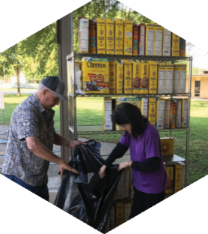

Pastor: Dr. Brice Mandaville
Associate Pastor: Josh Tylich
Youth Minister: Josh Graham
Minister of Music: Howard Hudiburg
Children’s/Volunteer Coordinator: Rhonda Hensarling

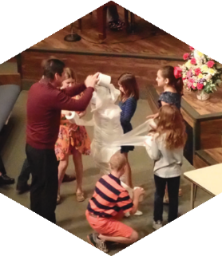
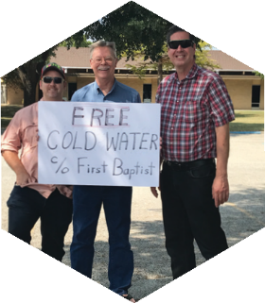

FIRST TIME HERE?
Text Welcome to
830-224-2046

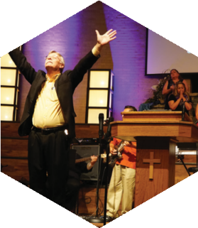

www.fbcseguin.org
830.379.4208
1314 E. Cedar St.

MORNING SERVICE
August 18, 2019 10:30 am

WELCOME/PRAYER Bro. Brice

DECLARATION OF PRAISE Congregation
10,000 Reasons
Come As You Are

SCRIPTURE – II Corinthians 1:1-14 Camdyn Mikes

NEWS FROM CENTRAL ASIA

WORSHIP MEDLEY Congregation
Open Up Our Eyes
O Come to the Altar *

MESSAGE: LIFE IN THE PRESSURE COOKER
Pastor Brice

RESPONDING TO GOD’S WORD Congregation
Jesus Is Lord of All (Hymn #296)

Offering
Prayer Allen Rhodes
Living Hope Praise Team

PRAYER FOR THOSE RETURNING TO SCHOOL

* Children 4 years old thru First Grade dismissed for children’s worship following this song

EVENING SERVICE
6:00 PM
Join us tonight for a traditional service of hymns and verse by verse preaching. Bro. Brice will be continuing his sermon series on the woman’s role in the church.

SEGUIN YOUTH SERVICES BACKPACK AND SUPPLIES
All completed backpacks must be back to the church today. Tomorrow, August 19, at 3:00 PM, SYS will host a back-to-school party where the backpacks will be given to the students. All church members are invited to attend, and those who donated a backpack will have the chance to give that backpack to their student. SYS is located at 901 N. Guadalupe St.

BACK TO SCHOOL PRAYER WALK
Following the morning service, the pastor invites you to join him in prayer walking at Seguin High School in preparation for the upcoming school year. Afterwards he will be travelling to Navarro and Marion to prayer walk at those schools as well.

MORE INFORMATION
For more information about the church, please write your name and email address on one of the cards in the pews and place in the offering plate. Any prayer requests may be written on the back of the card as needed.

