GRAIN OFFERING
NEXT SUNDAY
Next Sunday is our monthly collection of Cheerios. We collect to stock the shelves at the Christian Cupboard, here in town, to aid in their outreach to the city of Seguin. Please bring one or two boxes of Cheerios to place on the shelves in the church foyer.

CHURCH OFFICE/CAMPUS CLOSED
SEPTEMBER 2
The church office and campus will be closed September 2 in observance of Labor Day. The campus will be open, regular hours, beginning Tuesday and continuing through the remainder of the week.

CHILDREN’S MISSIONS KICKOFF
SEPTEMBER 4
We will have a kickoff for Wednesday night missions and choir for 4 year old (by Sept. 1, 2019) through 6th grade, from 5:30-6:30 in the fellowship hall, Sept. 4. Unlike previous years, the preschoolers will also meet in the fellowship hall. Come enjoy games and refreshments and learn about our exciting year. Our theme for the year is “GO FOR IT!” Parents must come to register their children and remain with them as they play games.

WOMEN’S BIBLE STUDIES
Ladies we have multiple options available for you to get connected with God’s Word and each other.
- Wednesday evening bible study, led by Frieda Savage, is currently going through a study on the women of the bible in bldg. 3, at 6:00 PM.
- Tuesday morning study, led by Lisa Robbins, will begin Sept. 10, in the Fellowship Hall at 9:00 AM with a study on Gideon by Priscilla Shirer.
- Thursday morning study, led by Kay Rhodes, will begin Sept. 12 , in the Fellowship Hall at 9:30 AM with a study on the book of Hebrews.
- Thursday evening Mom’s study, led by Rhonda Hart, will begin Sept. 5, in the Youth building at 6:30 PM with a study called “It’s Not Supposed to Be This Way” by Lysa Terkeurst.
Please see the individual class leaders for a study guide. New to bible study? We welcome your questions – please call the church office with any questions and/or concerns.

CHURCH CHOIRS
Just a reminder that all of our church ensembles and choirs have started up. Glory Singers & Handbells meet on Mondays, and Worship choir meets on Wednesdays. Come make a joyful noise with us! Please contact Howard Hudiburg if you would be interested in either choir at howardfbcseguin@gmail.com.

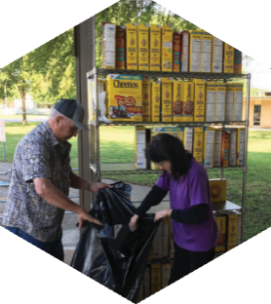

Pastor: Dr. Brice Mandaville
Associate Pastor: Josh Tylich
Youth Minister: Josh Graham
Minister of Music: Howard Hudiburg
Children’s/Volunteer Coordinator: Rhonda Hensarling

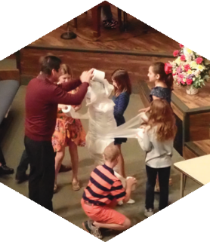
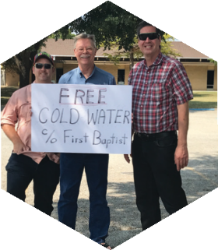

FIRST TIME HERE?
Text Welcome to
830-224-2046

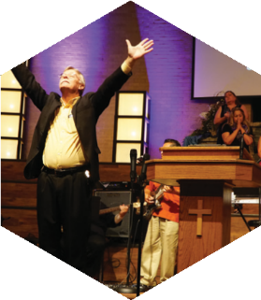

www.fbcseguin.org
830.379.4208
1314 E. Cedar St.

MORNING SERVICE
August 25, 2019 10:30 am

DECLARATION OF PRAISE Congregation
Praise to the Lord, the Almighty (Hymn #14)
Holy Spirit

WELCOME/PRAYER Bro. Brice

SCRIPTURE – II Corinthians 1: 19-22 Sidney Scott

WORSHIP MEDLEY Congregation
Standing on the Promises (Hymn #335)
I Will Wait For You *

GOD ALWAYS KEEPS HIS PROMISES
Pastor Brice

RESPONDING TO GOD’S WORD Congregation
Wherever He Leads I’ll Go (Hymn #285)

Offering
Prayer Raymond Schubert
Days of Elijah Praise Team

BENEDICTION

* Children 4 years old thru First Grade dismissed for children’s worship following this song.

EVENING SERVICE
6:00 PM
Join us tonight for a traditional service of hymns and verse by verse preaching. Bro. Tylich will be bringing the message tonight.

SERVICE OPPORTUNITY
SEPTEMBER 6 7:00 PM
Looking for a way to get involved and impact your community? Friday, September 6 we will gather to wash the windshields of the cars parked in our lots for the Seguin High School football game that night. This is a fun and easy outreach to our community and those visiting for the game. Children & students are encouraged to join in the fun. If you would be interested in helping, please write “windows,” your name and contact number on the blue serving card (found in the pew) and place it in the offering plate.

KEENAGER’S LUNCHEON
SEPTEMBER 9
Please note the date! In observance of Labor Day, the monthly KeenAger’s luncheon will be moved to September 9. Table games and fellowship will begin at 10:00 AM followed by lunch at 11:30 AM and an informational presentation at noon. Sign up today in the church foyer.

MORE INFORMATION
For more information about the church, please write your name and email address on one of the cards in the pews and place in the offering plate. Any prayer requests may be written on the back of the card as needed.

