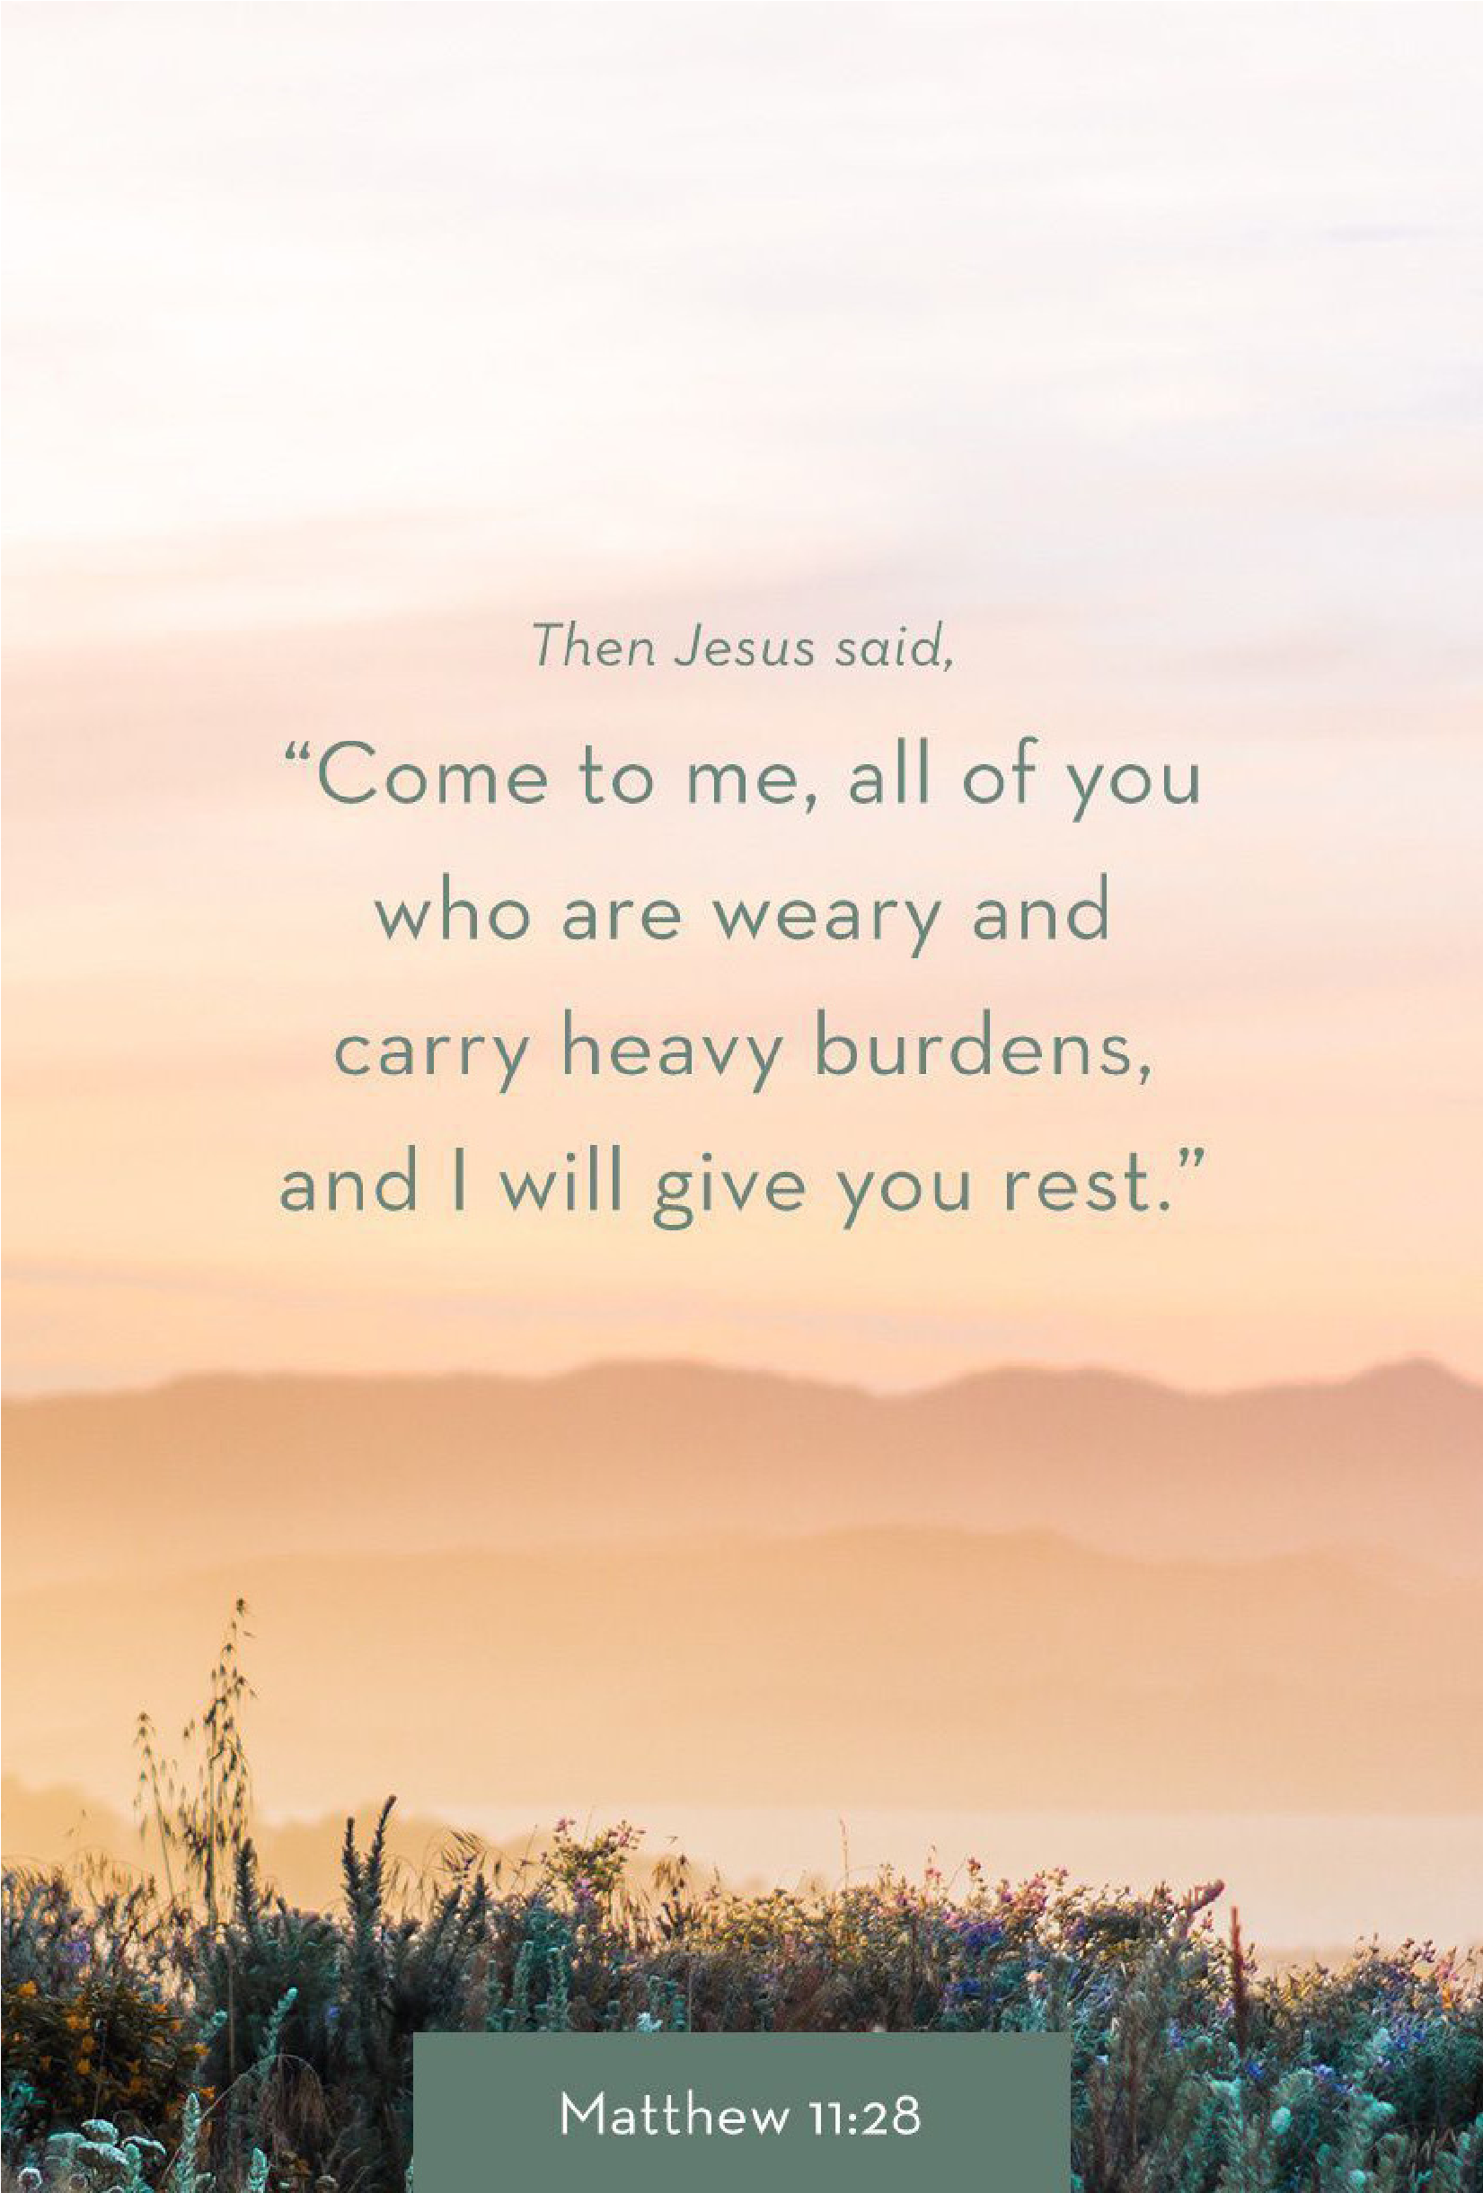
1314
E. Cedar Seguin, Tx
78155 830-379-4208
www. fbcseguin.org
COWBOY BREAKFAST
SEPTEMBER 15 COURTYARD 8:30 – 9:30 AM
Join us bright and early Sunday, September 15th for our annual Cowboy Breakfast. We will enjoy cowboy-sized breakfast tacos as well as games and fun for adults and kids alike. There will be music and fellowship, horses and trains. All the fixins for a wonderful time! We hope to see you there.

CHILDREN’S MISSIONS KICKOFF
SEPTEMBER 4 FELLOWSHIP HALL 5:30 – 6:30 PM
Come enjoy games and refreshments and learn about our exciting year. Our theme this year: “GO FOR IT!”

STATE MISSIONS WEEK OF PRAYER & OFFERING
SEPTEMBER 8-15
Next Sunday begins our Texas Missions week of prayer and offering, also known as the Mary Hill Davis Offering. Please be in prayer about what God would have you give to the ministries impacting our great state.

MEN’S PRAYER BREAKFASTS
SEPTEMBER 10 6:30 AM
And, we’re back! We invite all men available, to join us on even numbered Tuesday mornings for a Men’s Prayer Breakfast. Bro. Brice will be making breakfast and leading a short devotional, followed by a time of prayer and encouragement.

BAPTIST STUDENT MINISTRY LUNCHEON
SEPTEMBER 18
Once again, this September, we will host a luncheon for the students at the Baptist Student Ministry in San Marcos. Peggy Graxiola and crew are planning a sloppy joe lunch complete with chips and cookies, but we need cookies! Please bring your cookie donations to the church no later than September 17. Any cookies you choose will be perfect. Please label them BSM and leave them in the church kitchen. Your support of this ministry is appreciated.

RISE AGAINST HUNGER: MEALS WITH IMPACT
OCTOBER 19 9:00 AM
Rise Against Hunger is an organization dedicated to ending world hunger by 2030 and they are doing it one pre-packaged meal at a time. We are honored to have partnered with them to do our part in helping their ministry. Saturday, October 19, we will have a boxing day; packaging and preparing for shipment 1000 meals. We are looking for volunteers to help. Children are welcome to come help, so sign up the family! If you would like to donate to this ministry, please write “Rise Against Hunger” on your envelope & check. If you are interested in volunteering for the boxing day, please fill out the blue service card, found in the pew, and place it in the offering plate.

Senior Pastor: Brice Mandaville
Associate Pastor: Josh Tylich
Youth Pastor: Josh Graham
Minister of Music: Howard Hudiburg
Children’s/Volunteer Coordinator: Rhonda Hensarling

MORNING SERVICE
September 1, 2019 10:30 am

DECLARATION OF PRAISE Congregation
This I Believe (The Creed)
Be Thou My Vision (Hymn #60)

SCRIPTURE – II Corinthians 2:1-10 Bill Brown

OVERCOMER

WELCOME/PRAYER Bro. Brice

WORSHIP MEDLEY Congregation
Open Up the Heavens
Forever (We Sing Hallelujah)*

UNCOMFORTABLE CONVERSATIONS:
SPEAKING THE TRUTH IN LOVE
Pastor Brice

RESPONDING TO GOD’S WORD Congregation
Savior, Like a Shepherd Lead Us (Hymn #61)

Offering
Prayer David Smith
Victory in Jesus (Hymn #426) Praise Team

BENEDICTION

* Children 4 years old thru First Grade dismissed for children’s worship following this song.
OVERCOMER
TONIGHT AT 7:00 PM
In place of our service tonight, we’d like to encourage everyone to join us at the King Ranger theater for a 7:00 PM showing of “Overcomer” – the new movie by the Kendrick Bros. Tickets are $6 for adults and $4 for children.

GRAIN OFFERING
Today is our monthly collection of Cheerios. Please place your boxes of Cheerios on the shelves in the church foyer.

CHURCH OFFICE/CAMPUS CLOSED
SEPTEMBER 2
The church office and campus will be closed tomorrow in observance of Labor Day. The campus will be open, regular hours, beginning Tuesday and continuing through the remainder of the week.

SERVICE OPPORTUNITY
SEPTEMBER 6 7:00 PM
Looking for a way to get involved and impact your community? This Friday we will gather to wash the windshields of the cars parked in our lots for the Seguin High School football game. This is a fun and easy outreach to our community and those visiting for the game. Children & students are encouraged to join in the fun. If you would be interested in helping, please write “windshields,” your name and contact number on the blue service card (found in the pew) and place it in the offering plate.

KEENAGER’S LUNCHEON
SEPTEMBER 9
Please note the date! In observance of Labor Day, the monthly KeenAger’s luncheon will be moved to September 9. Table games and fellowship will begin at 10:00 AM followed by lunch at 11:30 AM and a mini concert by Dottsy Dwyer & Marianne Hudiburg at noon. Sign up today in the church foyer.

MORE INFORMATION
For more information about the church, please write your name and email address on one of the cards in the pews and place in the offering plate.

