SERVICE OPPORTUNITY
SEPTEMBER 28
We have partnered, once again, with the Seguin High School Band Boosters for their 3rd annual band competition. Our church will serve as their competition day hub and they need volunteers to prepare, box and deliver food for/to the visiting bands. This is a great way to represent our church in serving the community and those visiting. If you’d be interested in helping, please write “SHS” on the blue serving card, found in the pew, and place it in the offering plate.

PRESCHOOL KIDS EVENT @ J&R GYMNASTICS
SEPTEMBER 29 5:00 – 6:30 PM
This event is for children, babies – kindergarten, and their parents. We have reserved the mats at J&R Gymnastics for our church families to enjoy. “Playnastics” will be from 5:00 PM – 6:00 PM and afterwards we will indulge in a time of fellowship over pizza before heading home! Parents will need to stay with their kids as they play. J&R is located at 1307 Court St. – across from the TLU Campus.

MEN’S PRAYER BREAKFAST
SEPTEMBER 24 6:30 AM
We invite all men available to join us for breakfast and bible study, first thing Tuesday morning. This is a time of fellowship and reverent prayer for all. We hope you will join us.

“SAW” YOU AT THE POLE
SEPTEMBER 25
This is an event for all area students 6th – 12th grade to gather for fellowship, worship and prayer. We will meet at Hillcrest church 6:30 PM for pizza and games, worship and prayer will begin at 7:00 PM. The program will end at 8:00 PM. Parents, please drop off and pick up your students at Hillcrest church as we will not be providing transportation.

STATE MISSIONS OFFERING
SEPTEMBER 2019
This offering goes to help plant churches across the state, as well as to meet practical needs such as hurricane relief, lodging for family members to visit those in prison, youth camps, and feeding the hungry. Please write “state missions” on your offering envelope if you would like to make a gift to this cause.

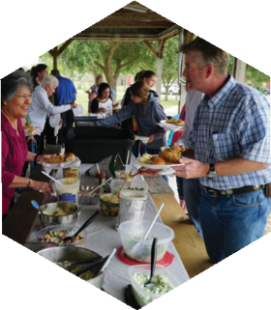
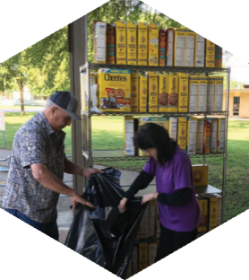

Pastor: Dr. Brice Mandaville
Associate Pastor: Josh Tylich
Youth Minister: Josh Graham
Minister of Music: Howard Hudiburg
Children’s/Volunteer Coordinator: Rhonda Hensarling

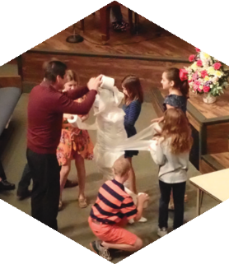
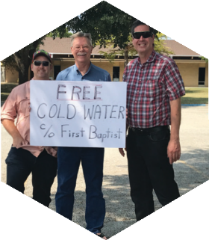

FIRST TIME HERE?
Text Welcome to
830-224-2046

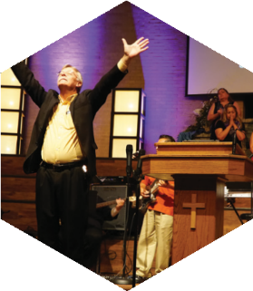

www.fbcseguin.org
830.379.4208
1314 E. Cedar St.

MORNING SERVICE
September 22, 2019 10:30 am

DECLARATION OF PRAISE Congregation
Doxology (Hymn #253)
Days of Elijah
Your Grace Finds Me

SCRIPTURE - Luke 23: 39-43 Jini Etten

WELCOME/PRAYER Brother Josh Tylich

WORSHIP MEDLEY Congregation
God of This City
For You Are Holy*

The Man That Wanted A Second Chance
Herman Cramer

RESPONDING TO GOD’S WORD Congregation
Just As I Am (Hymn #307)

Offering
Prayer Bruce Allen
Good, Good Father Praise Team

BENEDICTION

* Children 4 years old thru First Grade dismissed for children’s worship following this song.

The flowers are placed today in celebration of Elisabet Doss’ birthday and 18th wedding anniversary.
EVENING SERVICE
6:00 PM
Join us this evening for a traditional service of hymns and preaching. Bro. Cramer will bring the sermon tonight.

CHILD DEDICATION
SEPTEMBER 29
We will have a short dedication service Sunday, Sept. 29 during the morning service. Parents who dedicate their children are making a promise to the Lord to do everything in their power to raise the child in a godly way. Please provide two digital pictures of your child (alone and with you - their parents) to Rhonda Hensarling if you wish to participate. Pictures are due tomorrow, Sept. 23.

WEDNESDAY MEALS
4:30 – 6:00 PM
We would like to encourage everyone to join us Wednesday afternoons in the Fellowship Hall for dinner! Meals are $5/plate with a $15 cap on families of 4 or more. A signup sheet along with a menu is available in the church foyer on the counter each week. As these are catered meals, please be sure to sign up for the meal by 5:00 PM the Monday prior to the meal.

RISE AGAINST HUNGER: MEALS WITH IMPACT
OCTOBER 19 9:00 AM
Rise Against Hunger is an organization dedicated to ending world hunger and they are doing it one pre-packaged meal at a time. We are honored to have partnered with them to help in their ministry. Saturday, October 19, we will have a boxing day; packaging and preparing 14,000 meals for shipment and we are looking for volunteers! Children are welcome to come help. If you are interested, please fill out the blue service card, found in the pew, and place it in the offering plate.

