PRESCHOOL KIDS EVENT @ J&R GYMNASTICS
TONIGHT 5:00 – 6:30 PM
This event is for children, babies – kindergarten, and their parents. We have reserved the mats at J&R Gymnastics for our church families to enjoy. “Playnastics” will begin at 5:00 PM. Parents will need to stay with their kids as they play.

WEDNESDAY KIDS MISSIONS FOOD DRIVE
OCTOBER 2019
Wednesday night mission kids are collecting canned food for the Christian Cupboard during the month of October. The kids can bring cans any Wednesday night or Sunday morning to Building 1 and the church family will find boxes in each building during October if they would like to help.

KEENAGER’S LUNCHEON
OCTOBER 7
Don’t miss your opportunity to sign up for the October KeenAger’s Luncheon. Table games and fellowship begin at 10 AM with a catered lunch served at 11:30. At noon, we will hear from Shirley Loeffelholz with an update on her Nicaragua sewing ministry. Stop by the foyer counter and sign up today!

GAME NIGHT
OCTOBER 10 6:00 PM
Join us in the fellowship hall, Thursday, October 10 for Game Night. Bring your favorite board or card game, an appetizer or entrée to share and join the fun.

THE LORD’S SUPPER
OCTOBER 13
We will observe the Lord’s Supper at the end of the morning worship service Sunday, October 13. We invite all who have accepted Jesus Christ as their Savior to join us as we partake of the elements. There will be gluten free wafers available to those on restricted diets.

FALL-O-WEEN JESUS G-FORCE EVENT
OCTOBER 27 4:30 – 6:00 PM
Join us for our second annual Fall Festival event, Fall-O-Ween (Following) Jesus. This event is for students 1st – 5th grades and their parents. There will be games, pictures, and…what fall event would be complete without candy? Grab a friend and meet us for Jesus and fun!

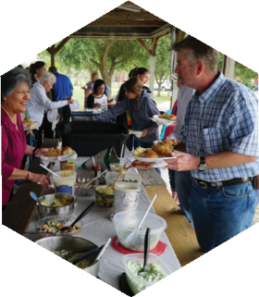
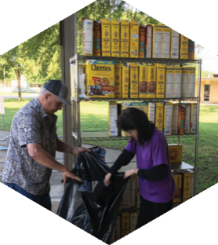
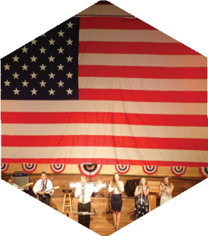

Pastor: Dr. Brice Mandaville
Associate Pastor: Josh Tylich
Youth Minister: Josh Graham
Minister of Music: Howard Hudiburg
Children’s/Volunteer Coordinator: Rhonda Hensarling

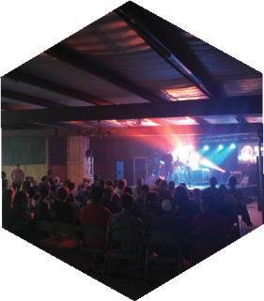
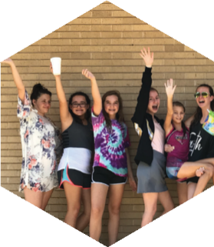
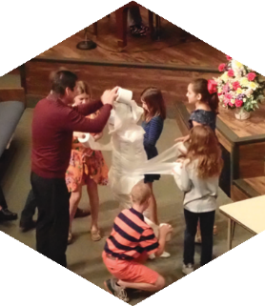
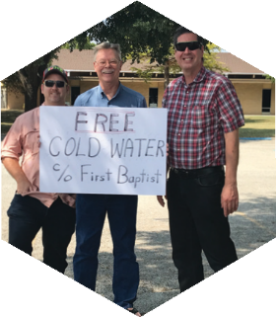

FIRST TIME HERE?
Text Welcome to
830-224-2046

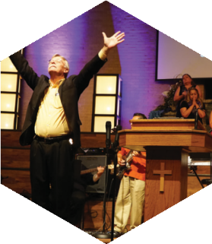

www.fbcseguin.org
830.379.4208
1314 E. Cedar St.

MORNING SERVICE
September 29, 2019 10:30 am

WELCOME Pastor Brice

PRAYER Jeremy Hamilton

SONG MEDLEY Congregation
Jesus Loves Me
This Little Light of Mine
If You’re Happy and You Know It

PARENT/CHILD DEDICATION

WORSHIP MEDLEY Congregation
Amazing Grace (Hymn #330)
Stronger

SCRIPTURE: II Cor 5: 16-21 Reagan Holdman

MESSAGE: “Helping Others be Reconciled to God” Pastor Brice

RESPONDING TO GOD’S WORD Congregation
Standing on the Promises (Hymn #335)

Offering
Prayer David Anderson
The Lion and the Lamb Praise Team

There will be no Children’s Church or Sermon this morning. All children are encouraged to remain in the service.

EVENING SERVICE
6:00 PM
Join us this evening for a traditional service of hymns and preaching. Bro. Tylich will bring the sermon tonight.

GRAIN OFFERING
OCTOBER 6
Remember to bring your Cheerio boxes for our monthly grain offering, next Sunday, October 6. Each month we strive to collect 100 boxes of Cheerios to stock the shelves at the Christian Cupboard for the month.

RISE AGAINST HUNGER: MEALS WITH IMPACT
OCTOBER 19 9:00 AM
Rise Against Hunger is an organization dedicated to ending world hunger and they are doing it one pre-packaged meal at a time. We are honored to have partnered with them to help in their ministry. Saturday, October 19, we will have a boxing day; packaging and preparing 14,000 meals for shipment and we are still looking for volunteers! Children are welcome to come help. If you are interested, please fill out the blue service card, found in the pew, and place it in the offering plate.

WEDNESDAY MEALS
4:30 – 6:00 PM
We would like to encourage everyone to join us Wednesday afternoons in the Fellowship Hall for dinner! Meals are $5/plate with a $15 cap on families of 4 or more. A signup sheet along with a menu is available in the church foyer on the counter each week. As these are catered meals, please be sure to sign up for the meal by 5:00 PM the Monday prior to the meal.

