GRAIN OFFERING
TODAY
Please place your offering on the shelves available in the church foyer.

KEENAGER’S LUNCHEON
OCTOBER 7
Table games and fellowship begin at 10 AM with a catered lunch served at 11:30. At noon, we will hear from Shirley Loeffelholz with an update on her Nicaragua sewing ministry.

MEN’S PRAYER BREAKFAST
THIS TUESDAY - OCTOBER 8 – 6:30 AM
All available men are encouraged to join us this Tuesday in the Fellowship Hall for a home cooked breakfast and a time of prayer as we go through a study of living “Radical” for Jesus.

GAME NIGHT
OCTOBER 10 6:00 PM
Join us in the fellowship hall, Thursday, October 10 for Game Night. Bring your favorite board or card game, an appetizer or entrée to share and join the fun.

FALL-O-WEEN JESUS G-FORCE EVENT
OCTOBER 27 4:30 – 6:00 PM
Join us for our second annual Fall Festival event, Fall-O-Ween (Following) Jesus. This event is for students 1st – 5th grades. Grab a friend and come celebrate Fall and following Jesus with lots of fun games. Parents we encourage you to stay for the quarterly business meeting and meal in the Fellowship Hall upon picking up your child.

Scan the code above for more information on church events

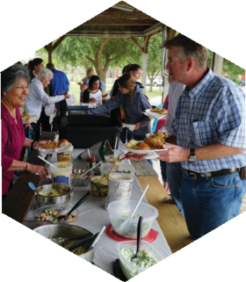
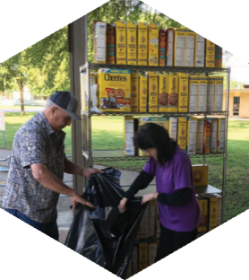

Pastor: Dr. Brice Mandaville
Associate Pastor: Josh Tylich
Youth Minister: Josh Graham
Minister of Music: Howard Hudiburg
Children’s/Volunteer Coordinator: Rhonda Hensarling

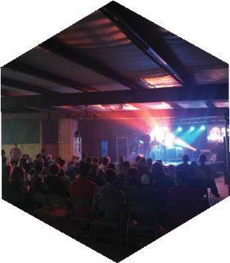
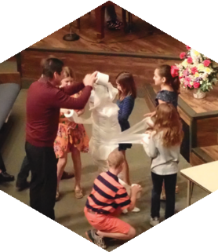
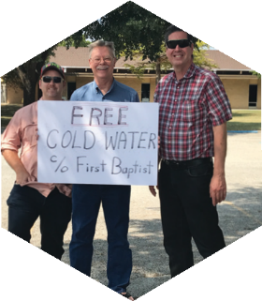

FIRST TIME HERE?
Text Welcome to
830-224-2046

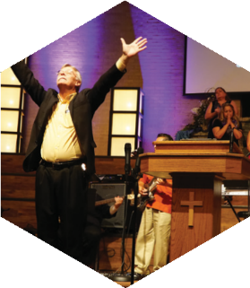

www.fbcseguin.org
830.379.4208
1314 E. Cedar St.

MORNING SERVICE
October 6, 2019 10:30 am

DOXOLOGY

WELCOME Pastor Brice

PRAYER Pastor Brice

SCRIPTURE READING Tania Mullins
II Corinthians 5:1-11

TESTIMONY: DEALING WITH DEATH
Nona Kay Scales

SONG MEDLEY
Revelation Song
Be Unto Your Name
I Can Only Imagine*

MESSAGE Pastor Brice
“What Happens when a Person Dies?”

RESPONDING TO GOD’S WORD
Just As I Am

Offering
Prayer Richard Bailey
When We All Get to Heaven (Hymn #514) Praise Team

* Children 4 years old thru First Grade dismissed for children’s worship following this song.

EVENING SERVICE
6:00 PM
Join us this evening for a traditional service of hymns and preaching. Bro. Graham will bring the sermon tonight.

THE LORD’S SUPPER
OCTOBER 13
We will observe the Lord’s Supper at the end of the morning worship service next Sunday. We invite all who have accepted Jesus Christ as their Savior to join us as we partake of the elements. There will be gluten free wafers available to those on restricted diets.

WEDNESDAY KIDS MISSIONS FOOD DRIVE
OCTOBER 2019
Wednesday night mission kids are collecting canned food for the Christian Cupboard during the month of October. The kids can bring cans any Wednesday night or Sunday morning to Building 1 and the church family will find boxes in each building during October if they would like to help.

RISE AGAINST HUNGER: MEALS WITH IMPACT
OCTOBER 19 9:00 AM
We are still in need of a few strong armed people to help with loading and unloading of supplies and packages. Please let Rhonda Hensarling know if you can be available for this part of our day.

MORE INFORMATION
If you would like more information about the church, please fill out the white pew card and place in the offering plate. Prayer requests may be written on the back.

