MISSIONS FOOD DRIVE
OCTOBER 2019
Wednesday night mission kids and the children’s Sunday School classes are collecting canned food to benefit the Christian Cupboard during the month of October. The kids can bring cans any Wednesday night or Sunday morning to Building 1. The church family will find boxes in each building during October if they would like to help.

FALL-O-WEEN JESUS G-FORCE EVENT
OCTOBER 27 4:30 – 6:00 PM
Join us for our second annual Fall Festival event, Fall-O-Ween (Following) Jesus. This event is for students 1st – 5th grades. Grab a friend and come celebrate Fall and following Jesus with lots of fun games. Parents, we encourage you to stay for the quarterly business meeting and meal in the Fellowship Hall upon picking up your child.

KEENAGER’S SAFARI
NOVEMBER 4
You are invited to sign up for the November KeenAger’s Safari at the Natural Bridge Wildlife Ranch. Sign up at the counter in the foyer and enjoy an African safari, Texas style! Payments for the trip can be made in the office. Checks should be made out to First Baptist Church. Stay tuned for more details.

VETERAN’S DAY SERVICE
NOVEMBER 10
We hope you will join us for a special service, honoring our military veterans! For the service, we will feature a slide show of all the men and women who have served – or are currently serving and who call our church home. If you would like to see your loved one featured in the slide show, please submit a picture of them in their uniform, notated with their name, rank and branch of military, to info@fbcseguin.org. The slide show does take time to put together, so we ask that you have your photos in no later than November 3. If you have submitted a picture in the past, there is no need to submit another.

YOUNG ADULT CAREERS CLASS
We have a new class dedicated to young adults who have graduated college but are not quite “family” status yet. Taught by Bob & Patsy Moore, they will meet in room 315 and will follow the Explore the Bible quarterly literature.

Mary Hill Davis/State Missions Goal: $5,500
Total Collected: $7,018.51

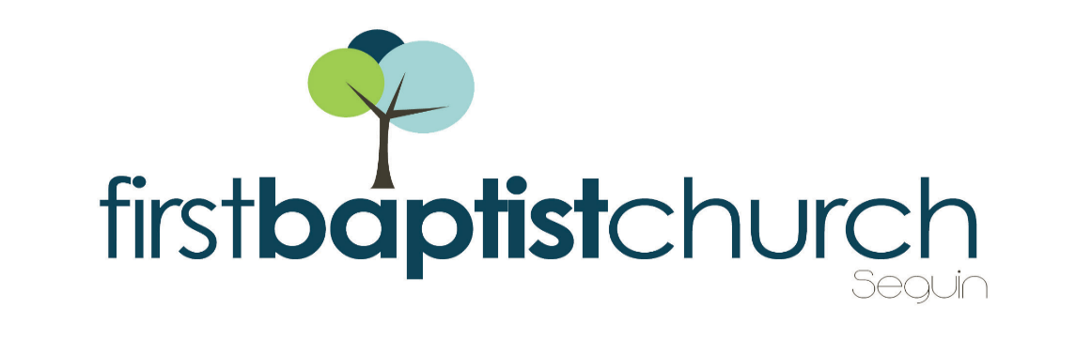
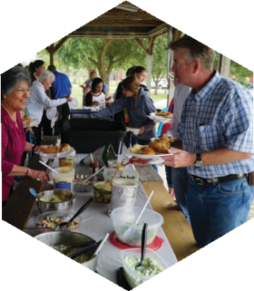
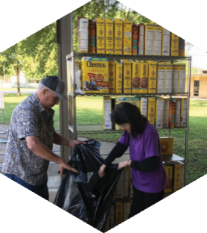
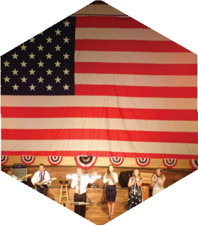

Pastor: Dr. Brice Mandaville
Associate Pastor: Josh Tylich
Youth Minister: Josh Graham
Minister of Music: Howard Hudiburg
Children’s/Volunteer Coordinator: Rhonda Hensarling

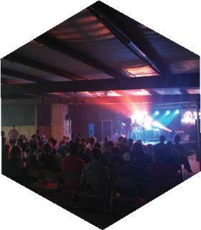
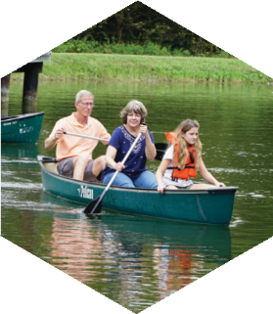
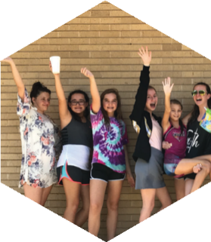
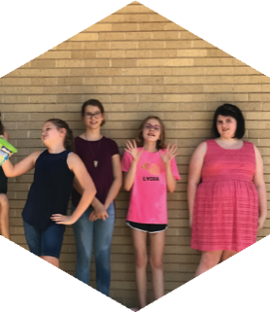
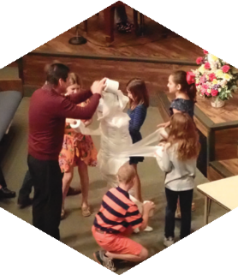
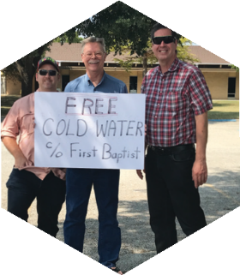
FIRST TIME HERE?
Text Welcome to
830-224-2046

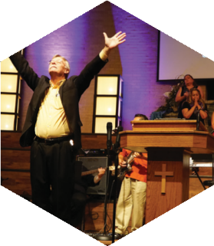

www.fbcseguin.org
830.379.4208
1314 E. Cedar St.

MORNING SERVICE
October 13, 2019 10:30 am

ANNOUNCEMENTS

BETTER IS ONE DAY Congregation

SCRIPTURE: II Cor 6:11-18 Brian Hunter

PRAYER/WELCOME Pastor Brice

WORSHIP MEDLEY Congregation
Higher Ground (Hymn #484)
Change My Heart O God
You Are My King*

MESSAGE: “Come Out from Among Them”
Pastor Brice

RESPONDING TO GOD’S WORD Congregation
Wherever He Leads I’ll Go (Hymn #285)

OFFERING
Prayer Greg Doss
Across the Lands You’re the Word of God Worship Choir

OBSERVANCE OF THE LORD’S SUPPER
Communion Hymn Handbell Choir

* Children 4 years old thru First Grade dismissed for children’s worship following this song.

EVENING SERVICE
6:00 PM
Join us this evening for a traditional service of hymns and preaching. Bro. Graham will bring the sermon tonight.

RISE AGAINST HUNGER: MEALS WITH IMPACT
OCTOBER 19 9:00 AM - 11:00 AM
Our truck of supplies will arrive around 8:00 AM. We will have tables set up in the fellowship hall for teams of 5 people each. Teams will get one box of each ingredient, instructions and a set up/funnel to fill your bags. Once filled, teams will seal/label their bags and set aside. As all teams finish, the bags will be packed into a shipping box and loaded back onto the truck. Please remember that children are encouraged to come help. This is sure to be a fulfilling time of fellowship and service with and to God’s people. We are looking forward to sharing the morning with you.

THE LORD’S SUPPER
OCTOBER 13
We invite all who have accepted Jesus Christ as their Savior to join us as we partake of the elements this morning. For those on restricted diets, gluten free wafers are available on the counter in the foyer.

QUARTERLY BUSINESS MEETING & MEAL
OCTOBER 27
We hope you will join us Sunday evening in the Fellowship Hall on October 27 for our quarterly business meeting and meal. The Deacons will be making and serving spaghetti that evening. Dinner will be served at 6:00 PM followed by a short business meeting. We will discuss new members and the previous quarter’s financials.

MORE INFORMATION
If you would like more information about the church, please fill out the white pew card and place in the offering plate. Prayer requests may be written on the back.

