OPERATION CHRISTMAS CHILD
NOVEMBER 3 -17
We are excited to again partner with Samaritan’s Purse in their Operation Christmas Child ministry. Folded, ready to fill shoeboxes are available in the church foyer today through Sunday, November 10. Please be sure to swing by and pick up a shoe box (or two) to fill. Boxes are due back to the church by November 17. Our church will again be the drop off location for all local churches and businesses participating in the ministry. These boxes are then shipped to children all over the world to light up their lives with the love of Jesus Christ.

GRAIN OFFERING
NOVEMBER 3
We have shelves available in the foyer for you to place your offerings. Thank you for your help in reaching the city of Seguin.

KEENAGER’S SAFARI
TOMORROW
We will meet tomorrow morning in the back parking lot at 9:00 AM. Our tour begins at 10:30 AM, so we will leave no later than 9:30 AM. We are taking the church van. Marvin McCall will drive. The tour will take about an hour and lunch will be served on site.

ADULT SUNDAY SCHOOL TRAINING
NOVEMBER 10
Immediately following the morning service next Sunday, all adult Sunday school teachers will have their quarterly training. Dr. Steve Hartwick will be here to talk about the point in which Sunday Morning and evangelism intersect. Join us for lunch and stick around for another great training!

MEN’S PRAYER BREAKFAST
NOVEMBER 12 6:30 AM
All men available are encouraged and invited to join us in the Fellowship Hall next Tuesday morning for breakfast, a time of study and prayer. We are going through “Radical,” a study by David Platt.

OFFICE/CAMPUS CLOSED
VETERANS DAY NOVEMBER 11
The church office and campus will be closed in honor and observance of Veterans Day Monday, November 11.

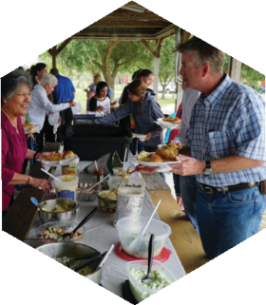
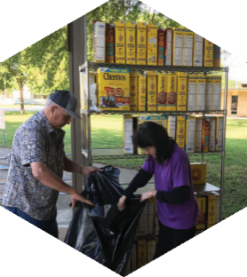
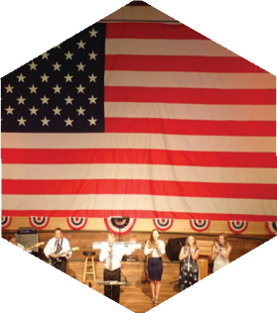

Pastor: Dr. Brice Mandaville
Associate Pastor: Josh Tylich
Youth Minister: Josh Graham
Minister of Music: Howard Hudiburg
Children’s/Volunteer Coordinator: Rhonda Hensarling

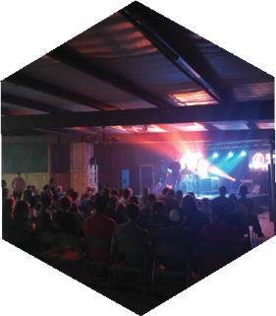
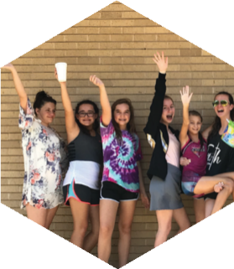
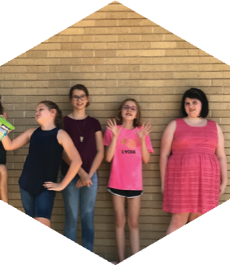
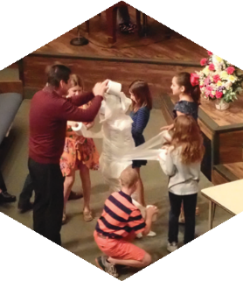
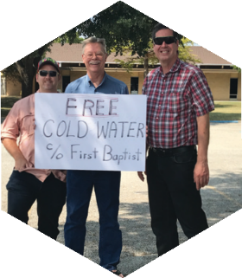
FIRST TIME HERE?
Text Welcome to
830-224-2046

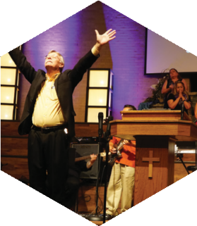

www.fbcseguin.org
830.379.4208
1314 E. Cedar St.

MORNING SERVICE
November 3, 2019 10:30 am

ALLELUIA, ALL CREATION SINGS
Young Musicians Choir

I WILL WAIT FOR YOU Congregation

PRAYER/WELCOME Pastor Brice

OPERATION CHRISTMAS CHILD Video

HELPLESS Worship Choir

SCRIPTURE: II Cor 9:6-15 Aaron Krause

WORSHIP MEDLEY Congregation
Jesus Paid It All
At the Cross (Hymn #138)

HOW TO DEVELOP A GENEROUS SPIRIT (PART II)
Pastor Brice

RESPONDING TO GOD’S WORD Congregation
Living for Jesus (Hymn #282)

OFFERING
Prayer Doug Harding
Only King Forever Praise Team

* Children 4 years old thru First Grade dismissed for children’s worship following this song.
NO EVENING SERVICE
DUE TO
STARCKE PARK FAMILY FUN
NOON – 3:00 PM
We will be at the pavilion, located behind the Starcke Park baseball fields, following the service this morning. The church will provide a lunch of hot dogs and hamburgers. Don’t forget your board games for fellowship under the pavilion or any lawn games/sports equipment you may want to enjoy for the afternoon (i.e. Frisbee, basketball, volleyball, fishing kickball & softball). There is a big playground for the kids a short drive away and a nature trail for exploring. Maps are available on the counter in the foyer.

VETERANS DAY SERVICE
NEXT SUNDAY
Join us for a special service, honoring our military veterans! For the service, we will feature a slide show of all the men and women who have served, or are currently serving, and who call our church home. If you would like to see your loved one featured in the slide show, please submit a picture of them in their uniform, notated with their name, rank and branch of military to info@fbcseguin.org or holly@fbcseguin.org. The slide show does take time to put together, so we ask that you have your photos in no later than Monday (tomorrow) at 5:00 PM. *If you have submitted a picture in the past, there is no need to submit another*

MORE INFORMATION
If you are interested in further information about the church and/or membership, please fill out the white pew card and place it in the offering plate. All prayer requests may be written on the back.

