OPERATION CHRISTMAS CHILD
Folded, ready to fill shoeboxes are available in the church foyer today through Sunday, November 10. Please be sure to swing by and pick up a shoe box (or two) to fill. Boxes are due back to the church next Sunday. Our church will again be the drop off location for all local churches and businesses participating in the ministry. These boxes are then shipped to children all over the world to light up their lives with the love of Jesus Christ.

OFFICE/CAMPUS CLOSED
VETERANS DAY TOMORROW
The church office and campus will be closed in honor and observance of Veterans Day Monday, November 11.

MEN’S PRAYER BREAKFAST
NOVEMBER 12 6:30 AM
All men are encouraged and invited to join us in the Fellowship Hall this Tuesday morning for breakfast, a time of study and prayer. We are going through “Radical,” a study by David Platt.

GAME NIGHT
NOVEMBER 14
Every second Thursday of the month, we meet for games, food and lots of fun! It all starts at 6:00 PM, in the Fellowship Hall. All are welcome! Bring your favorite board or card game and an entrée or appetizer to share. We look forward to seeing you there.

CHILDREN’S CHOIRS, MISSIONS & YOUTH
LAST DAY NOVEMBER 20
The Wednesday night classes for children and youth will have their last class of 2019 on Wednesday November 20. Classes will resume January 8. Enjoy your holiday break!

2020 BUDGET PRESENTATION
NOVEMBER 24 EVENING SERVICE
We would like to invite you to join us Sunday evening, November 24 as we present the 2020 church budget. We will have copies of the proposed budget available on the church foyer counter beginning November 17. We encourage you to pick up a copy to look over. On the 24th, we will open it up to discussion and answer any questions you may have. We will then vote, by ballot, during the morning worship service on December 15.

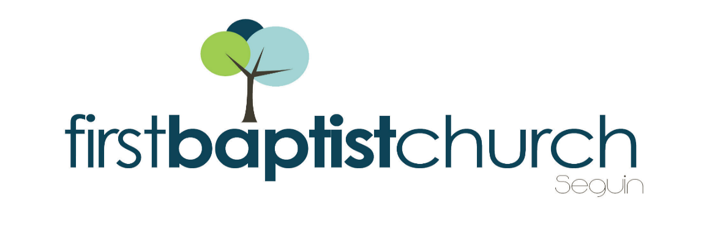
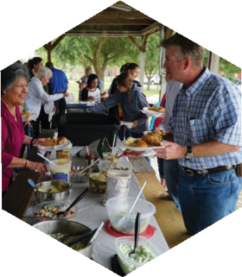
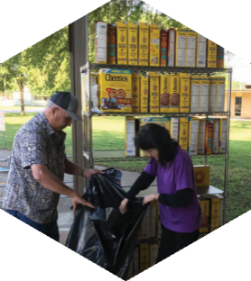
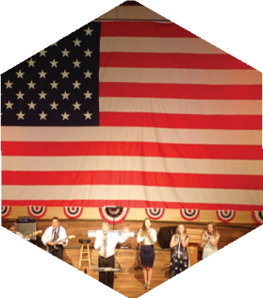

Pastor: Dr. Brice Mandaville
Associate Pastor: Josh Tylich
Youth Minister: Josh Graham
Minister of Music: Howard Hudiburg
Children’s/Volunteer Coordinator: Rhonda Hensarling

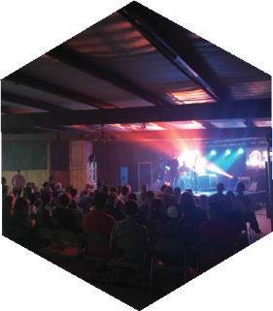
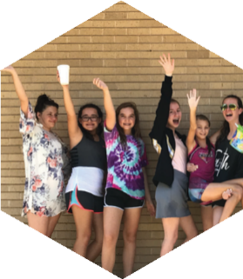
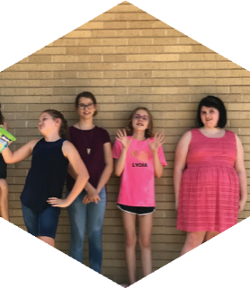
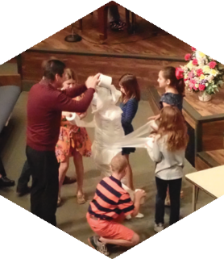
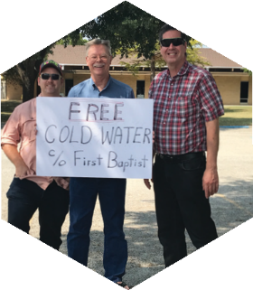
FIRST TIME HERE?
Text Welcome to
830-224-2046

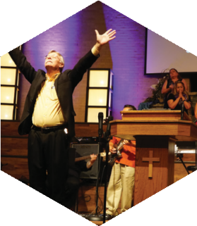

www.fbcseguin.org
830.379.4208
1314 E. Cedar St.

MORNING SERVICE
November 10, 2019 10:30 am

WELCOME/PRAYER Pastor Brice

MINE EYES HAVE SEEN THE GLORY Congregation

HONORING OUR VETERANS Video
Veterans present in the service please stand at the end of the video when your service song is played.

WORSHIP MEDLEY Congregation
Good, Good Father
Faith of Our Fathers (Hymn #352)

SCRIPTURE: II Cor 10:12-17 Hannah Patterson

MESSAGE Pastor Brice
STAYING FOCUSED ON JESUS
IN A DOG EAT DOG WORLD

RESPONDING TO GOD’S WORD Congregation
How Deep the Father’s Love

Offering
Prayer Tres Hewell
Mighty to Save Praise Team

* Children 4 years old thru First Grade dismissed for children’s worship following this song.

Flowers are given today in honor of the active duty, retired, and prior military at FBC Seguin and in memory of those who gave their all in service to our country by Allen and Kay Rhodes

EVENING SERVICE
6:00 PM
Join us tonight for a traditional service of hymns and verse by verse preaching. Bro. Brice will be bringing the message. We will also have Scott Harris of the IMB here to speak on how God is working in the lives of the Chinese.

ADULT SUNDAY SCHOOL TRAINING
NOVEMBER 10
Immediately following the service this morning, all adult Sunday school teachers will have their quarterly training in the Fellowship Hall. Dr. Steve Hartwick is here to talk about the point in which Sunday Morning and evangelism intersect.

COMMUNITY THANKSGIVING SERVICE
NOVEMBER 26 FIRST METHODIST
There will be a community wide Thanksgiving service held at First United Methodist Church (the pumpkin patch church), Tuesday, November 26 at 7:00 PM. We encourage you to grab a friend or family member and meet us there. Rev. Jim Price will be preaching and choirs/groups from all over Seguin will be bringing the worship. This will be a time to come together in thankful praise and worship to God for all the many blessings He gives. We hope to see you there.

MORE INFORMATION
If you are interested in further information about the church and/or membership, please fill out the white pew card and place it in the offering plate. All prayer requests may be written on the back.

