OPERATION CHRISTMAS CHILD
Boxes are due back to the church today. Our church will again be the drop off location for all local churches and businesses participating in the ministry. Drop-off for the area will begin tomorrow and go through next Monday, the 25th. See the church website for drop off hours.

CHILDREN’S MISSIONS & YOUTH
LAST DAY - NOVEMBER 20
The Wednesday night missions classes for children and youth will have their last class of 2019 on Wednesday November 20. Classes will resume January 8. Enjoy your holiday break!

MEN’S PRAYER BREAKFAST
NOVEMBER 26 6:30 AM
All men available are encouraged and invited to join us in the Fellowship Hall next Tuesday morning for breakfast, a time of study and prayer.

COMMUNITY THANKSGIVING SERVICE
NOVEMBER 26 FIRST METHODIST
There will be a community wide Thanksgiving service held at First United Methodist Church (the pumpkin patch church), Tuesday, November 26 at 7:00 PM. We encourage you to grab a friend or family member and meet us there. Rev. Jim Price will be preaching and choirs/groups from all over Seguin will bring the worship. This is sure to be a time of thankful praise and worship to God for all the many blessings He gives. We hope to see you there.

KEENAGER’S LUNCHEON
DECEMBER 2
We hope you will join us for the last KeenAger’s Luncheon of 2019! Beginning at 10:00 AM we will have a gift exchange. Please bring a small, inexpensive gift if you would like to participate in the game. At 11:30 AM lunch will be served followed by an encouraging word brought to you by the Chaplain of the San Antonio Spurs, Rich Garza.

OFFICE/CAMPUS CLOSED
NOVEMBER 28 – 29
The church office and campus will be closed Thanksgiving Day, November 28, as well as Friday, November 29 to allow the office and ministerial staff, as well as our wonderful custodian, the opportunity to enjoy the holiday.

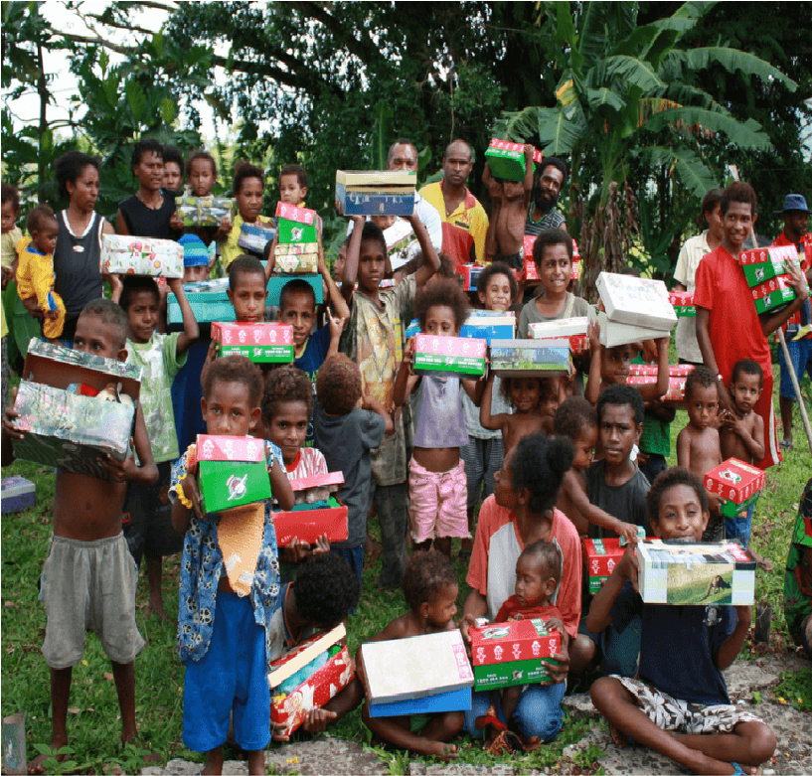
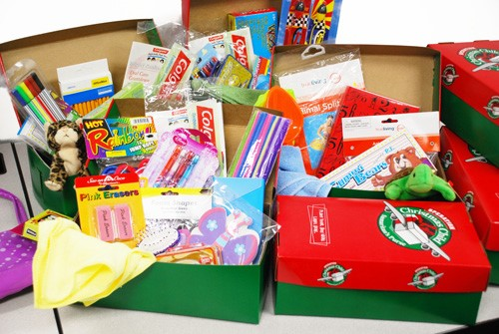
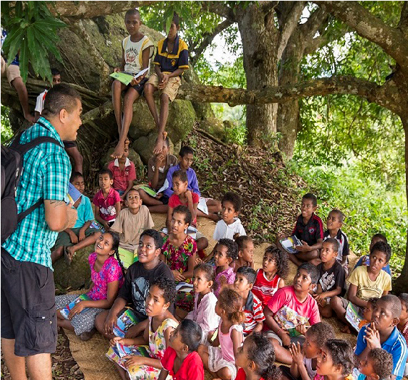
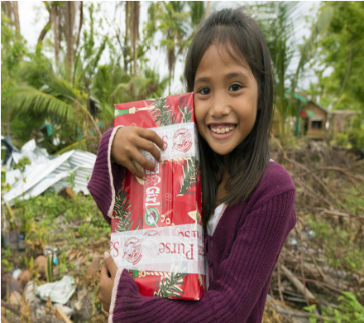
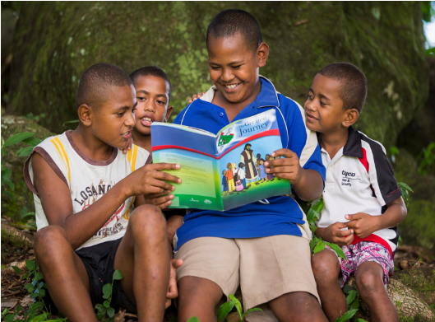
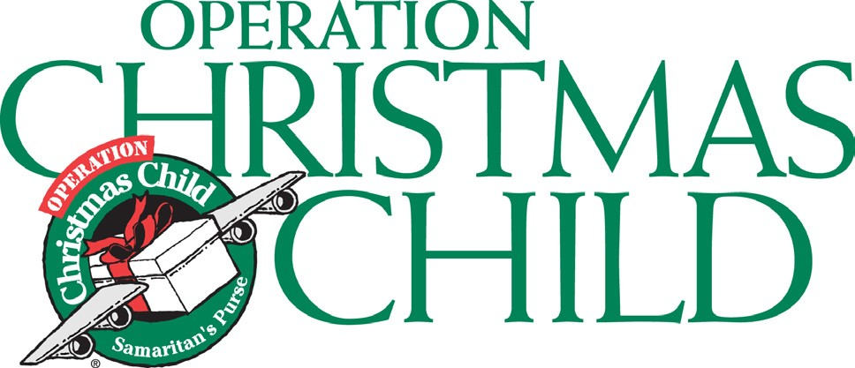
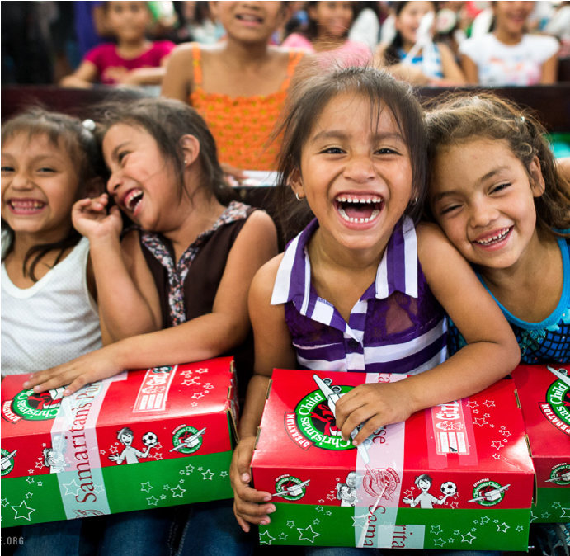
Senior Pastor: Brice Mandaville
Associate Pastor: Josh Tylich
Youth Pastor: Josh Graham
Music Minister: Howard Hudiburg
Children’s/Volunteer Coordinator:
Rhonda Hensarling

www. fbcseguin.org
FIRST TIME HERE?
Text Welcome to
830-224-2046

MORNING SERVICE
November 17, 2019 10:30 am

PRAYER/WELCOME Pastor Brice

WORSHIP MEDLEY Congregation
Before the Throne of God Above
Forever (We Sing Hallelujah)

SCRIPTURE: II Cor 11:1-9 Tenley Jackson

EMBRACE GRACE Video

WORSHIP MEDLEY Congregation
Nothing but the Blood (Hymn #135)
How Great Thou Art (Hymn #10)

HOW MUCH SHOULD THE PREACHER BE PAID
Pastor Brice

RESPONDING TO GOD’S WORD Congregation
O Come to the Altar

OFFERING
Prayer Tres Hewell
Open Up Our Eyes Praise Team

* Children 4 years old thru First Grade dismissed for children’s worship following this song.

EVENING SERVICE
6:00 PM
Join us tonight for a traditional service of hymns and verse by verse preaching. Bro Brice will bring the message.

2020 BUDGET PRESENTATION
NOVEMBER 24 EVENING SERVICE
Copies of the proposed budget are available, as of today, on the church foyer counter. We encourage you to pick one up and look it over. On the evening of 24th, we will open the budget up to discussion and answer any questions you may have. We will then vote, by ballot, during the morning worship service on December 15.

EMBRACE GRACE
A little over a year ago, we began a very special ministry called Embrace Grace. Its mission: to reach out to women who find themselves in an unplanned pregnancy. Usually the product of a bad relationship, these women arrive broken, in need of support, education and, most of all, love. With this ministry, women are introduced to the grace of God and learn how to accept and flourish in it for the sake of their children – who are precious to Him. Wanda Kollaus and Catherine Page would like to invite you to learn more about the program by stopping by the table in the foyer today. They will be there to answer any and all your questions. Like all of our ministries, support is always needed. Please be in prayer about what God would have you do to aid in the furthering of His church and the “blossoming” of His children.

MISSIONS FAIR: A TASTE OF MISSIONS
DECEMBER 8
We would like to invite you to join us for our annual Missions Fair on the second Sunday of December. Following the morning service we will have a church wide lunch in the Fellowship Hall. We will be serving a plethora of dishes native to the countries in which our IMB missionaries work. After lunch, we hope you will make your way over to our various displays for more information on the day to day lives of the people to whom our missionaries reach out. This will be a day of global sized fun. Please mark your calendars to join in.

