GRAIN OFFERING
TODAY
Shelves are available in the church foyer for you to place your donations.

KEENAGER’S LUNCHEON
TOMORROW
Beginning at 10:00 AM we will have a gift exchange. At 11:30 AM lunch will be served followed by an encouraging word brought to you by the San Antonio Spurs Chaplain, Rich Garza.

DEACONS & HOT CHOCOLATE
DECEMBER 6 5:30 – 8:30 PM
The deacon body would like to invite you to join them this Friday at the Seguin Area Sip & Stroll in downtown Seguin. They will have a booth in the lobby of First United Bank on Austin St. where they will have fresh hot chocolate for your enjoyment! Grab a friend and join us!

YOUTH CHRISTMAS PARTY
DECEMBER 6 5:30 – 8:00 PM
Calling all Youth (7th – 12th)! Join us in the youth building Friday, December 6 for fun games, food & gifts. We will have a white elephant gift exchange. Please wrap & bring one pair of socks (must be unused; themed, Christmas, or plain white for extra fun) to participate. Parents are welcome to attend with their student.

GAME NIGHT
DECEMBER 12
It’s here: the last game night of 2019. Join us in the Fellowship Hall for a time of food, fun & fellowship. We kick off at 6:00 PM. If you are interested in joining in the fun, please bring an entrée or appetizer to share and your favorite board/card game.

EMBRACE GRACE
A little over a year ago, we began a very special ministry called Embrace Grace. With this ministry, women who have found themselves in an unexpected pregnancy are introduced to the grace of God and learn how to accept and flourish in it for the sake of their children – who are precious to Him. Like all of our ministries, support is always needed. Please stop by the table in the foyer to see how you can help.

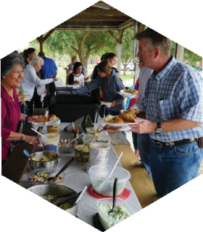
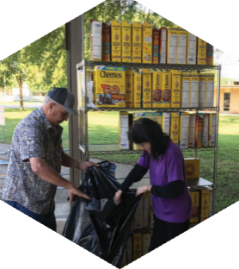
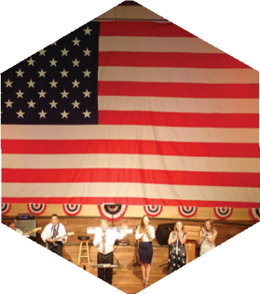

Pastor: Dr. Brice Mandaville
Associate Pastor: Josh Tylich
Youth Minister: Josh Graham
Minister of Music: Howard Hudiburg
Children’s/Volunteer Coordinator: Rhonda Hensarling

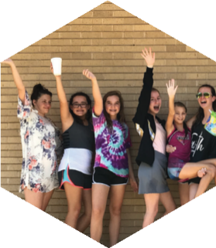
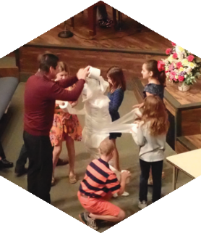
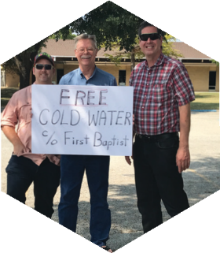
FIRST TIME HERE?
Text Welcome to
830-224-2046

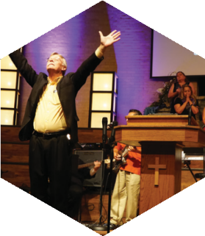

www.fbcseguin.org
830.379.4208
1314 E. Cedar St.

MORNING SERVICE
December 1, 2019 10:30 am

PRAYER/WELCOME Pastor Brice

ADVENT CANDLES Music Makers Choir

WORSHIP MEDLEY Congregation
O Come, O Come Emmanuel (Hymn #76)
Mercy

SCRIPTURE: II Cor 4:14-15 Gail Schievelbein

BAPTISM

WORSHIP MEDLEY Congregation
Be Thou My Vision
The First Nowell (Hymn #85)*

THANKSGIVING GRACE Pastor Brice

RESPONDING TO GOD’S WORD Congregation
Amazing Grace (Hymn #330)

OFFERING
Prayer Aaron Krause
Little Drummer Boy Worship Choir

* Children 4 years old thru First Grade dismissed for children’s worship following this hymn.

The flowers are placed today to commemorate Ann & Milt Watson’s 55th Wedding Anniversary!
EVENING SERVICE
6:00 PM
Join us this evening for a traditional service of hymns and verse by verse preaching. Bro. Howard will lead our worship and Bro. Brice will bring the message.

MISSIONS FAIR: A TASTE OF MISSIONS
NEXT SUNDAY - DECEMBER 8
You’re invited to join us for our annual Missions Fair next Sunday. Following the morning service we will have a church wide lunch in the Fellowship Hall. We will be serving a plethora of dishes native to the countries in which our missionaries work. After lunch, make your way over to our various displays for more information on the day to day lives of the people to whom our missionaries reach out. We will also begin the Christmas season with the nativity animals, having a live camel, sheep, goat, and donkey. There will be no evening service that night.

FINANCIAL PEACE UNIVERSITY
BEGINNING SUNDAY, JANUARY 12
Can we all agree that a little financial help is always welcomed? We are excited to offer just that in the new year. We are hosting a Financial Peace Seminar beginning January 12, 5:00 PM – 7:00 PM, in the Fellowship Hall. Bob Moore, our facilitator, will guide you and you spouse through the Dave Ramsey course Financial Peace. Curriculum for the course can be purchased online at https://www.fpu.com/1103466. Be sure to use this link for a discounted price on curriculum. Upon purchase you will be automatically enrolled in the class, no additional work required! This class is open to anyone ready to put their finances in check.

MORE INFORMATION
If you are interested in more information about the church, please fill out the white pew card and place it in the offering plate. Please feel free to write in a physical address if you do not have an email. Any prayer requests may be written on the back of the card!

