FINANCIAL PEACE UNIVERSITY
BEGINNING SUNDAY, JANUARY 12
When: January 12, 2020 - 5:00 PM – 7:00 PM
Where: Fellowship Hall
Facilitator: Bob Moore
Small Group Leaders: Stephanie & Matt Nolte, Kay & Allen Rhodes, Kayla & Patrick Hamilton, Susan & David Holdman
Curriculum for the course can be purchased online at https://www.fpu.com/1103466. Scan the QR Code above for quick access to a discounted price on curriculum. Upon purchase you will automatically be enrolled in the class, no additional work required. If you have any questions or need help enrolling, please fill out and write “Financial Peace” on the yellow Next Steps card in the pew and place it in the offering plate.

WEDNESDAY ACTIVITIES
JANUARY 8
Wednesday activities for children and youth will resume Wednesday January 8, beginning with children’s choirs & youth at 5:30 PM. Mission friends and Children in Action will resume at 6:00 PM that evening. Chef Carolyn will also have a Wednesday meal prepared for you and your family. Stop by the counter in the foyer to sign up!

GAME NIGHT
JANUARY 9 6:00 PM
Every second Thursday of the month, we meet in the Fellowship Hall for food & fun! Would you consider joining us for table games and fellowship? No signup required, just bring your favorite board/card game, an appetizer or entrée to share and your game face! We are always looking for new folks to join in the fun.

SEGUIN AREA MEN’S PRAYER BREAKFAST
JANUARY 11 8:00 AM
Mark your calendars for the first Seguin Area Men’s Prayer Breakfast of 2020. All available men are welcomed to meet in the Fellowship Hall for breakfast, worship and a time of prayer and study. Fathers bring your sons; sons bring your fathers.

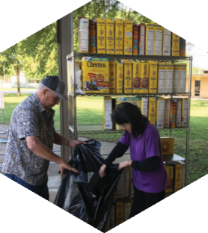

Pastor: Dr. Brice Mandaville
Youth Minister: Josh Graham
Children’s/Volunteer Coordinator: Rhonda Hensarling

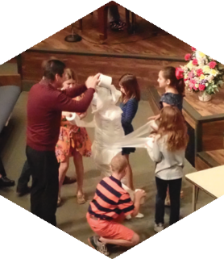
FIRST TIME HERE?
Text Welcome to
830-224-2046

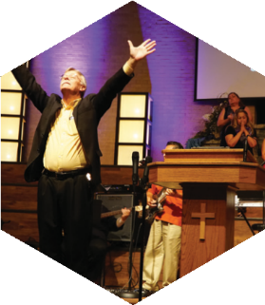

www.fbcseguin.org
830.379.4208
1314 E. Cedar St.

MORNING SERVICE
January 5, 2020 10:30 am

WORSHIP MEDLEY Congregation
Come Thou Fount of Every Blessing
Christ Is Risen

PRAYER/WELCOME Pastor Brice

HOPE FOR 2020 Video

SCRIPTURE: Matt 17:4,9; Num 13:27-30, 14:1-4 Josh Graham

WORSHIP MEDLEY Congregation
Be Thou My Vision
Forever (We Sing Halleluiah)
Before The Throne of God Above

WHAT IS YOUR CHOICE FOR 2020?
Herman Cramer

RESPONDING TO GOD’S WORD Congregation
Wherever He Leads, I’ll Go

OFFERING
Prayer Travis Phillips
Always Praise Team

* Children 4 years old thru First Grade dismissed for children’s worship following this song.
MORNING SERVICE
Welcome Brother Herman Cramer who will be bringing the morning message. Herman is a full time evangelist who is a long-time member of our church.

EVENING SERVICE: 6:00 PM
Join us tonight for a traditional service of hymns straight from the hymnal and verse by verse preaching by Bro. Graham.

GRAIN OFFERING
TODAY
Today is our first grain offering of the new year! Our goal is 100 boxes. Please place your offering on the available shelves in the foyer. Thank you for your help in reaching the city of Seguin.

KEENAGER’S LUNCHEON
JANUARY 6
Table games and fellowship will begin at 10:00 AM followed by a catered lunch at 11:30 AM. At noon we will have music by Clifton Janskey.

MORE INFORMATION
If you are interested in more information about the church, please fill out the white pew card and place it in the offering plate. Please feel free to write in a physical address if you do not have an email. Any prayer requests may be written on the back of the card.

