BUSINESS MEETING & CHILI SUPPER
JANUARY 26 6:00 PM
Join us for our first quarterly business meeting of the new year. We will discuss the previous quarter’s financials and new membership. The Deacon body will serve a hot dinner of homemade chili and cornbread!

MEN’S PRAYER BREAKFAST
JANUARY 14 6:30 AM
The wait is over. The even numbered Tuesdays Men’s Prayer Bible Study and Breakfast is back! Join Bro. Brice for a hot breakfast and a time of study in the Fellowship Hall.

WEDNESDAY ACTIVITIES
4:30 – 7:00 PM
Just a reminder that all Wednesday activities have started up. This includes everything children, youth and adult. This means that the Wednesday meals are also back in full swing. If you are interested in fellowshipping with us over a homecooked meal, please be sure to sign up by 5:00 PM the Monday prior to the meal. A weekly menu and signup sheet can be found, every Sunday, on the counter in the foyer.

EMBRACE GRACE
We would like to take a minute to remind you of the ministry opportunities of the Embrace Grace program. From snacks and gift wrapping, to prayer and financial help, this ministry could use you. We began offering this program at the church a little over a year ago to women who have found themselves in an unexpected pregnancy. Each woman enrolled in the class learns their value as mandated by their heavenly father and how to pay forward that value to their children. If you would be interested in helping out, please feel free to contact Wanda Kollaus or Catherine Page.

SECURITY TEAM
As the calendar flips to a new year, we flip over a new need. We would like to encourage you to be in prayer about joining the security team here at First Baptist Church. As our church grows, so does our need for more volunteers. If you would be interested in joining the team or would like more information about the team and what is involved, please fill out the blue Serving card found in the pew and place it in the offering plate.

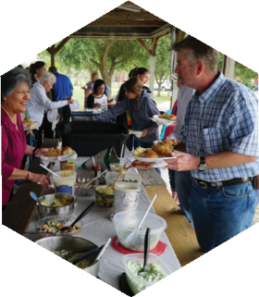
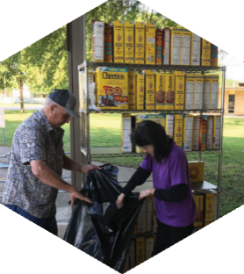
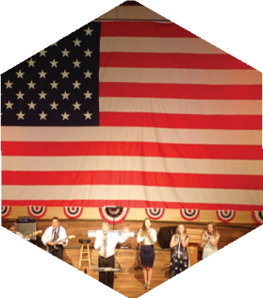

Pastor: Dr. Brice Mandaville
Youth Minister: Josh Graham
Children’s/Volunteer Coordinator: Rhonda Hensarling

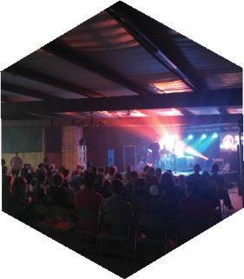
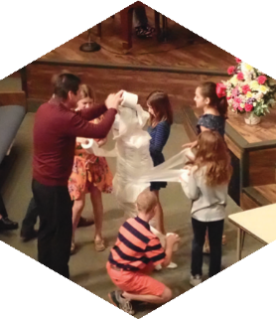
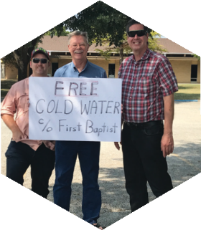
FIRST TIME HERE?
Text Welcome to
830-224-2046

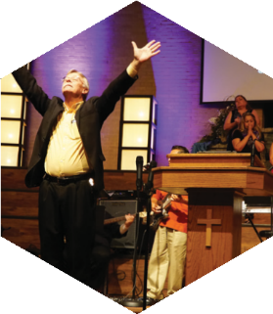

www.fbcseguin.org
830.379.4208
1314 E. Cedar St.

MORNING SERVICE
January 12, 2020 10:30 am

WORSHIP MEDLEY Congregation
10,000 Reasons
Nothing But the Blood of Jesus (Hymn #135)

SCRIPTURE: Judges 1:1-4 Audrey Medrano

PRAYER/WELCOME Pastor Brice

SERVING SEGUIN IN 2020 Video

WORSHIP MEDLEY Congregation
When We All Get to Heaven (Hymn #514)
I Will Wait for You
Mercy

FIGHTING SPIRITUAL BATTLES Pastor Brice

RESPONDING TO GOD’S WORD Congregation
Wherever He Leads, I’ll Go (Hymn #285)

OFFERING
Prayer Jim Ransdell
Lord I Need You Praise Team

* Children 4 years old thru First Grade dismissed for children’s worship following this song.

EVENING SERVICE
6:00 PM
Join us tonight for a traditional service of hymns straight from the hymnal and verse by verse preaching by Bro. Brice.

FINANCIAL PEACE UNIVERSITY
TODAY
When: 5:00 PM – 7:00 PM
Where: Room 209 (east end Fellowship Hall building)
Facilitator: Bob Moore
Small Group Leaders: Stephanie & Matt Nolte, Kay & Allen Rhodes, Kayla & Patrick Hamilton, Susan & David Holdman

Classes start tonight at 5:00 PM in Building 2, across from the bathrooms – room 209, but there is still plenty of time to sign up. This is a 9 week course over money management, insurance and investing guidelines. Scan the QR code above for quick access to discounted curriculum or type the following URL address into your internet browser: www.fpu.com/1103466.

MLK JR CHURCH SERVICE & CONCERT
JANUARY 16 & JANUARY 19
We are excited to once again partner with the Seguin Area Martin Luther King, Jr. committee to bring you a time of celebration and fun! In addition to the annual Sunday evening concert on Sunday January 19, our church will host a special MLK Day church service at 7:00 PM in the sanctuary, Thursday, January 16. We hope you will join us as we partner and celebrate with the other area churches a defining and steadfast man of history.

MORE INFORMATION
If you are interested in more information about the church, please fill out the white pew card and place it in the offering plate. Please feel free to write in a physical address if you do not have an email. Any prayer requests may be written on the back of the card.

