JOB OPENING: MINISTER OF WORSHIP
Our church is currently seeking an individual to fill the full-time position of minister of worship. This person will be responsible for the praise team, church choirs and ensembles, as well as other ministry responsibilities. Resumes may be sent to info@fbcseguin.org.

SEGUIN AREA MEN’S PRAYER BREAKFAST
FEBRUARY 1 8:00 AM
Due to a scheduling conflict in the month of January, the Seguin Area Men’s prayer breakfast has been moved to the first weekend in February. This is a time of fellowship among men, breakfast, worship and prayer! Things kick off at 8:00 AM in the Fellowship Hall. Hope to see you there.

WEEKLY BIBLE STUDIES
In case you were wondering, we have weekly Bible studies available for all ages. See below a quick list of what’s available during the week.
- Tues. AM Ladies: 9:00 AM, Room 209 (Beginning in Feb.)
- Wed. Prayer Bible Study: 6:00 PM, Room 200
- Wed. PM Ladies: 6:00 PM, Room 300
- Thurs. AM Ladies: 9:30 AM, Room 203
- Thurs. PM Men’s: 6:30 PM, Room 313 (Beginning in Feb.)
- Thurs. PM Ladies: 6:30 PM, Room 308 (Beginning Jan. 23)
If you are interested in any of these studies feel free to call the church office for more information or walk on in. Everyone is welcome to join us as we dig deeper into God’s Word and Truth!

MORE INFORMATION
If you are interested in more information about the church, please fill out the white pew card and place it in the offering plate. Please feel free to write in a physical address if you do not have an email. Any prayer requests may be written on the back of the card.

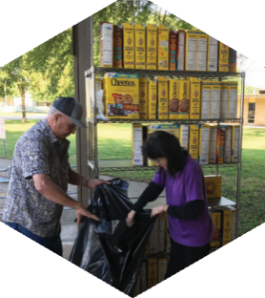

Pastor: Dr. Brice Mandaville
Youth Minister: Josh Graham
Children’s/Volunteer Coordinator: Rhonda Hensarling

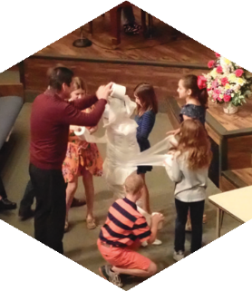
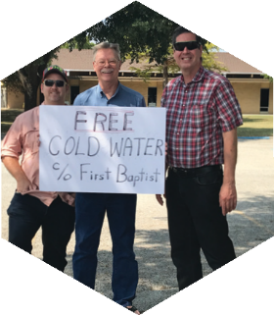
FIRST TIME HERE?
Text Welcome to
830-224-2046

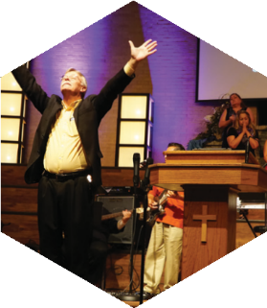

www.fbcseguin.org
830.379.4208
1314 E. Cedar St.

MORNING SERVICE
January 19, 2020 10:30 AM

WORSHIP MEDLEY Congregation
The Lilly of the Valley (Hymn #189)
The Way of the Lord

SCRIPTURE: Judges 1:22-28 Judy Rogers

PRAYER/WELCOME Pastor Brice

I HAVE A DREAM Video

WORSHIP MEDLEY Congregation
At The Cross (Hymn #139)
Lord, I Need You
How Deep the Father’s Love for Us

SERMON: GETTING RID OF CANAANITES
Pastor Brice

RESPONDING TO GOD’S WORD Congregation
Wherever He Leads, I’ll Go (Hymn #285)

OFFERING
Prayer Whitney Reese
Oh Come To the Alter Praise Team

* Children 4 years old thru First Grade dismissed for children’s worship following this song.

MLK JR GOSPEL CONCERT
TONIGHT 7:00-9:00 PM
We are excited to once again partner with the Seguin Area Martin Luther King, Jr. Committee to bring you a time of celebration and fun! Tonight our church will be busting at the seams with music! This is a fun time of fellowship with the members of our community. We encourage you to join us as we partner and celebrate with other area churches a defining and steadfast man of history.

BUSINESS MEETING & CHILI SUPPER
JANUARY 26 6:00 PM
Join us for our first quarterly business meeting of the new year. We will discuss the previous quarter’s financials and new membership. The Deacons will serve a hot dinner of homemade chili and cornbread!

SECURITY TEAM
As the calendar flips to a new year, we flip over a new need. We would like to encourage you to be in prayer about joining the security team here at First Baptist Church. As our church grows, so does our need for more volunteers. If you would be interested in joining the team or would like more information about the team and what is involved, please fill out the blue Serving card found in the pew and place it in the offering plate.

