DEACON RECOMMENDATIONS
Enclosed is a ballot for the acceptance of BJ Jeffers, Everett Harcrow and Billy Smith to serve as deacons in the church. Please place it in the offering plate upon completion.

GAME NIGHT
FEBRUARY 13 6:00 PM
Join us for Game Night. Every second Thursday of the month we gather for games, food and fun. Everyone is welcome. Mickey Peoples will serve chicken & sausage gumbo and shrimp gumbo for dinner. We would like to ask that you bring a side or dessert to accompany the dish and your favorite card or board game.

EVEN TUESDAY MEN’S PRAYER BREAKFAST
FEBRUARY 18 6:30 AM
Men, next Tuesday morning in the Fellowship Hall, join us for breakfast, Scripture, and prayer. We look forward to seeing you there.

BETH MOORE CONFERENCE – SAN ANTONIO
APRIL 3-4
Ladies, you’re invited to the Living Proof Live party with Beth Moore. This is a two day event complete with worship led by Dove Award winner Travis Cottrell and a one of a kind, encouraging message from Beth Moore. Tickets are $65 per person for groups of 10 or more. If you are interested in attending this extraordinary event, please write “Beth Moore” on and fill out the yellow Next Steps card then place it in the offering plate. You may also stop by the church office to sign up. All checks/payments should be made out to First Baptist Church.

For more information about the event, you can visit the website: https://www.lifeway.com/en/events/living-proof-live/living-proof-live-san-antonio

ISRAEL TRIP
OCTOBER 30 – NOVEMBER 10, 2020
We are excited to invite you on a tour of Israel. We will tour all of the major sites in Israel (Jerusalem, Bethlehem, Nazareth, Qumran, Masada, Dead Sea, Jordan River, Sea of Galilee, Capernaum, etc.). The trip will cost $3400 per person. Price covers travel, lodging, breakfasts/dinners and tours of the various sites. Extra money will be needed for tips (app. $200), lunches and any souvenirs. If you are interested, please fill out (completely) a yellow pew card. Please write Israel Trip on the card and drop it in the offering plate. Brochures are available in the church foyer.

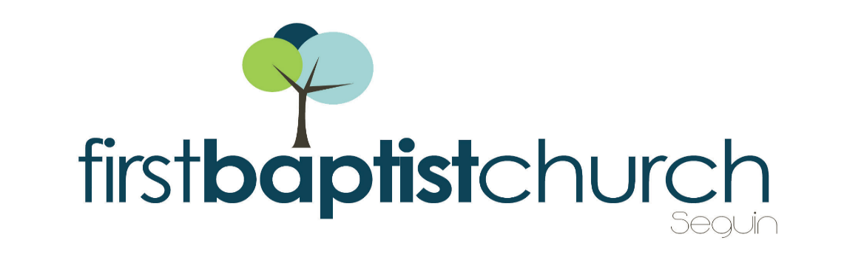
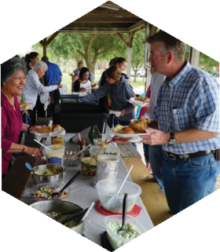
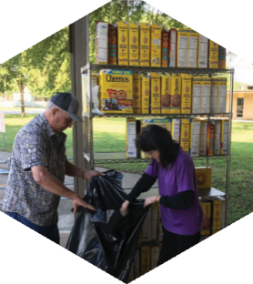
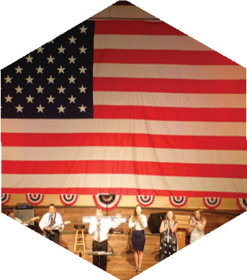

Pastor: Dr. Brice Mandaville
Youth Minister: Josh Graham
Children’s/Volunteer Coordinator: Rhonda Hensarling

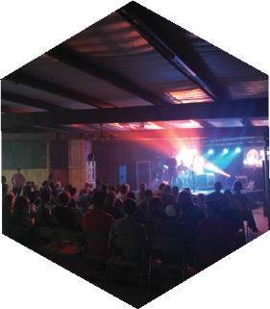
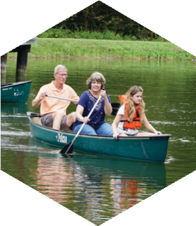
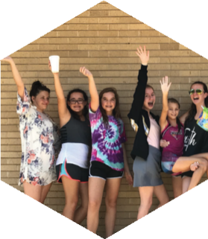
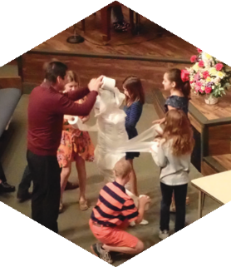
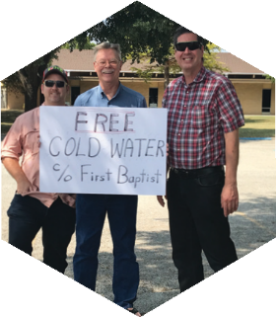
FIRST TIME HERE?
Text Welcome to
830-224-2046

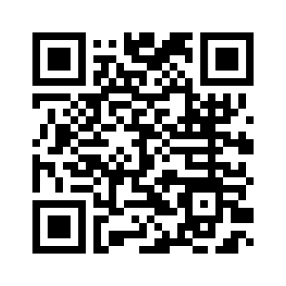

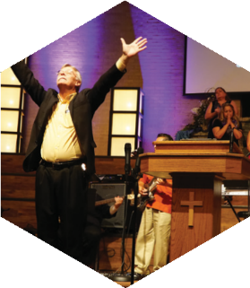

www.fbcseguin.org
830.379.4208
1314 E. Cedar St.

MORNING SERVICE
February 9, 2020 10:30 AM

WORSHIP MEDLEY Congregation
Always
Jesus Paid It All (#134)

SCRIPTURE: Judges 4:1-10 Allen Rhodes

PRAYER/WELCOME Pastor Brice

SERVICE UPDATE Video

WORSHIP MEDLEY Congregation
Here I Am To Worship
I Will Wait For You
How Deep the Father’s Love For Us

MESSAGE
DEBORAH: STEPPING OUT IN FAITH
Pastor Brice

RESPONDING TO GOD’S WORD Congregation
Just As I Am

OFFERING
Prayer Milt Watson
Because He Lives (#407) Praise Team

* Children 4 years old thru First Grade dismissed for children’s worship following this song.

EVENING WORSHIP
6:00 PM
Please join us for a traditional service of hymns and verse by verse preaching. Bro. Brice will be preaching tonight.

YOUTH S.N.A.C.
TONIGHT 5:00 – 7:00 PM
This event is for all youth, grades 6th – 12th. Tonight’s SNAC will be in the Youth building. We will have a pasta buffet for dinner with fellowship and fun to follow.

*Volunteer host homes are needed. Please write “youth fellowship” on a blue card and place in the offering if you would be interested in hosting the Youth for an evening.*

2019 CONTRIBUTION STATEMENTS
Contribution statements for the tax year 2019 have been mailed. Upon receiving your statement, please be sure to look it over carefully. If there are any discrepancies to be discussed, please call Holly in the church office. **Please note that statements totaling $100 or less will not be mailed. If you do not receive a statement, please stop by the church office.

SCRIPTURE READERS
We are looking for volunteers to read Scripture on Sunday mornings. If you would be interested, please fill out a blue pew card with current contact info and write the word Scripture on the line labeled “other.”

MORE INFORMATION
If you would like more information about the church, please fill out a white pew card and place it in the offering plate. If you do not have an email address, please feel free to write in a physical address. Any prayer requests may be written on the back.

