EVEN TUESDAY MEN’S PRAYER BREAKFAST
FEBRUARY 18 6:30 AM
Men, next Tuesday morning in the Fellowship Hall, join us for breakfast, Scripture, and prayer. We look forward to seeing you there.

EMBRACE GRACE BABY SHOWER
FEBRUARY 28
The Embrace Grace Wednesday night class will be holding a special celebration for each of their “blossoms” the last Friday night of this month. Help is needed as they prepare to shower these women with God’s love. If you would be interested in helping in any of the following areas, please contact Wanda Kollaus or Catherine Page:
- Gift wrapping
- Setup/tear down
- Food prep
- Decorating

BETH MOORE CONFERENCE – SAN ANTONIO
APRIL 3-4
Ladies, you’re invited to the Living Proof Live party with Beth Moore. This is a two day event complete with worship led by Dove Award winner Travis Cottrell and a one of a kind, encouraging message from Beth Moore. Tickets are $65 per person for groups of 10 or more. If you are interested in attending this extraordinary event, please write “Beth Moore” on and fill out the yellow Next Steps card then place it in the offering plate. You may also stop by the church office to sign up. All checks/payments should be made out to First Baptist Church.

For more information about the event, you can visit the website: https://www.lifeway.com/en/events/living-proof-live/living-proof-live-san-antonio

ISRAEL TRIP
OCTOBER 30 – NOVEMBER 10, 2020
We are excited to invite you on a tour of Israel. We will tour all of the major sites in Israel (Jerusalem, Bethlehem, Nazareth, Qumran, Masada, Dead Sea, Jordan River, Sea of Galilee, Capernaum, etc.). The trip will cost $3400 per person. Price covers travel, lodging, breakfasts/dinners and tours of the various sites. Extra money will be needed for tips (app. $200), lunches and any souvenirs. If you are interested, please fill out (completely) a yellow pew card. Please write Israel Trip on the card and drop it in the offering plate. Brochures are available in the church foyer. Please make all payments and checks to First Baptist Church.

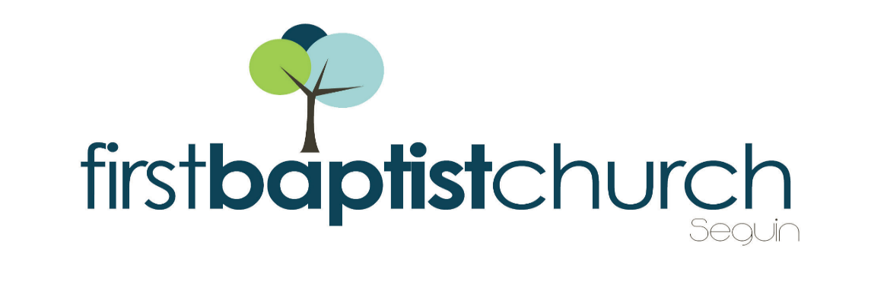
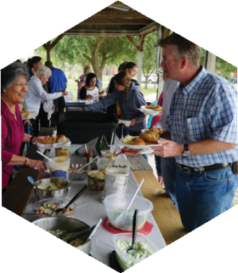
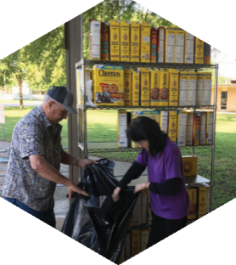
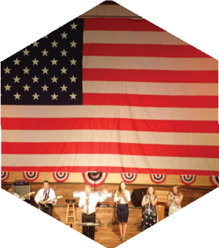

Pastor: Dr. Brice Mandaville
Youth Minister: Josh Graham
Children’s/Volunteer Coordinator: Rhonda Hensarling

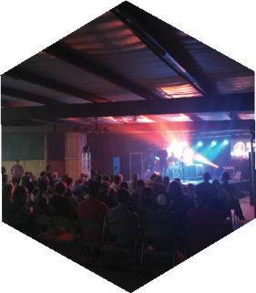
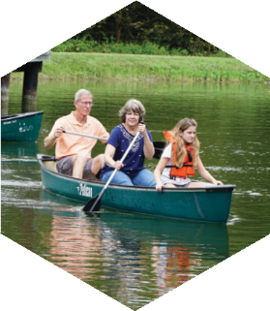
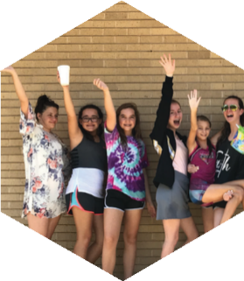
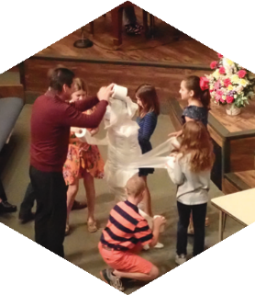
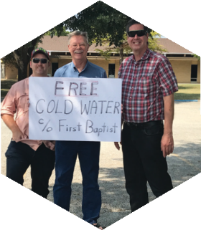

www.fbcseguin.org
830.379.4208
1314 E. Cedar St.

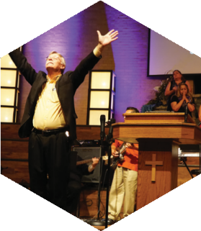

MORNING SERVICE
February 16, 2020 10:30 AM

WORSHIP MEDLEY Congregation
Holy Holy Holy (Hymn #2)
We Are Here For You

SCRIPTURE: Judges 6:7-13 Randall Lawrence

PRAYER/WELCOME Pastor Brice

Just As I Am, I COME BROKEN Choir

WORSHIP MEDLEY Congregation
WayMaker
Mercy*

message Pastor Brice
If the Lord is with us, why then
has all this happened to us?

RESPONDING TO GOD’S WORD Congregation
Just As I Am

OFFERING
Prayer David Smith
Lord I Need You Praise Team

* Children 4 years old thru First Grade dismissed for children’s worship following this song.

EVENING WORSHIP
6:00 PM
Please join us for a traditional service of hymns and verse by verse preaching. Bro. Graham will be preaching tonight.

DEACON ORDINATION
FEBRUARY 23
During our evening service, next Sunday, we will be ordaining BJ Jeffers, Everett Harcrow and Billy Smith to serve as deacons in our church. We hope you will join us in support of their commitment to serve the Lord and this church.

SCRIPTURE READERS
We are looking for volunteers to read Scripture on Sunday mornings. If you would be interested, please fill out a blue pew card with current contact info and write the word Scripture on the line labeled “other.”

SPRING FORWARD
MARCH 7
Daylight savings time begins in about a month’s time. In the event you don’t have a smart phone or device that automatically recognizes it, be sure to set you clocks ahead 1 hour before heading to bed. Don’t forget the oven or the car clock!

MORE INFORMATION
If you would like more information about the church, please fill out a white pew card and place it in the offering plate. If you do not have an email address, please feel free to write in a physical address. Any prayer requests may be written on the back.

