DESSERT AUCTION
MARCH 22 6:00 PM
In tandem with the North American Missions Annie Armstrong Easter Offering, we will be holding a live auction of specialty desserts as a fun way to raise money toward such a vital ministry. If you would like to submit a dessert for auction, there will be a signup sheet in the church foyer beginning Sunday, March 1. Remember that you will need to bring 2 of each dessert you submit (one for trying, one for buying). Mark your calendars for this convention of culinary confections!

WOMENS MISSIONARY UNION ANNUAL MEETING
MARCH 27-28
The annual meeting of the Texas WMU will be held at Oakwood Baptist Church in New Braunfels this year. Speakers include Cindy Townsend, Emily Swader, and Lena Plunk, and there will be both general and breakout sessions. Those desiring to attend may register online at WMUTX.org.

BETH MOORE CONFERENCE – SAN ANTONIO
APRIL 3-4
Ladies, you’re invited to the Living Proof Live party with Beth Moore: a two day event complete with worship led by Dove Award winner Travis Cottrell. Tickets are $65 per person for groups of 10 or more. If you are interested in attending this extraordinary event, please write “Beth Moore” on and fill out the yellow Next Steps card then place it in the offering plate. You may also stop by the church office to sign up. All checks/payments should be made out to First Baptist Church.
For more information about the event, you can visit the website: https://www.lifeway.com/en/events/living-proof-live/living-proof-live-san-antonio

ISRAEL TRIP
OCTOBER 30 – NOVEMBER 10, 2020
We are excited to invite you on a tour of Israel. We will tour all of the major sites in Israel (Jerusalem, Bethlehem, Nazareth, Qumran, Masada, Dead Sea, Jordan River, Sea of Galilee, Capernaum, etc.). The trip will cost $3400 per person. Price covers travel, lodging, breakfasts/dinners and tours of the various sites. Extra money will be needed for tips, lunches and any souvenirs. If you are interested, please fill out (completely) a yellow pew card. Please write Israel Trip on the card and drop it in the offering plate. Brochures are available in the church foyer. Please make all payments and checks to First Baptist Church.

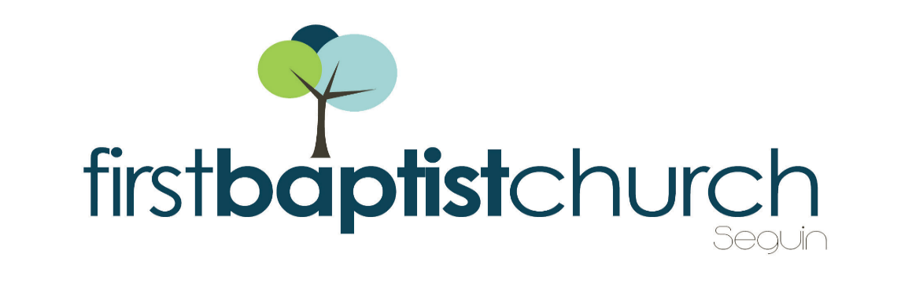
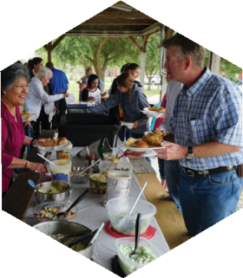
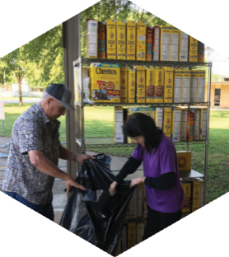
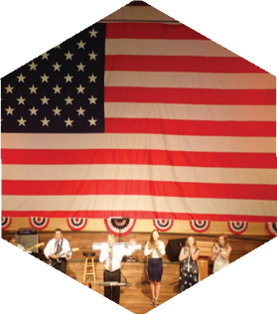

Pastor: Dr. Brice Mandaville
Youth Minister: Josh Graham
Children’s/Volunteer Coordinator: Rhonda Hensarling

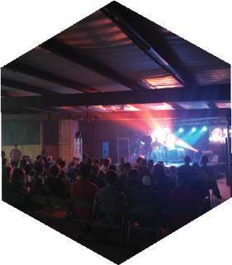
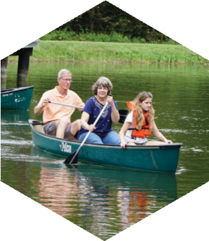
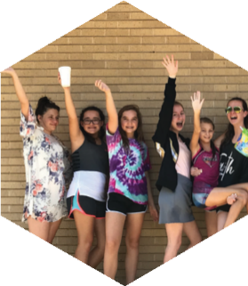
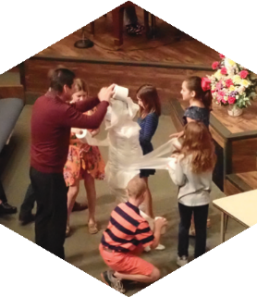
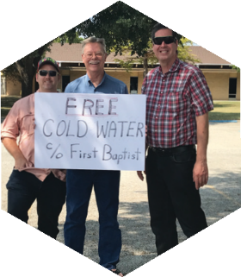

www.fbcseguin.org
830.379.4208
1314 E. Cedar St.

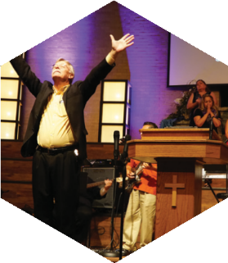

MORNING SERVICE
February 23, 2020 10:30 AM

Higher than the Heavens Young Musicians

WORSHIP MEDLEY Congregation
Come Thou Fount of Every Blessing #15
The Way of the Lord

SCRIPTURE: Judges 6:33-40 Catherine Page

PRAYER/WELCOME Pastor Brice

ISRAEL TOUR 2020 Video

WORSHIP MEDLEY Congregation
The Blood Will Never Lose Its Power #133
Forever (We Sing Halleluiah)*

ASKING GOD FOR A SIGN
Pastor Brice

RESPONDING TO GOD’S WORD Congregation
Just As I Am #307

OFFERING
Prayer Bob Whitener
Living Hope Praise Team

* Children 4 years old thru First Grade dismissed for children’s worship following this song.

EVENING WORSHIP
6:00 PM
We invite you to join us as we ordain the following men to serve as deacons in our church: BJ Jeffers, Everett Harcrow and Billy Smith. We hope you will join us in support of their commitment to serve the Lord and this church.

KEENAGER’S LUNCHEON
MARCH 2
Be sure to sign up today for the March KeenAger’s luncheon. Table games and fellowship will begin at 10:00 AM with lunch served at 11:30 AM. Beginning at noon we will have a special presentation about hummingbirds by Treva Hicks.

SPRING FORWARD
MARCH 7
Daylight savings time begins in two weeks. Don’t forget the car clock…

SCRIPTURE READERS
If you would be interested in reading Scripture during the Sunday morning service, please fill out a blue pew card with current contact info and write the word Scripture on the line labeled “other.”

MORE INFORMATION
If you would like more information about the church, please fill out a white pew card and place it in the offering plate. If you do not have an email address, please feel free to write in a physical address. Any prayer requests may be written on the back.

