KEENAGER’S LUNCHEON
TOMORROW
We are excited to have Treva Hicks with us tomorrow morning to give a presentation on hummingbirds and monarch butterflies for our March luncheon. Table games and fellowship begin at 10:00 AM with lunch served at 11:30 AM. We’ll see you there.

SPRING FORWARD
MARCH 7
Daylight savings time begins on Saturday. We’ll see you bright and early (literally) next Sunday!

YOUTH SNAC
MARCH 8
This event is for all youth, grades 6th – 12th. This month we are at the Ransdell house (located at 118 Lakeside Dr. here in Seguin). There will be food, there will be games, there will be awesome fun! We hope to see you there.

WOMENS MISSIONARY UNION ANNUAL MEETING
MARCH 27-28
The annual meeting of the Texas WMU will be held at Oakwood Baptist Church in New Braunfels this year. Speakers include Cindy Townsend, Emily Swader, and Lena Plunk, and there will be both general and breakout sessions. Those desiring to attend may register online at WMUTX.org.

BETH MOORE CONFERENCE – SAN ANTONIO
APRIL 3-4
This is a two day event complete with worship led by Dove Award winner Travis Cottrell. A signup sheet is available in the church foyer on the counter. Friends are welcome! We are working on making the church van available for the event. Payment for the event should be made to First Baptist Church and are due no later than March 29.
For more information about the event, you can visit the website: https://www.lifeway.com/en/events/living-proof-live/living-proof-live-san-antonio

ISRAEL TRIP
OCTOBER 30 – NOVEMBER 10, 2020
We are excited to invite you on a tour of Israel. We will tour all of the major sites in Israel. The trip will cost $3400 per person. Price covers travel, lodging, breakfasts/dinners and tours of the various sites. Brochures are available in the church foyer. Please make all payments and checks to First Baptist Church.

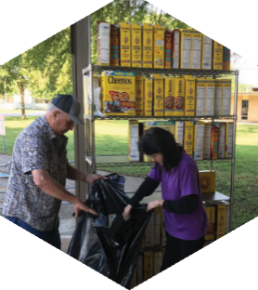

Pastor: Dr. Brice Mandaville
Youth Minister: Josh Graham
Children’s/Volunteer Coordinator: Rhonda Hensarling

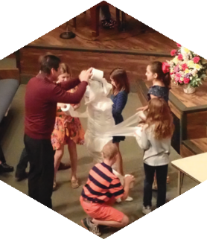
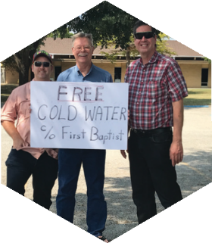

www.fbcseguin.org
830.379.4208
1314 E. Cedar St.

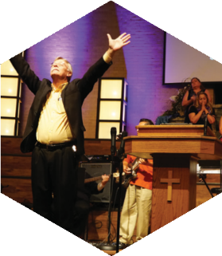

MORNING SERVICE
March 1, 2020 10:30 AM

10,000 Reasons Congregation

Come Thou Fount of Every Blessing
Little Angels Choir

PRAYER/WELCOME Pastor Brice

CHURCH PLANTING IN SEATTLE Video

WORSHIP MEDLEY Congregation
Doxology (#253)
Christ Is Risen
Oh Come To The Alter*

SCRIPTURE: Judges 8:1-9 Cody Hamilton

message Pastor Brice

DEALING WITH DIFFICULT PEOPLE

RESPONDING TO GOD’S WORD Congregation
Softly and Tenderly (Hymn #312)

OFFERING
Prayer Bruce Allen
King of My Heart Praise Team

* Children 4 years old thru First Grade dismissed for children’s worship following this song.
EVENING WORSHIP
6:00 PM
Please join us for a traditional service this evening of hymns and verse by verse preaching by Bro. Brice.

WEEK of PRAYER FOR N. AMERICAN MISSIONS
MARCH 1 – 8
Each Spring, we take up an offering in support of new church plants in North America, many of which are in areas that have no effective witness of the gospel. Enclosed is a prayer guide for the week and an offering envelope. Your prayers and financial support through the Annie Armstrong Easter Offering are important to these missionaries. Please be in prayer about what God would have you give to this important ministry.

DESSERT AUCTION
MARCH 22 6:00 PM
In tandem with the North American Missions Annie Armstrong Easter Offering, we will be holding a live auction of specialty desserts as a fun way to raise money toward such a vital ministry. If you would like to submit a dessert for auction, there will be a signup sheet in the church foyer beginning Sunday, March 1. Remember that you will need to bring 2 of each dessert you submit (one for trying, one for buying). Mark your calendars for this convention of culinary confections!

MORE INFORMATION
If you would like more information about the church, please fill out a white pew card and place it in the offering plate. If you do not have an email address, please feel free to write in a physical address. Any prayer requests may be written on the back.

