MEN’S EVEN TUESDAY PRAYER BREAKFAST
MARCH 10 – 6:30 A.M. – FELLOWSHIP HALL

GAME NIGHT
MARCH 12
Join us for our monthly Game Night, this Thursday in the Fellowship Hall. We will provide a dinner of beef stew and cornbread, but you are encouraged to bring a dessert or appetizer to share along with your favorite board or card game. The fun starts at 6:00 PM, we hope to see you there.

CALLED BUSINESS MEETING
MARCH 22
We will have a short, called business meeting before the dessert auction begins to discuss and vote on the proposed funding of three projects around/for the church: $70k for a new roof on the Fellowship Hall; $5k to host another Rise Against Hunger Event; $5k to assist Josh & Sarah & children (missionaries from our church) with housing while they are in the States for next school year.

WOMENS MISSIONARY UNION ANNUAL MEETING
MARCH 27-28
The annual meeting of the Texas WMU will be held at Oakwood Baptist Church in New Braunfels this year. Speakers include Cindy Townsend, Emily Swader, and Lena Plunk, and there will be both general and breakout sessions. Those desiring to attend may register online at WMUTX.org.

BETH MOORE CONFERENCE – SAN ANTONIO
APRIL 3-4
This is a two day event complete with worship led by Dove Award winner Travis Cottrell. A signup sheet is available in the church foyer on the counter. Friends are welcome! We will have the church van available. Payment for the event should be made to First Baptist Church and is due no later than March 29.

ISRAEL TRIP
OCTOBER 30 – NOVEMBER 10, 2020
We are excited to invite you on a tour of Israel. We will tour all of the major sites in Israel. The trip will cost $3400 per person. Price covers travel, lodging, breakfasts/dinners and tours of the various sites. Brochures are available in the church foyer. Please make all payments and checks to First Baptist Church.

For more information about the church, please fill out a white pew card and place it in the offering plate. All prayer requests can be written on the back of the card.

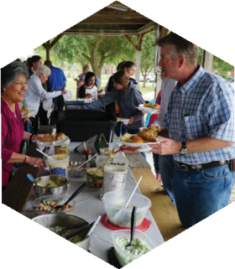
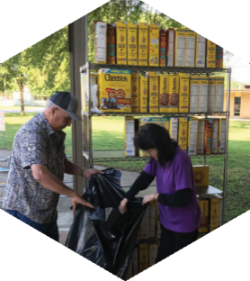

Pastor: Dr. Brice Mandaville
Youth Minister: Josh Graham
Children’s/Volunteer Coordinator: Rhonda Hensarling

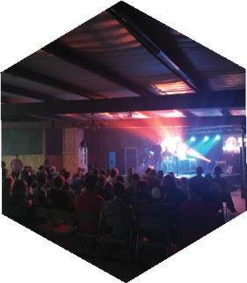
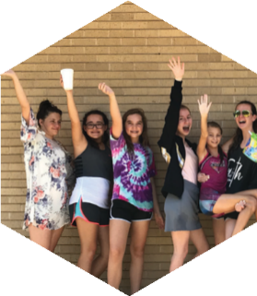
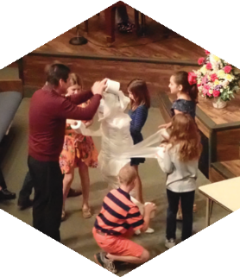
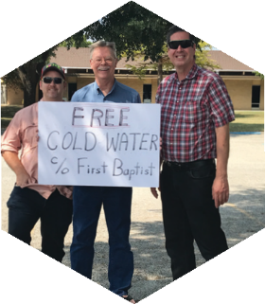

www.fbcseguin.org
830.379.4208
1314 E. Cedar St.

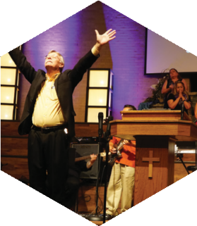

MORNING SERVICE
March 8, 2020 10:30 AM

I Stand Amazed in the Presence (#547)
Congregation
We Delight In the King of Kings
Music Makers Ensemble

PRAYER/WELCOME Pastor Brice

CHURCH PLANTING IN DENVER Video

WORSHIP MEDLEY Congregation
WayMaker
King of My Heart
Holy Spirit *

SCRIPTURE: Romans 1:1-7 Tanner Beedy

message Pastor Brice
GRACE AND PEACE

RESPONDING TO GOD’S WORD Congregation
Softly and Tenderly (Hymn #312)

OFFERING
Prayer David Anderson
Nothing But the Blood of Jesus Praise Team

* Children 4 years old thru First Grade dismissed for children’s worship following this song.

EVENING WORSHIP
6:00 PM

Please join us for a traditional service this evening of hymns and verse by verse preaching by Bro. Brice.

YOUTH FELLOWSHIP
TONIGHT – 5-7 PM

This event is for all youth, grades 6th – 12th. Tonight, we are at the Ransdell house (located at 118 Lakeside Dr. here in Seguin). There will be food, there will be games, there will be awesome fun! We hope to see you there.

OFFERING FOR CHURCH PLANTING

Each Spring, we take up an offering in support of new church plants in North America through our Southern Baptist Mission Agency. Most of these new churches are in areas that have no effective witness of the gospel. We will be collecting for this ministry through the month of March. Please be in prayer about what God would have you give to this important ministry.

DESSERT AUCTION
MARCH 22 6:00 PM

In tandem with the Church Planting Offering, we will be holding a live auction of specialty desserts as a fun way to raise money toward such a vital ministry. If you would like to submit a dessert for auction, there is a signup sheet in the church foyer. Please be sure to sign up by March 15th as we will need time to make the proper labels for your submission.

